FAIR 337

B E R L I N :
C I T Y O F R E M E M B E R I N G
+ F O R G E T T I N G

12 credits
Fall 2023

INSTRUCTOR
Robert Yerachmiel Sniderman, MFA, Assistant Professor in Socially Engaged Art
snyder24@wwu.edu

BERLIN-BASED CO-FACILITATOR
Rachel Pafe, MA, MRes, PhD Candidate at the University of Leipzig
rachelpafe@gmail.com

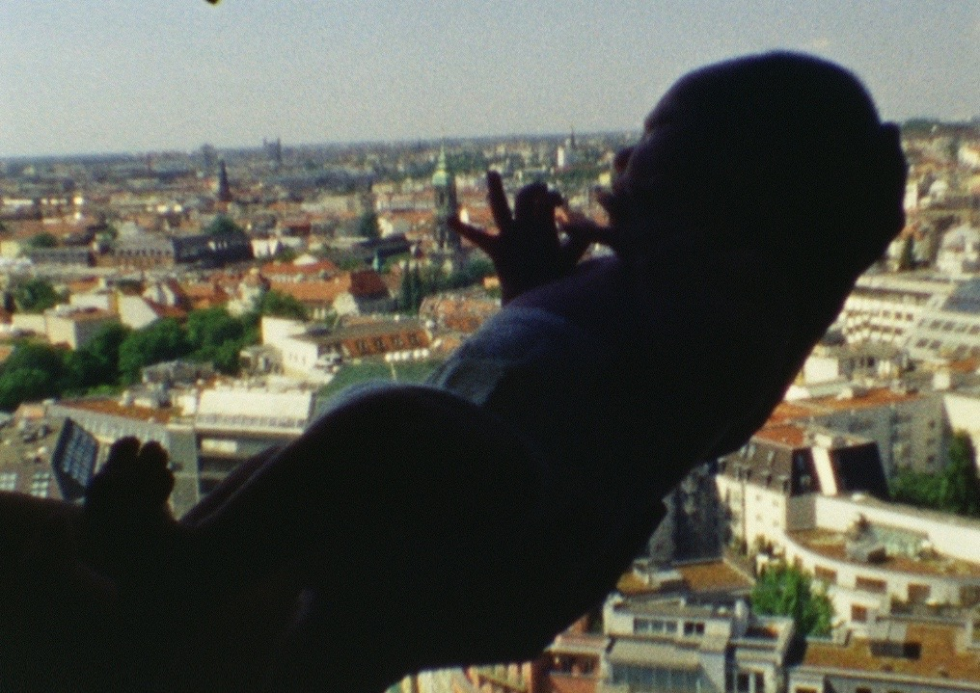
from Born in Berlin (2012), a life project and film by Polish artist Joanna Rajkowska

Course description:
In this Fairhaven College Global Learning Program, we will travel to the European metropolis of Berlin, a city marked by mass traumas and complex cultural systems. In reading, writing, site study, art, collaborations, interventions, and critical discussions, we will interrogate, argue over, struggle in, and reveal how violent histories are remembered and overwritten in the city and how they persist in shaping its present, entangling our roots and futures by way even of immersive visitation. We will investigate and respond to the living force of German colonization and genocide in Namibia; Nazism and the Holocaust; the US and Britain’s bombing destruction of Berlin; postwar mass migrations, displacements, and resettlements; the four-decade separation of the city into opposing capitalist and socialist States; and contemporary diasporas of immigrants, migrant workers, refugees, and returned exiles. Most important, we will walk extensively, rooted in the above concerns, engaging Berlin’s turbulent layers and networks in everyday place-responsive practices of witness, critique, creation, and relationality.

During our collective study, we will work through the following core questions core questions: How do we engage with invisible landscapes underlying visible spaces? What are our own documentary and representational impulses and what ethical-aesthetic implications do they bear? How memorialize an event that is ongoing? How are Germany’s violent pasts negotiated within and between different demographic communities within and beyond its contemporary and historical borders? What relations exist between German memoryscapes of historical violence and those in the US? What is the role of art, literature, and cultural activism in sparking, facilitating, and holding accountable processes of redress, reparation, and repair?

A faculty-led study abroad experience, this course will span intensive on-campus introductory sessions and six weeks of engagement in Berlin, Germany. In Berlin, we will meet three to four days a week, leaving the rest of the week for solo project work and free space for rest, integrating heavy materials, and exploring Berlin. Within such contexts, participants must be able to walk for three-five hours in a day with reasonable accommodations. Our meetings each week will include space for reflection and discussion. In addition to traditional course work and site visits, students will meet Berlin-based artists, scholars, community groups, organizations, and activists.

Student research in the form of critical writing and/or artistic production will culminate in the creation of a handmade book (aka zine). In Week 9, students will participate in a bookmaking workshop at Colorama, a small art space and risoprinting studio, through which each student will design, print, and bind ten copies of their own zine. The program will end the second to last week of Fall quarter, meeting once remotely in the last week, and not returning to Western. Students will have the option to continue traveling in Europe afterwards through Winter Break. No previous study with memory, language/s, or culture/s of Germany is required.

Required Materials:

Nathaniel Flakin, Revolutionary Berlin: A Walking Guide (Pluto Press 2022)

Christopher Isherwood, Goodbye to Berlin (any edition—originally published 1939)

Marie Jalowicz Simon, Underground in Berlin, trans. Anthea Bell (Little Brown 2015)

Notebook or Sketchbook (any size but w/ enough pages for breadth of class)

*Required books must be acquired by the start of the course
**All other materials will be available as PDFs or online

Learning Objectives:
By the end of the course, students will:
—Understand methods and contexts by which official, communal, and private memory of large-scale violence is shaped, altered, represented, and erased in Berlin.
—Analyze the stakes in the creation, maintenance, representation, erasure, and denial of memory in Berlin.
—Examine and critically reflect on the methods and contexts by which official, communal, and private memory of large-scale violence is worked out and contested by artists, writers, and activists working in Berlin.
—Critically consider the relations and discord between German memoryscapes of histories of violence and those in the US.
—Materialize research and course material a variety of forms, including collective discussion, critical prose, creative writing, performance art, textile art, and bookmaking.

ASSIGNMENTS
—Weekly Reflection: By Friday each week, reflect on the week's materials, discussions, and/or experiences in writing (min. 200 words), via Canvas Discussions. This writing can be pulled from or end up in your journal (see below).
—Journal: You will be required to keep a journal during our travels. This will help you to record and process the small and insignificant as well as the more challenging, and, perhaps, mysterious that tends to be part of any extended travel experience and deep study. You will occasionally receive specific journaling prompts, which we will occasionally share during meetings. Submit five transcribed pages in the final week.
—One-on-One Conference: Meet with Robert or Rachel in the 6th or 7th week to discuss prompt work (see below).
—Zine: Create a handmade book in
—Zine Presentation: 15-20 minute presentation and feedback in Week 10.
—Prompts (select and complete two):
—Transmedia Journal: Whether through sketching, photography, video, mixed-media art, ephemeral performances, or the intentional foraging of found objects and materials, maintain ongoing transmedia elements to your written journal.
—Site Analysis: Produce in-depth written analysis of one of the sites that is referenced to in our course materials and visits integrating critical observation, personal reflection, and cultural-political-historical contextualization.
—Creative Biography: Trace a figure that you encounter through our study or your own exploration of Berlin and represent your research in a text or artwork.
—Durational Contemplation: Engage with a site through repeated visitations and place-responsive ritual/art actions and research.
—Performance Action: Devise a performance that is based in one of the sites that is referenced to in our course materials or connects different such sites in the city which you want to constellate, juxtapose, activate, and/or bring into proximity with your body, memory, and research.
—Creative Text Series: Write a series of creative texts (poems, stories, scripts, essays etc.) which engages with Berlin’s memoryscapes.
—Participate: Volunteer for a Berlin organization, collective, or project that is relevant, in some way, to the course content, and document the experience in a text or artwork.
—Object Analysis: Reflect on a work of art or object that you encountered in a museum space.

Criteria for Evaluation and Classroom Culture:
Attendance + Participation
The course follows a carefully crafted trajectory of themes, experiences, reading and multimedia materials, and assignments. Thereby, the main requirement in this program is that students show up and participate. Unless you are ill, we ask students not to miss more than three sessions in the quarter. Keep in mind, as an abroad course, many of the programs have been paid for in advance. Lastly, the nature of the course does not allow much time for making up absences or catching up on content.

Readings
The first two weeks on campus are reading intensive and lay the foundation for the experiential component in Berlin. This period will not require the submission of other assignments, so you are expected to read the texts and engage with the films and other media closely and come to class prepared with notes and questions to contribute to our discussions.

Assignments
By departure in Week 10, submit the following:
Journal: five transcribed pages excerpted from the whole
Zine: submit one of the ten physical copies of your zine
Prompts: Text-based submissions should be a minimum of 1000 words per prompt. In the case of creative texts, contact professors for case-by-case parameters. Art-based prompts: each submission should include a minimum of two pieces of documentation media and one 500-word text that narrates and contextualizes the work.

Narrative Evaluations
Students will be evaluated based on attendance, participation in class activities, and submission of assignments. Further, students will be evaluated based on their individual journey, in terms of the quality and arc of their work and participation, over the quarter, as opposed to a predetermined, universal expectation. The most weighted elements in the course are engaged attendance and the zine.

