FR 301: French Grammar Review and Composition

French Language in Montreal
5 CH GUR: HUM

Professeure: Christina Keppie
Courriel: christina.keppie@wwu.edu
Lieu: Université du Québec à Montréal (UQAM) et en ville
4 juillet - 5 août, le lundi/mardi/mercredi/jeudi/vendredi, 9h-12h00

Breakdown of hours

Pre-departure workshop: 3hrs/day x 3 days = 9hrs + 1hr homework/day x 3 days = 12 hrs

In class: 3hrs/day x 4days x 5 weeks = 60 hrs

‘Allez plus loin’ activities (preparation outside of class): 2hrs/day x 4days x 5 weeks = 40 hrs

Exercices (workbook), revision, and compositions/peer review days: 1.5hrs/day x 5days x 5 weeks = 37.5 hrs

Total approximate hours: 149.5

Dates importantes:
- **Required** pre-departure on-campus workshop (3 days, June 2022)
- Optional presentation during Scholars Week, May 2023

Matériaux obligatoires:
- Desjardins, Proulx, Sauvé, 2016. Par ici, Méthode de français B1, 5-6 (CD inclus), Éditions MD
- Desjardins, 2019. Par ici, cahier d’exercices B1 5-6, Editions MD
- Un ordinateur portable ou une tablette
- Canvas

Description du cours:
- As a Humanities GUR, this course will use "critical, historical, and aesthetic approaches to explore how people experience and document their lives, examine and question the values of their societies, and creatively engage with their world" (see WWU Catalog, Course Competencies). You will learn to analyze and communicate ideas effectively in oral, written, and visual forms.
- This course will also have as a focus the (lexical, phonetic, morpho-syntactic) structure of the Canadian French language.
- This course allows students to acquire the language essentials you need for everyday communication. This course is designed for anyone wishing to learn French as it is spoken in Quebec and elsewhere in North America, with a view to study there, to work there, and more generally to integrate (into) the new society.
- Daily life activities will be integrated into this course as a means of working with the material presented in the classroom

Student Learning Outcomes for students enrolled in FR 301, as established by the Department of Modern and Classical Languages:
- Students will understand the linguistic variety of regional/national usages within French/Francophone cultures as well as the complexity of advanced grammatical structures and concepts in the French language.

Composants du cours:
Participation / Assiduité: 30%
Devoirs (Allez plus loin): 30%
Travaux de révisions et compositions: 30%
On campus pre-departure workshop: 10%

Répartition des notes:
A: 93%-100% B+: 86%-89% C+: 72%-77% D+: 65%-66% F: -60%
A- : 90%-92% B: 82%-85% C: 70%-71% D: 62%-64%
B- : 78%-81% C- : 67%-69% D- : 60%-61%

1. Participation /assiduité (30%):
Participation: La participation sera évaluée chaque semaine (5x), selon la rubrique suivante: 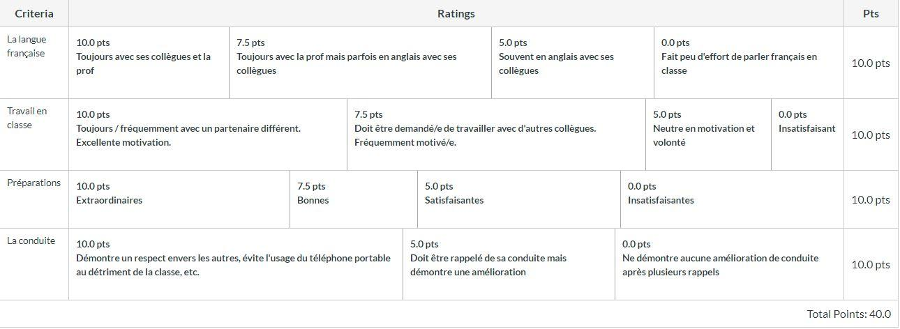
Cliquer ci-dessous pour vous rendre à chaque évaluation hebdomadaire:
Participation 1
Participation 2
Participation 3
Participation 4
Participation 5
Assiduité: Plus de 3 absences non-justifiables résulteront à un F comme note finale dans le cours. Un retard de 5 minutes sera noté ainsi dans Canvas. Un retard de plus de 5 minutes sera noté comme une absence.

2. Devoirs Allez plus loin (40%):
Les Épisodes Par ici contiennent des activités contextualisées nommées "Allez plus loin" qui servent comme exercices culminants. Chaque activité est à rendre à 9h le matin, soit en forme de présentation en classe, soit téléchargée sur Canvas. Pour leur réussite, les activités demandent l'usage des concepts grammaticaux spécifiques à chaque Épisode. Ces activités, présentées en classe et/ou téléchargées sur Canvas, sont évaluées chacune sur une échelle de 20 points. Cliquer ci-dessous pour une description de chaque activité "Allez plus loin":
- Épisode 1: Une image ou mille mots
- Épisode 2: Mauvaise surprise
- Épisode 3: Épargner...pour mieux dépenser
- Épisode 4: Quoi de neuf?
- Épisode 6: Les nouvelles de la journée
- Épisode 7: Belle nouvelle!
- Épisode 8: Aux petits soins
- Épisode 9: Comment te sens-tu?
- Épisode 11 : On se retrousse les manches
- Épisode 12 : Oui, âllo ?
- Épisode 13: Le Québec à la carte
- Épisode 14: Tu me manques
- Épisode 16: Bonnes vacances!
- Épisode 18: Et si tu me racontais...
- Épisode 19 : Un monde de possibilités
These activities culminate each chapter or ‘episode’ and require students to use their surroundings to complete each assignment. For example, preparing a shopping list to accommodate people with food sensitivities and then pricing their items at the grocery store. Each assignment/activity requires students to use the practical language presented in the episode in both an oral and written manner by interacting with the public and presenting their findings.

3. Travaux de révisions (20%):
Ce cours ne comprend pas d'examen final. Trois jours sont alloués aux révisions et aux compositions (qui servent comme travaux cumulatifs). Ces révisions sont toutes à finir avant 17h le soir (voir les dates ci-indiquées). Les détails de ces jours de révisions seront donnés le jour en classe.
- le lundi 23 juillet, Épisode 5: Bilan: On s'installe (révision des Épisodes 1-4)
- le lundi 30 juillet, Épisode 10: Bilan: On se débrouille! (révision des Épisodes 6-9)
- le jeudi 9 août, Épisode 15: Bilan: On célèbre! ET Épisode 20: Bilan: On va au théâtre! (révisions des Épisodes 11-14 et 16, 18-19)
Students are required to complete assignments in their workbook prior to the beginning of each chapter/episode in order to capitalize on in-class time. As well, revision days (Episodes 5, 10, 15, and 20) serve as unofficial testing days in class. Peer reviewed compositions are part of the material presented in Episodes 10 and 20, serving as midterm and final assignments.

4. On campus pre-departure workshop (10%):
Cet atelier demande l'assiduité de chaque étudiant. Le but de cet atelier est de familiariser le groupe avec les demandes et les attentes du programme. Chaque étudiant aura à signer un ‘contrat d’intention’ pour ne parler qu’en français pendant le long du séjour. Il y aura aussi des activités de préparation.

Policies for FREN 301:
1) Homework is not accepted late; all late assignments automatically receive a grade of 0. The instructor will happily provide feedback on the content of late assignments.
2) REASONABLE ACCOMMODATION -“Reasonable accommodation for persons with documented disabilities should be established within the first week of class and arranged through Disability Resources for Students: telephone 650-3083; email drs@wwu.edu; and on the web at Disability Resources.” (http://www.wwu.edu/newfaculty/documents/Praxis.pdf )
3) Use of cell phones in class for reasons other than course-related work will have immediate points deducted from their participation grade.
4) Students are to come to each class prepared for new material, as listed on the course schedule. Students should always have their textbook, writing materials, and (most likely) access to the internet.
5) Use of cell phones in class for reasons other than course-related work will result in immediate points deducted from their participation grade.
6) Students are expected to come to each class prepared for new material by having read/studied the text ahead of time (most frequently the "Expansion" section of each chapter).
7) All guidelines regarding academic honesty will be strictly abided. Students are strongly encouraged to be familiar with what entails academic honesty and the possible consequences of its violation. Please be familiar with the information provided here.
8) Western provides reasonable accommodation for students to take holidays for reasons of faith or conscience or for organized activities conducted under the auspices of a religious denomination, church, or religious organization. To learn about how to go about requesting accommodation, please consult this link.
9) As guests at UQAM, students will be respectful of the host classroom and always remove all garbage from the room at the end of class.
10) For each hour spent in the classroom, students will be prepared for at least 1 hour of dedicated work outside of the classroom dedicated to studying and working on homework and assignments.
- 1 Student credit hour = (approx.) 3 hours of total student work
11) Students are responsible for having read and understood the syllabus.

