FREN 385: Culture and Conversation

La Culture de Montréal

5 CH
Professeure: Christina Keppie
Courriel: christina.keppie@wwu.edu
Lieu: Université du Québec à Montréal (UQAM) et en ville
4 juillet - 5 août, le lundi/mardi/mercredi/jeudi/vendredi en après-midi / soirée

Breakdown of hours
Daily cultural activities: 2.5hrs/day x 4days x 5weeks = 50 hrs
Daily cultural activity assignments/preparations: 1hr/day x 4days x 5 weeks = 20 hrs
Individual research project: 6hrs/week x 5 weeks = 30 hrs
Blog project: 10hrs/week x 5 weeks = 50 hrs
Total approximate hours: 150

Dates importantes:
- **Required** pre-departure on-campus workshop (3 days, June 2022)
- Optional presentation during Scholars Week, May 2023

Matériaux obligatoires:
- Un cahier pour prendre des notes
- Un appareil photo, une caméra pour prendre des vidéos
- Un ordinateur portable ou une tablette
- Canvas
- De la créativité, de l'énergie, un esprit ouvert, un sens aventurier!

Description du cours:
- This course focuses on living in French in Montreal and learning of the city's cultural uniqueness by participating in various out-of classroom activities designed to assist students in their linguistic and cultural acquisition of French in a North American francophone metropolis. Students will be required to conduct independent research and document their daily activities.

Student Learning Outcomes for students enrolled in FREN 385, as established by the Department of Modern and Classical Languages:
- Students will have a general grasp of the geographical, historical, social, and political dimensions of French/Francophone cultures.

Composants du cours:
Participation / Langue: 30%
Blog: 50%
Recherche indépendante (présentation finale): 20%

Répartition des notes:
A: 93%-100% B+: 86%-89% C+: 72%-77% D+: 65%-66% F: -60%
A- : 90%-92% B: 82%-85% C: 70%-71% D: 62%-64%
B- : 78%-81% C- : 67%-69% D- : 60%-61%

1. Participation / Langue (30%):
Participation: La participation sera évaluée 2 fois, selon la rubrique suivante:
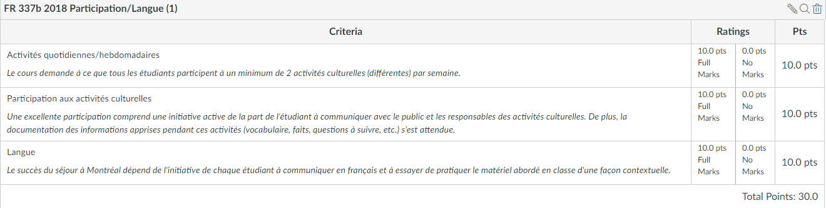

Cliquer ci-dessous pour vous rendre à chaque évaluation:
Participation / Langue 1
Participation / Langue 2
Les étudiants sont eux-mêmes responsables de ne pas se relâcher et de toujours laisser la professeure savoir de leurs intentions chaque jour à propos de leur assiduité aux activités culturelles.

2. Blog (50%):
Les étudiants ont à documenter chaque étape de leur séjour (à l'écrit, en photos, en forme vidéo, etc.). Cette documentation résultera à un blog comme projet cumulatif.
This blog project documents their experience, beginning with the pre-departure workshop. Canvas provides a detailed guide to the types of posts to include (10 total), such as pre-departure expectations, reflections on weekend excursions to Mt Tremblant, Ottawa, and Quebec City, their interactions with the public, their improvements in French and in cultural competencies, and a post-program post. Blog posts are to be accompanied by photos and videos. Students are also to follow and regularly comment on the blogs of at least 2 other students. Blogs are due 7-10 days after the end of the program.

Cliquer ci-dessous pour une description du blog et les étapes à suivre:
Description du blog
Initialiser le blog
Le partage et la discussion des blogs
le blog final

3. Recherche indépendante / présentation finale (20%):
Les étudiants doivent choisir un sujet de recherche sur lequel ils auront l'après-midi pour y travailler chaque mercredi. Cette recherche résultera à une présentation finale devant la classe le dernier jour en classe (5 août).
Each Wednesday afternoon is dedicated to individual research on a topic of the students’ choice. Topics must be related to Montreal (history, environment, immigration, etc.). The project must include regular visits to a specific location (museum, site, organization, neighbourhood etc.). This allows students to follow a topic of their own personal interest while abroad. Each week, students must submit a progress report on their research (known as ‘Faire le point’) before presenting the projects on the last day of class.

Cliquer ci-dessous pour une description de la recherche indépendante (présentation finale) et les étapes à suivre:
Description:
Recherche indépendante / présentation finale
Travaux:
Faire le point 1
Faire le point 2
Faire le point 3
Faire le point 4
Présentation finale

Policies for FREN 385:
1) Homework is not accepted late; all late assignments automatically receive a grade of 0. The instructor will happily provide feedback on the content of late assignments.
2) REASONABLE ACCOMMODATION -“Reasonable accommodation for persons with documented disabilities should be established within the first week of class and arranged through Disability Resources for Students: telephone 650-3083; email drs@wwu.edu; and on the web at Disability Resources.” (http://www.wwu.edu/newfaculty/documents/Praxis.pdf )
3) Use of cell phones in class for reasons other than course-related work will have immediate points deducted from their participation grade.
4) Students are to come to each class prepared for new material, as listed on the course schedule. Students should always have their textbook, writing materials, and (most likely) access to the internet.
5) Use of cell phones in class for reasons other than course-related work will result in immediate points deducted from their participation grade.
6) Students are expected to come to each class prepared for new material by having read/studied the text ahead of time (most frequently the "Expansion" section of each chapter).
7) All guidelines regarding academic honesty will be strictly abided. Students are strongly encouraged to be familiar with what entails academic honesty and the possible consequences of its violation. Please be familiar with the information provided here
8) Western provides reasonable accommodation for students to take holidays for reasons of faith or conscience or for organized activities conducted under the auspices of a religious denomination, church, or religious organization. To learn about how to go about requesting accommodation, please consult this link
9) As guests at UQAM, students will be respectful of the host classroom and always remove all garbage from the room at the end of class.
10) For each hour spent in the classroom, students will be prepared for at least 1 hour of dedicated work outside of the classroom dedicated to studying and working on homework and assignments.
- 1 Student credit hour = (approx.) 3 hours of total student work
11) Students are responsible for having read and understood the syllabus.

