Engage InPlace: Vietnam

Peacebuilding, Sustainability & Development in Vietnam
Summer 2022 Field Program in Vietnam
INTL437 – 6 credits
Instructor: Ashley Hollenbeck, ashley@villagestudies.org

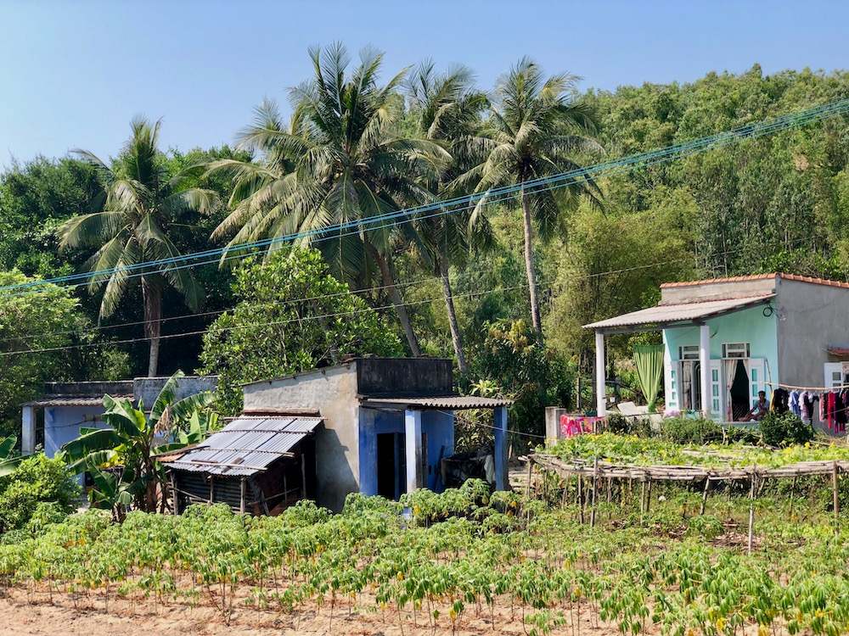 | 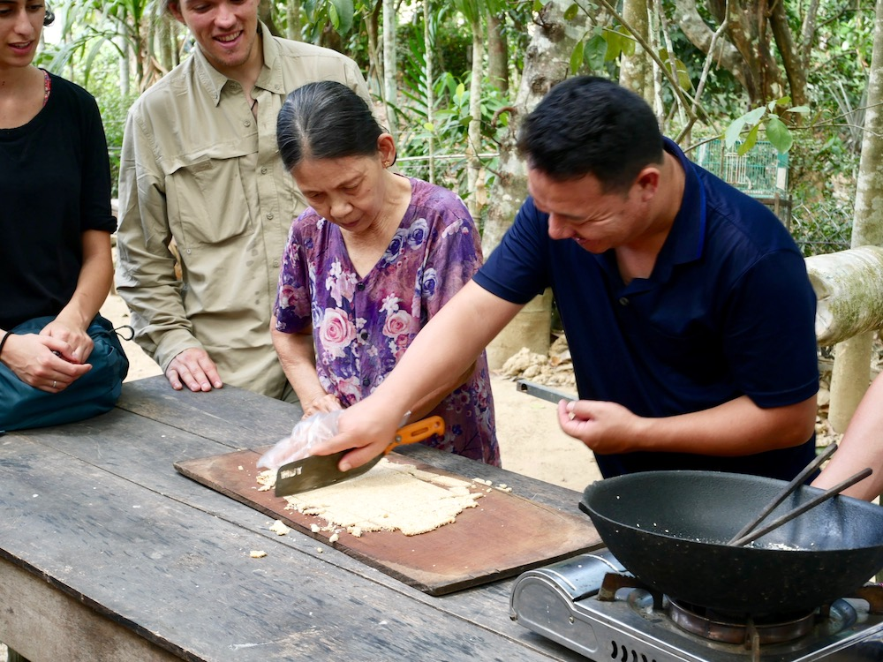 | 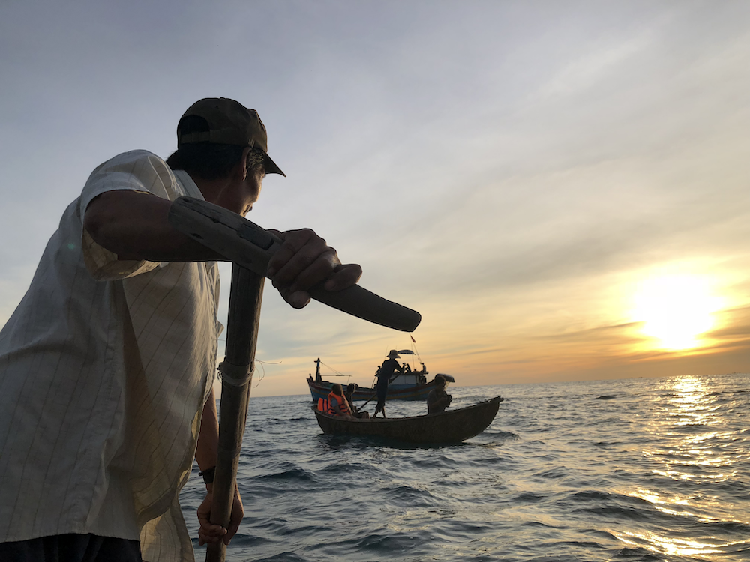

Course Description & Overview:
In today’s fast-paced and increasingly globalized world, it is imperative to develop awareness and leadership skills for global citizenship. This course is designed to give students a first-hand perspective into the field of international development, and critically analyze its effectiveness in the context of globalization in a post-conflict environment. On our visit to Vietnam, we will examine the connections between urban and rural communities that are essential to maintain local livelihoods and ecosystems by utilizing an asset-based community development methodology. Students will have the opportunity to take a more in-depth look at governmental and non-governmental organizations, as well as important social and environmental issues in Vietnam through the eyes of engaged local leaders and youth. By the end of the course, students will have a variety of practical skills that will be valuable in their future research and careers, as well as understand how grassroots community development can aid in creating more sustainable, long-lasting solutions to the challenges we face around the world.

This four-week intensive program, in partnership with the Institute for Village Studies and the University of Education in DaNang, requires participants to work directly with students from Vietnam to complete assignments in the field. This will provide opportunities for cultural immersion and cross-cultural engagement.

Students will spend time in Hue, DaNang, selected areas in the Quang Nam and Quang Ngai Provinces and Ho Chi Minh City. Participants will first be introduced to local history and culture in Hue City before joining students from around Vietnam for an intensive summer school training, Global Village Vietnam, that will take place in DaNang and the Quang Ngi Province. During this intensive training, students will work in cross-cultural teams to uncover the assets and strengths of the sites we visit before co-creating a project with local community members in the village where we will stay. At the end of the program, students will present ideas to local stakeholders and reflect upon how they can use these skills upon the completion of the course.

At the conclusion of the Global Village Program, the group will then travel to Ho Chi Minh City to see regional contrasts and begin to analyze sustainability and post-conflict development in the context of urbanization. This will aid in the continued discussion of urban-rural linkages, to better understand potential security threats to Doi Moi and peacebuilding process in the era of globalization.

Course Objectives:
- Provide basic knowledge of the cultural dynamics, religious traditions, historical patterns, and contemporary issues that contribute to the identities of the communities we visit, and assess how these factors have contributed (or not) to the development process.
- Introduce students to interdisciplinary conceptual frameworks, particularly those of sustainable community development, to develop important skills they may be valuable in their future careers.
- Enable participants to interpret their experiences, focus their service, and establish a context for specific inquiry.

Course objectives will be accomplished through experiences, field exercises, and direct instruction by local experts and WWU faculty. Outcomes of the course will be deepened by relationships that are developed with Vietnamese university students and members of the communities we visit.

Core Program Components:
Sustainability, Development & Community Engagement: Using a combination of guest talks, readings, lectures, and field observations collected through various assignments, we will explore sustainability and development in Vietnam. Students will be introduced to different frameworks surrounding sustainability (e.g., peacebuilding, sustainable development, asset-based community development, etc.) and see the reality of these paradigms and how they are impacting local communities through the development process in Vietnam. By the end of the course, students will have the skills to rethink traditional development narratives in the context of globalization, and examine their implications using a systematic approach that puts the community in the center of the development process.

Our role as outsiders is to approach international work with a huge dose of humility and let our community partners guide our involvement in the manner that they believe will be most meaningful. Service also does not end when we get back to the States, and in fact, this may be the most important part. With this recognition, students will create explore how to use this experience to be a positive resource for change, both in the communities we visited during the program and here at home.

Cultural Competency & Immersion: In addition to homestays and working with community partners, students will be required to work directly with Vietnamese students to finish assignments. This will necessitate a deep level of cultural competency and participants will be required to work through cultural differences (i.e., communication, high/low context, etc.) to have a productive fieldwork experience.

Responsible and Ethical Travel: The program is grounded in principles of responsible travel, which include ethical and culturally appropriate behavior, cultivating reciprocal relationships, learning from and valuing Indigenous knowledge, and supporting local economies and grassroots organizations. For the program to be successful and have a long-term positive impact, it requires a full commitment of all participants to uphold these principles. Before departure, we will cover general guidelines and expectations, as well as the responsibilities we carry as global travelers. We will also discuss potential moral dilemmas that can arise while traveling in another culture and strategies on how to handle such situations. With the understanding that responsible and ethical travel is an ongoing learning process, students will be encouraged to share questions, perspectives, and insights throughout the trip. Through this collaborative learning, we will aspire as a group to improve upon the practices and principles of the program.

Assignments and Assessment:
Group Participation & Final Project (60%): A large portion of this course includes working in small groups to complete different field assignments; therefore, it comprises the most significant part of student grades. The outcome (i.e., final project) is not as important as the process, and students will be graded on their ability to work as a valuable member of their cross-cultural team.

To Be a Good Member of the Team:
- Respect the local culture and norms. Be willing to learn from Vietnamese students, even if it pushes you outside of your comfort zone. You should be following their lead.
- Be an active member of the group. That means you are willing to share your opinions and ask questions during group discussion.
- BUT you should NOT DOMINATE the group. This is especially important in working with other cultures. Remember you are there to learn from locals and we don’t want to be the loudest (Americans) in the room. You should be very aware of how your actions affect the whole group.
- Demonstrates excellent listening skills by remaining attentive and respectful of other students, teachers, staff, and community members.
- Fully participate in all activities - even when things are not going like you think they should - demonstrate respect and self-control.

Final Projects Should:
- Demonstrates your (groups) ability to apply, analyze, and synthesize course material.
- Explore new ideas and challenging questions that you may be faced with throughout the course.
- Push yourself outside of your comfort zone to learn from local stakeholders and develop new ideas that you may not be able to learn from a textbook.
- Be based on the values and assets of the communities we work with, and ideally co-developed in partnership with local stakeholders.

Fieldwork Journal (30%): The fieldwork journal is a place to take notes and reflect upon learning experiences. Students will be expected to make daily entries and be prepared to submit their journal at the conclusion of the program. Entries may include personal reflection and observations, as well as responses to reflection prompts that will be given intermittently throughout the course and related to assigned activities/reading assignments.

Each Entry Should Include:
- Header: Date, location / or travel route for the day
- Assigned reflection prompt (if applicable): You will be assigned different reflection questions for reading assignments and activities throughout the course. This is intended to help you think through what you are learning and how it is related to the different communities we visit.
- Reflections & Summary: This is written at the end of the day and should include the highlights, challenges, lessons learned, questions that were answered and reflections.
- Questions: These are just as important as your observations. Every entry should have a few questions that you have during the course of the day. If you don’t have any questions - chances are you are not challenging yourself / immersing yourself in the local culture.

On occasion, you will be asked to select and share key passages that reflect your learning, connections to other experiences, or challenges to prior knowledge or points of view. This will aid in group discussion and reflection that is a critical component of the course and necessary for processing everything we learn along the way.

Final Self-Reflection/ Self-Evaluation (10%): Everyone will be required to write a final self-reflection/evaluation, in order to think about what you have learned and how you might use this skill/knowledge in the future. You may use the following prompts to get started. Grammar, proofreading, and writing quality are part of the grade. DO NOT just answer the questions, but make sure your reflection takes the form of a well-edited, organized essay.

Expectations and Goals
- What did I expect to learn? What were my goals? Was I able to meet my own expectations/goals by participating in this course?

Participation
- Be specific about your active participation in your group, meetings with partner organizations, and in the field. What was my role in group discussions? In other activities? Did I find ways to improve my participation over the course of the trip? How did my participation influence my learning in the course?
- Did I consistently follow the guiding principles and the group code of conduct throughout the trip?
- How did I work with Vietnamese students? What aspects of intercultural communication and emotional intelligence did I use to ensure our group was successful in our work?
- In what ways was I self-driven and engaged? How did I push myself to maximize the learning experience? What could I have done better?

Reflection
- How well did I do on this trip? What were my strengths and weaknesses? What new strengths or weaknesses did I discover? How did I address my weaknesses over the course of the trip?
- If I had problems or difficulties with the way the trip was working for me, did I first to solve the issues myself before bringing them to the attention of the instructor/others so circumstances could improve? Was I able to face challenges directly and productively solve problems?
- Did I seek out help when I needed it? How successful was I? What did I do/not do to make my experience as good as it could be?
- What did I learn (subject matter, skills, ways of knowing and working)?
- What changes happened in my attitude, my confidence, my way of going about or looking at things?
- What’s next? Where do I (could I) I go from here? How will this trip influence the next steps in my education?

Required Text and Supplies:
- Field journal or notebook of your choice. Bring something that is easy to carry around and that you want to write in. Please NOTE, you will need to turn it in at the conclusion of the class.
- 2 pens to write in your journal and take notes.
- Colored markers, pens or pencils. You will make presentation posters/ materials often during the course of the trip, so choose one thing to bring that you can share with the group to maximize your creative abilities. We can buy supplies in Vietnam, but the quality may not be as good, and you may choose to leave these supplies with the people in which we work.
- Vietnamese phrasebook, dictionary or app of your choice. Vietnamese is extremely hard, but learning a few key phrases will go a long way in integrating into local communities. You should note - you can download the Vietnamese version of Google translate.
- Small notebook to create your own dictionary that you can carry in your pocket
- Digital Course Pack with selected readings posted on Canvas. Internet access is widely available in Vietnamese, so you should be able to access readings overseas.
- One book of your choice related to Vietnam to read during the trip. This can be fiction or non-fiction. It will help you fill downtime and allow you to think more deeply about an issue you’re interested in. If you want recommendations – ask. I would encourage you to buy the book and bring the book with you (electronic or hard copy) because it can sometimes be hard to find English language books on sensitive subjects.

Itinerary:
The program begins at WWU with an orientation comprised of lectures, basic language training, team-building, and cross-cultural exercises. We then fly to Ho Chi Minh City where we will start to examine the topics of sustainability and peacebuilding in an urban setting, as well as meet with local project partners. From there, we will fly to Hue city. In Hue City, we will visit various world heritage sites, be introduced to local food, customs, and language, as well as learn from NGOs working in the area. Our time in Hue is designed to be a crash course into Vietnamese culture and history, as well as to see how the front lines of the Vietnam War has transformed into the city that it is today. After a brief introduction to Vietnam, we will take a van to Da Nang City where we will meet students from various places in Vietnam and begin the Global Village Vietnam summer school program. After the completion of the program, we will then travel to Hoi An to finish assignments and debrief as a group before heading back to the US.

Dates | Location | Student Activities
July 27 - 28 | Pre-Trip Seminar at WWU | Academics, Logistics, Health & Safety, Team-Building
July 29/30 | Depart Seattle
July 31- August 3 | Hoi Chi Minh City | Introduction to peacebuilding and development; program introduction with partners from HCMC National University
August 4-7 | Hue | Tour historic sites, meet with local NGOs, survival Vietnamese
August 8 - 11 | Da Nang | Start Global Village program with local university students, seminars, group work, meet with local NGOs & Government Agencies
August 12-14 | Cham Island (Quang Nam Province) | Homestays, Seminars & Service Learning with the Cu Lao Cham Marine Protected Area
August 15-21 | Go Co, Quang Ngai Province | Homestays, Supported project development/research, Presentation to local community, finish Global Village program with local university students
August 22-25 | Hoi An (Quang Nam Province) | Reflection on program with local students, seminars, visit UNESCO site, finish final assignments
August 26/27 | Depart Da Nang / Arrive Seattle

