Engage InPlace: Nepal

Biocultural Diversity in Nepal
Fall 2022 Field Program in Langtang National Park, Nepal

ESCI 437 – 15 credits
https://engageinplace.org/study-in-nepal
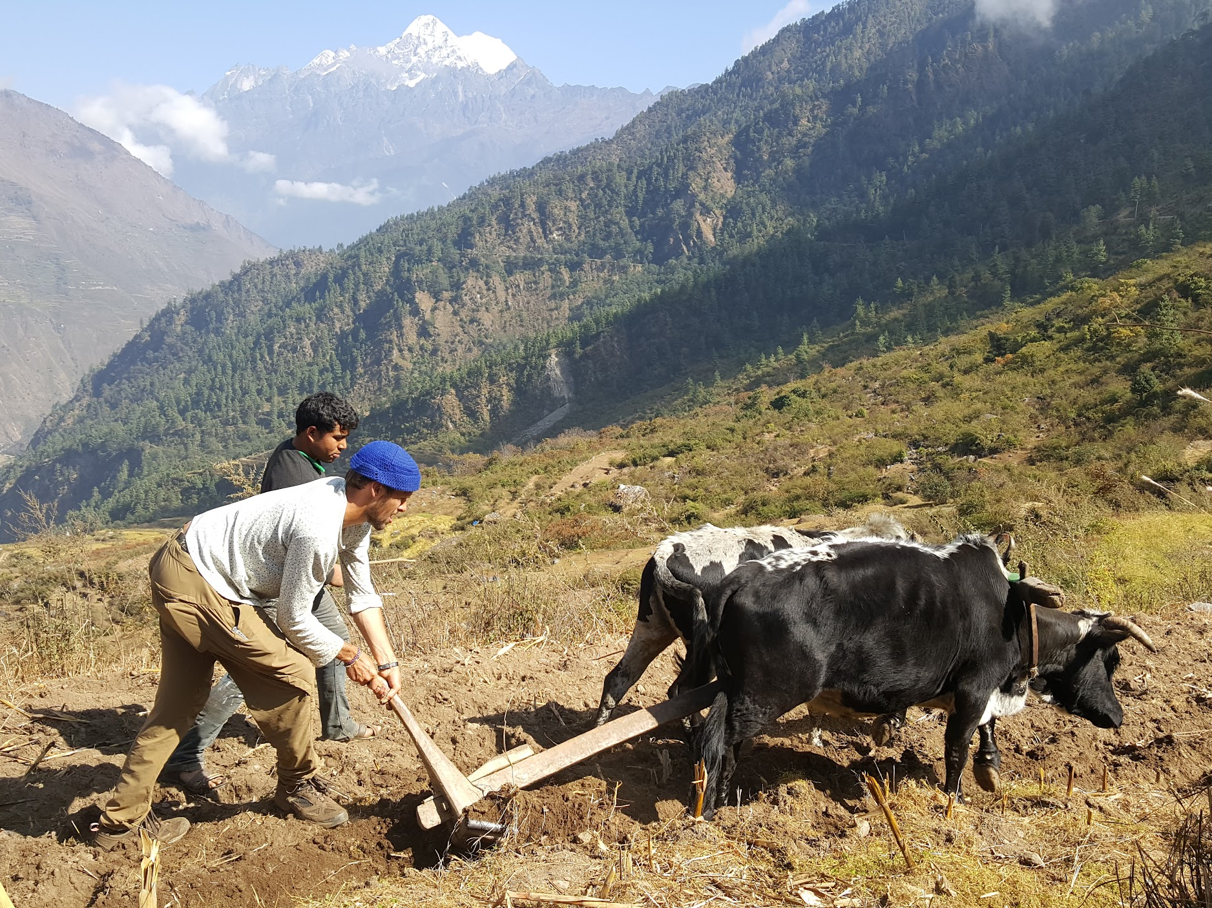
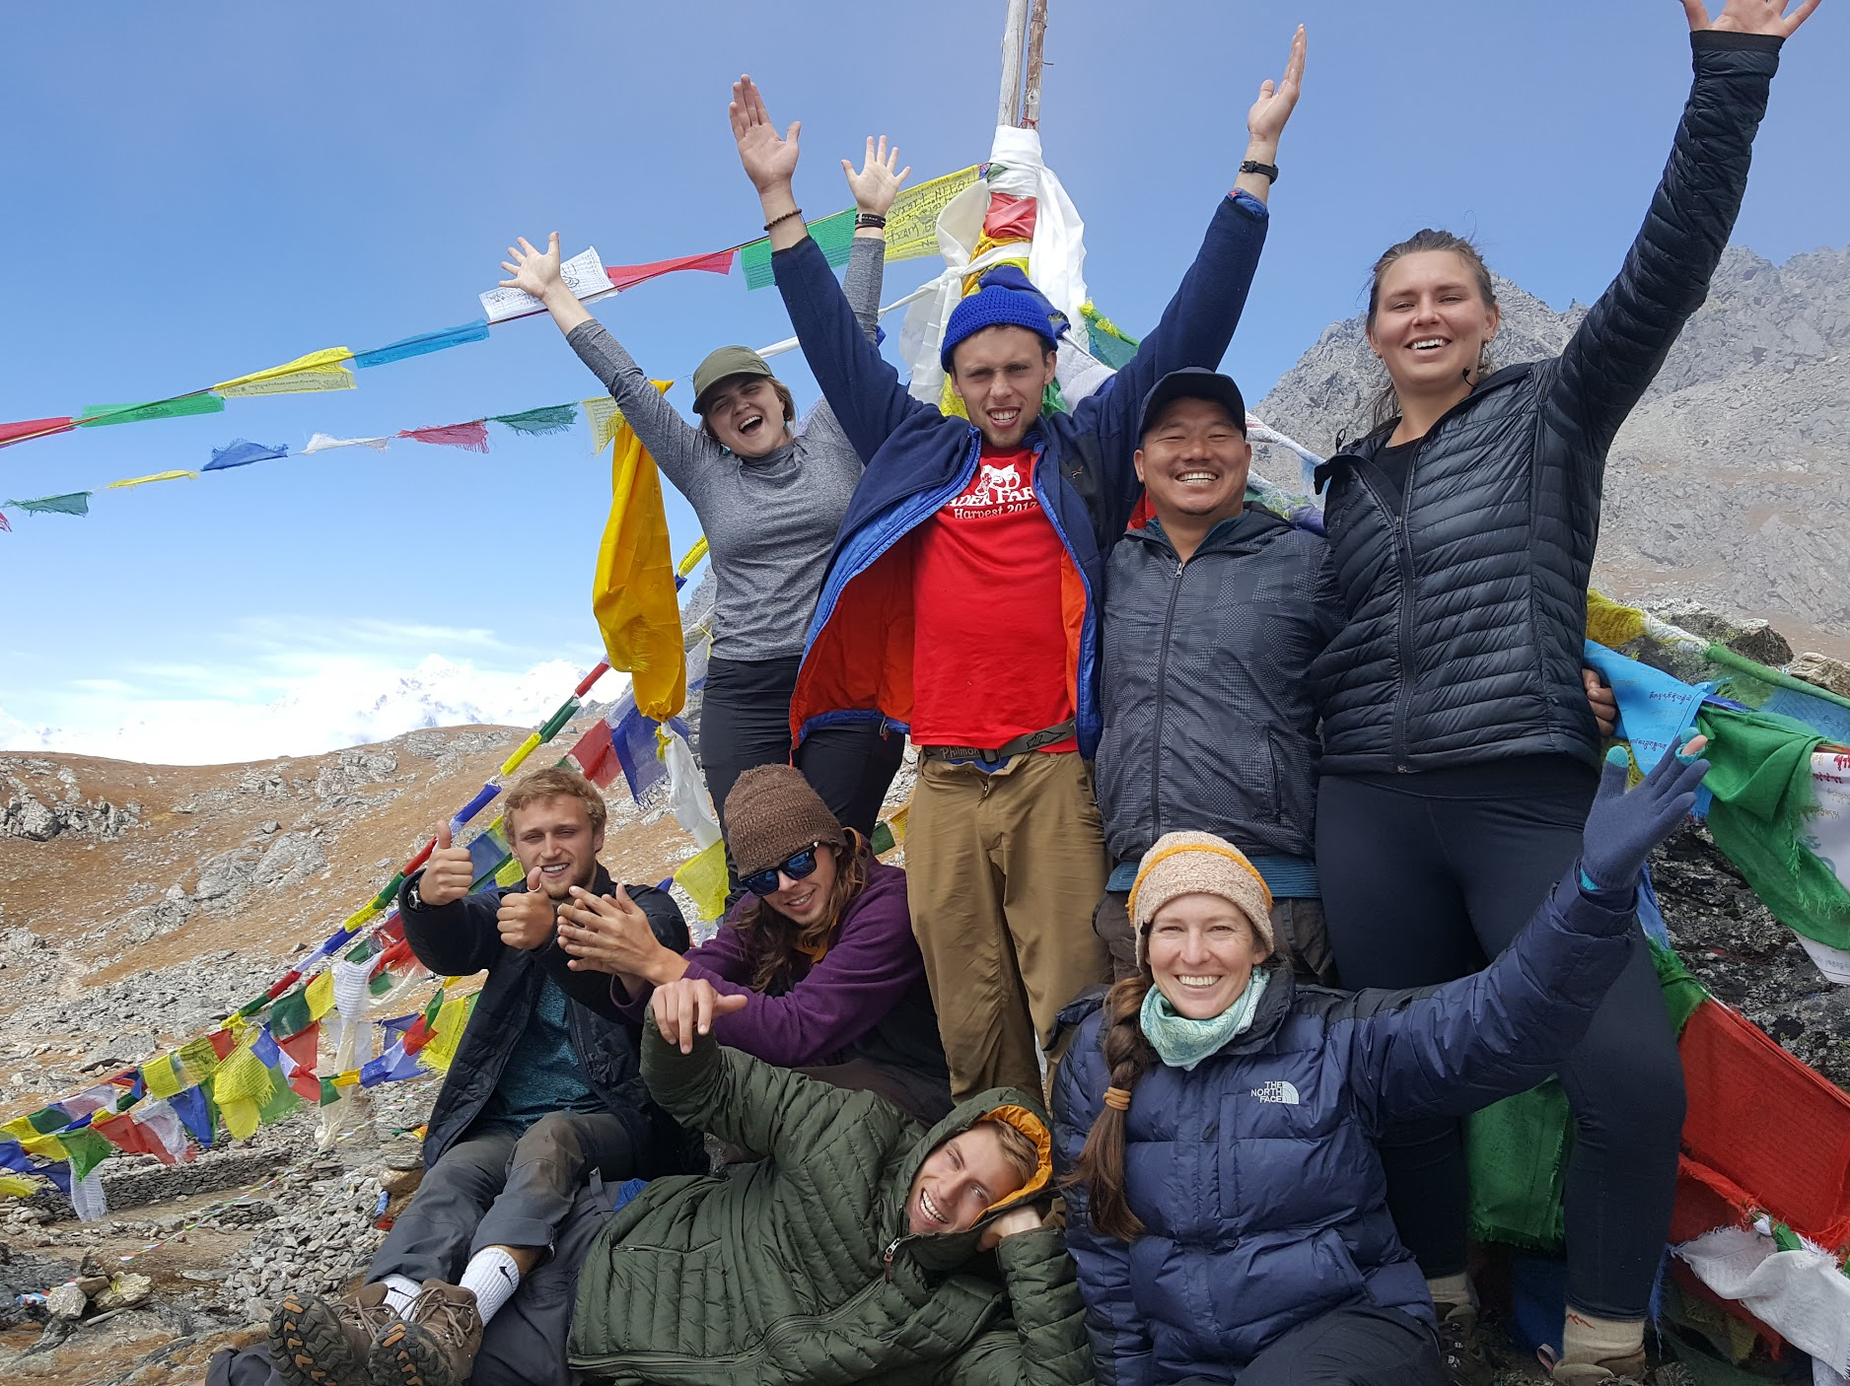
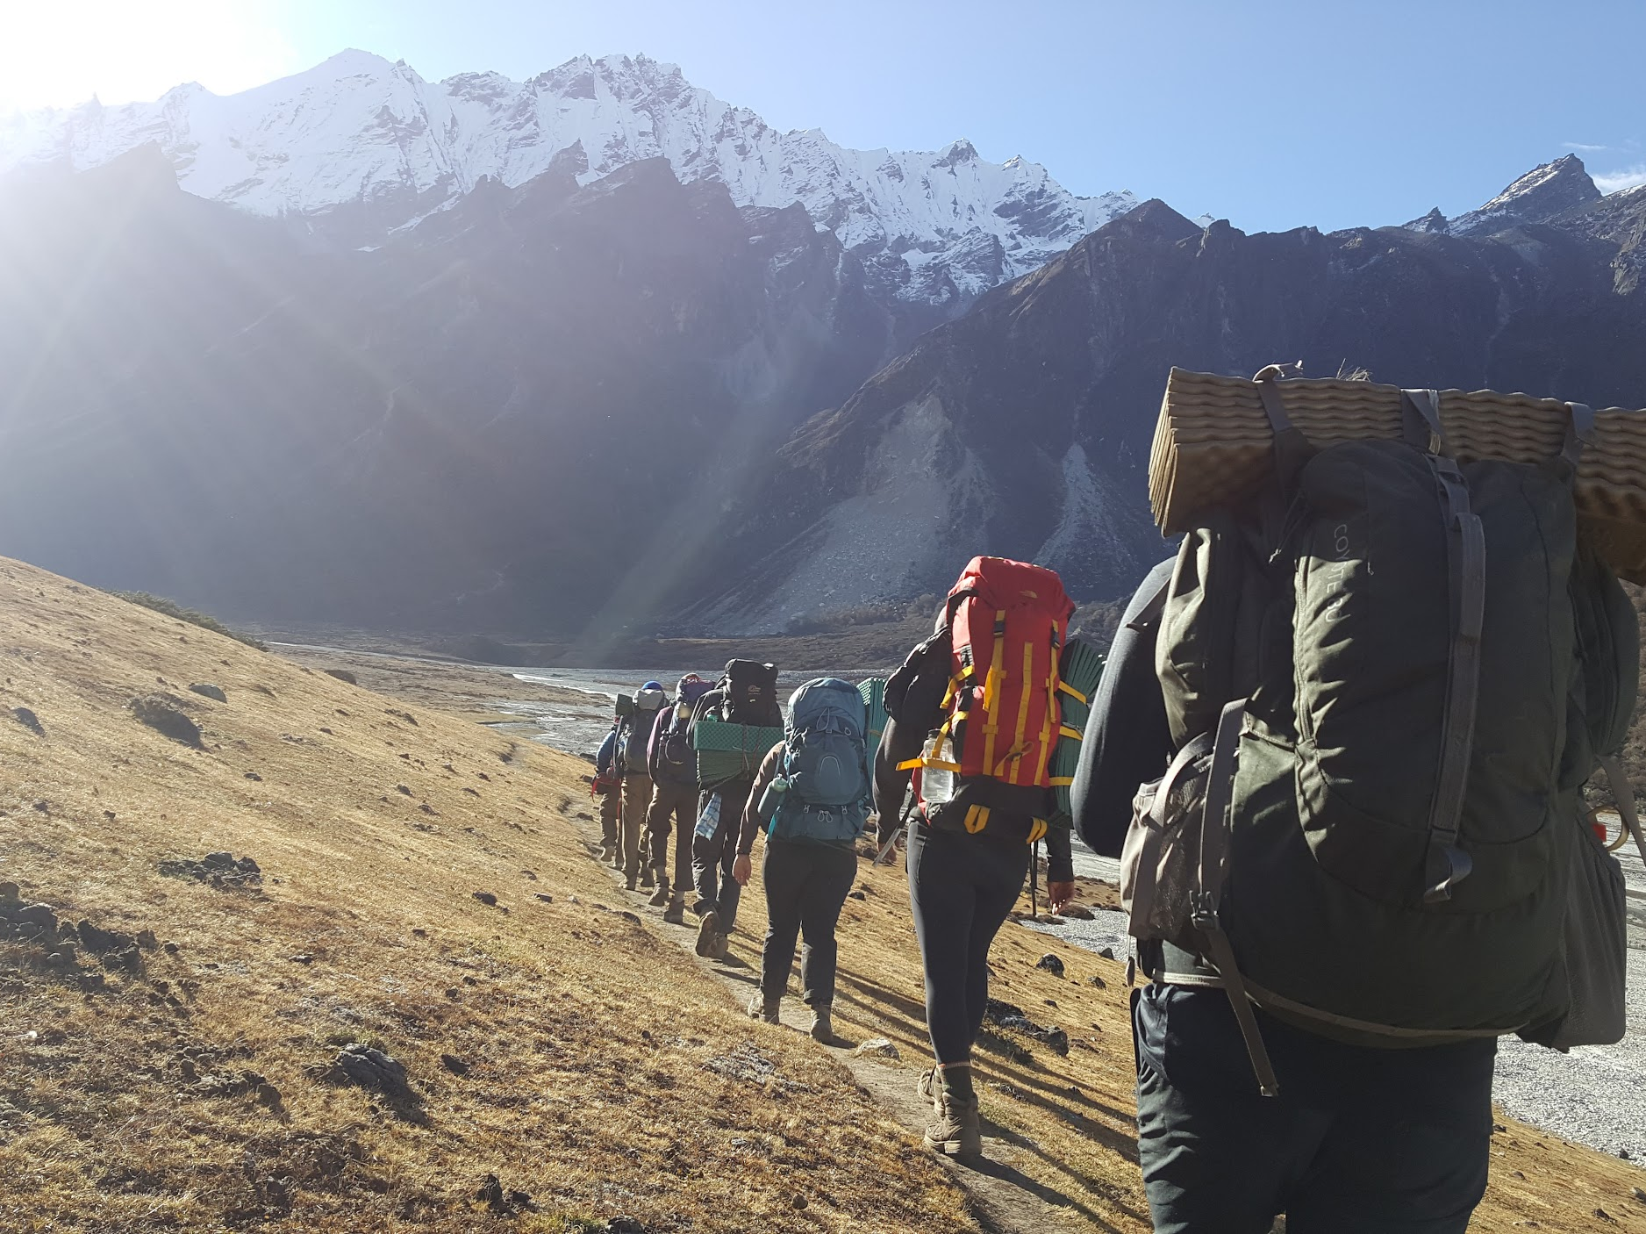
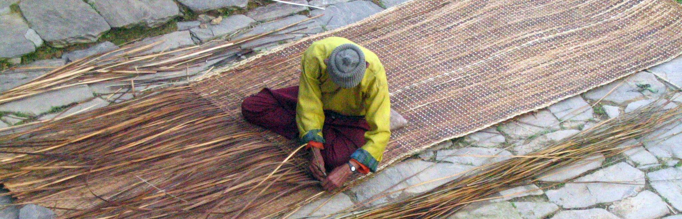

PROGRAM OVERVIEW

Langtang National Park in the Himalayas of Central Nepal is a high mountainous park with a mandate to conserve the area's rich biological diversity as well as its colorful cultural heritage. Critically endangered Red Pandas, Snow Leopards, and Musk Deer roam the mountains while Tamang farmers terrace hillsides, graze their Yaks in alpine meadows, and supplement their diet with wild mushrooms and greens. It has been four decades since the Langtang National Park was established and the Park’s unique legacy makes it an excellent living laboratory to explore issues of biodiversity, conservation and sustainable development. What is working and what challenges remain?

COURSE DESCRIPTION: BIOCULTURAL DIVERSITY OF THE HIMALAYAS

This program—run in partnership with InPlace—includes intensive field work that encompass academic studies in Himalayan biodiversity, conservation biology, ethnobiology, and community development. Students will begin by learning how biodiversity is defined, measured, mapped, and conceptualized by biologists and other scientists. A primary focus will be on how communities continue to depend on biodiversity despite shifts in land management, climate, and economic needs. How can biodiversity and ethnobiology serve as a touchstone for critical thinking about ecological sustainability? In exploring both threats to biodiversity and the ways that people and institutions are attempting to conserve it, we will examine underlying assumptions about globalization, sustainability, and environmental preservation. The seven week program includes a week in Kathmandu where we will tour Godavari Botanical Garden, The Mountain Institute, and other NGOs engaged in the protection of biodiversity before heading to Langtang National Park where we will trek to the holy Gosaikunde Lakes and the Langtang Valley between homestays with families in the villages of Melamchi, Briddhim, Thuman, and Gatlang.

This is a field-based course where students will have the opportunity to learn from ecologists, resource managers, villagers, conservation professionals, development organizations, and each other. Students are also expected to be actively engaged in their own learning through personal observations, and the use of print and digital resources.

Upon successful completion of this course, students will be able to:
- Discuss parallels between biological and cultural diversity
- Identify how humans are benefiting from biodiversity
- Identify several common plant and animal species found in the Himalayas and understand how the life-history strategy of each organism helps it thrive within its particular niche.
- Describe past and present anthropogenic impacts on the mountains, and how conservation efforts have attempted to reduce these impacts.
- Critically analyze and evaluate approaches to conservation issues and community development.
- Engage in meaningful cross-cultural dialogue.
- Travel in a developing country in an ethical manner.

This course is grounded in collaborative learning and ethical travel. Through an intellectually and physically rigorous schedule of activities, the experience promises to be both unique and transformative. Prior to travel, students will participate in orientation, team building, and preparatory study on ethical global citizenship, and biocultural diversity. While in Langtang, community, work, and family activities provide diverse experiences for participatory learning. As a “seminar in motion,” the program draws on remarkable local expertise and diverse social contexts, in a dynamic itinerary that entails both carefully planned and evolving activities. In addition to service learning projects, students will engage in on-site academic seminars, reading, writing, and reflective practice. This 15-credit course is designed to enable students to get the most out of their international experience by developing knowledge, skills, values, and their application in an intercultural context.

*Service learning is defined as a “course-based, credit-bearing educational experience in which students (a) participate in an organized service activity that meets identified community needs and (b) reflect on the service activity in such as way as to gain further understanding of course content, a broader appreciation of the discipline, and an enhanced sense of civic responsibility.” (Bringle & Hatcher, 1995).

CORE PROGRAM COMPONENTS
Biodiversity and Conservation: Using a combination of guest talks, readings, trailside mini-lectures, and field observation, students will explore the biodiversity and conservation of Langtang National Park. Students will study the importance of environmental factors such as geology and climate in shaping ecosystems. Students will identify several common plants and animal species found in the Himalayas and understand how the life-history strategy of each organism helps it thrive within its particular niche. Students will describe past and present anthropogenic impacts on the mountains, and how conservation efforts have attempted to reduce these impacts. Finally, we will identify how humans are benefiting from biodiversity and reflect on the parallels between biological and cultural diversity.

Cultural Competency & Immersion: The objective is to acquaint students with basic heritage, customs, and etiquette of the cultures they visit, facilitating a productive adaptation to village life. This includes instruction in basic language and homestays with local families. Students are expected to participate in a schedule of lectures and discussions from faculty and indigenous experts, and are accountable for core course readings.

Sustainable Development: The course will introduce students to theories of sustainable international development. We will discuss the ethics of international volunteer work and what could go wrong when trying to do right. We partner with grassroots organizations and local communities to work on projects that they initiate and lead. The service philosophy of this program is that local communities are the experts in their priorities and in how best to achieve them. Our role as outsiders is to approach international service with a huge dose of humility and let our community partners guide our involvement in the manner that they believe will be most meaningful.

Responsible and Ethical Travel: The program is grounded in principles of responsible travel, which include ethical and culturally appropriate behavior, cultivating reciprocal relationships, learning from and valuing Indigenous knowledge, and supporting local economies and grassroots organizations. For the program to be successful and have a long-term positive impact, it requires a full commitment of all participants to uphold these principles. Before departure we will cover general guidelines and expectations, as well as the responsibilities we carry as global travelers. We will also discuss potential moral dilemmas that can arise while traveling in another culture and strategies on how to handle such situations. With the understanding that responsible and ethical travel is an ongoing learning process, students will be encouraged to share questions, perspectives and insights throughout the trip. Through this collaborative learning, we will aspire as a group to improve upon the practices and principles of the program.

TYPICAL SCHEDULE:

Kathmandu (~9 days)
7:00-8:00 Birding
10:00-11:30 Visit NGO
12:30-1:00 Nepali Language
1:00-4:00 Visit world heritage sites, museums, botanic gardens, etc.
5:00-6:00 Reading discussion
7:00-8:00 Reflection exercises

Trekking (~27 days)
6:30-7:30 Natural walk (themes include identification of plant families and birding)
8:30-12:00 Hike to the next location with stops for trailside mini-lectures on topics related to geology and ecology.
12:30-1:00 Nepali Language
1:00-3:00 Finish hiking
3:00-5:00 Time to read and work on assignments
5:00-6:00 Reading discussion
7:00-8:00 Reflection exercises

Homestays (~14)
7:00-8:00 Natural Walk (themes include ethnobotany, sustainable agriculture, and pastoralism)
8:00-1:00 Help with home chores and meal prep
1:00-5:00 Group activity (blacksmithing, weaving, grain processing, etc.)
5:00-6:00 Reading discussion
6:00-8:00 Help family with dinner
8:00-9:00 Time to read and write

REQUIRED TEXT AND SUPPLIES
- 2 Rite-in-the-Rain notebooks (5”recommended)
- A digital camera or smart phone (plus extra batteries and charger)
- 7x35, 8x32, or 8x42 binoculars (Wingspan and Celestron are well priced).
- Biophilia by E.O Wilson (hardcopy or e-book)
- Nepali language resources:
  - Shrestha, Sushila 2014. Basic Nepali Phrase Book & Dictionary
  - Simply Learn Nepal app
  - Audio file lessons http://www.tibm.org/nepali-language-lessons.html
- Two books from the following list (audiobooks and e-books are OK):
  - Snow Leopard by Peter Matheson
  - 7 years in Tibet by Heinrich Harrer
  - Freedom in Exile, by the Dalia Lama
  - The Invention of Nature by Andrea Wulf
- One field ID book from the following list: (can be shared with one other person)
  - Flowers of the Himalaya by Oleg Polunin, Adam Stainton
  - Birds of Nepal: Revised Edition by Richard Grimmett et al.
- A digital course pack containing readings from the following books (downloadable on canvas)
  - Bishop, Naomi 1997. Himalayan Herders, Case Studies in Cultural Anthropology.
  - Miehe, George and Colin Pendry 2015. Nepal, An introduction to the natural history, ecology and human environment of the Himalayas.
  - Manandhar, Narayan 2002. Plants and People of Nepal.
  - Shrestha, and Lamstein 1997. From the Mango Tree and other Folktales from Nepal.
  - Adhikari, Anil 2010. Biodiversity Conservation & Sustainable Livelihoods: Success Stories
  - Kaptstein, Mathew 2014. Tibetan Buddhism, a very short introduction.
  - Davis, Wade 2007. Light at the Edge of the World. Chapter 6: Land of Snows.
  - Project summary report from TMI Medicinal Plant Report.

ASSIGNMENTS AND ASSESSMENT:

Field notebook and travel log (5pts/day = 500 pts):
The field notebooks is a place for you to take notes and document reflections on things that you learn and observe while hiking and observing along the trail, in camp, or during conversations with presenters, hosts, and villagers. All good naturalists and ethnologists keep field notebooks in addition to specific data that they may be collecting. Good field notebooks include the following types of information:
- Header: date, location or route for the day, weather.
- People involved: list the people that joined you for a side trip, or the names, contact info, etc. of people that give guest talks or that you are learning from.
- Purpose: if relevant, write a sentence that describes the entry that will follow.
- Observations, notes & data: This is real time information that you are writing down as you hike, sit and observe, or talk to people. Field sketches are a great way to increase your awareness of organisms that you see. Photographs can be pasted into the electronic version of the field notebook you will submit at the end of our trip. Note any photos taken or specimens collected (where appropriate). I find that it is also useful to document the things that I purchased along the way.
- Questions: These are just as important as your observations. Every entry should have a few questions that you are mulling over during the day. Write these down and treasure them as learning opportunities.
- Reflections & Summary: This is written at the end of the day and should include the highlights, challenges, lessons learned and reflections. This is also a great place to write down additional questions, or the answers you may have learned to previous questions. I encourage you to include both personal journaling as well as more course related content in this section. Personal notes can be obscured when you turn in photos of your notebook at the end of the quarter.

On occasion, you will be asked to select and share with the group key passages that reflect your learning, connections to other experiences, or challenges to prior knowledge or points of view.

Semi-weekly ethnographic exercises will be developed en situ, including on topics such as: global-local intersections; social relations; resolution of divergent viewpoints; interconnections of social/environmental wellbeing; and religious principles and practice. Specific topics will be assigned during orientation as well as around the numbers and kinds of borders that are crossed from Bellingham to the Himalayas.

Digital Species Collection (400 pts):
Make a photographic collection of 100 different organisms. You can focus on a particular group (such as flowering plants, mosses and lichens, mushrooms, insects, wildlife, etc.) or try and represent as many different types of organisms as possible. Upload your collection to our “Langtang NP WWU Biocultural Diversity” class project page on www.inaturalist.org. This exercise is designed to stretch your understanding of new organisms. Posted on the internet, these digital collections will be available to the public and help contribute to the knowledge of Himalayan biodiversity. Do your best to capture clear images in good lighting so that identification later will be easier.

If you are using a smart phone, be smart! Have the iNaturalist app loaded onto your phone before the trip and use the app to record observations directly into our project. Add identification guesses and habitat notes as you go so you aren’t swamped with these tasks at the end of the trip. Each species observation will be assessed based on inclusion of the following:
- Name of organism: Use a Common and Scientific recognized by iNaturalist (1 pt.). I will award full points for family level identifications for insects.
- Photo: You can upload more than 1 to iNaturalist. It may be useful to photograph several features of larger organisms such as the bark, needles, cones, and overall shape of a tree. (1 pt)
- Location (Some phones have a GPS that automatically stamps coordinates in the photo metadata. If not, you will need to figure out a system of determining the location of photos. I recommend also photographing landmarks such as trail junctions, creek crossings, etc. so that when you view your photographs chronologically, you can estimate proximity to these landmarks). (1 pt)
- Description: Use this space to record the habitat, associated species, and a description of features that might not be evident from the photograph. (1 pt)

Organism Report (50 pts):
Select one organism, that you observed during our travels and write a four to six page (double spaced) report. Your report should include a description of the organism, life history, niche, habitat and range, ethnobiology, considerations for conservation, and other information that you find interesting. Also include a bibliography and in text citations. I will publish high quality papers on a blog for this course, so this is a chance to contribute to the broader community of naturalists. Please write for this potential audience. Below are notes on style and content.

- Title: Include the scientific name and family for plants and animals as well as the order for insects.
- Why you are interested. Engage the reader with a few anecdotes
- Description: Size, shape, color, texture, etc. Include the family and lower classification for plants and common animals such as birds and mammals. Include the order for lesser known animals such as insects. Include higher levels of classification for esoteric organisms such as slime molds, mosses, bacteria, etc.
- Life History: How long does it live? What life stages does it go through? When does it become sexually mature?
- Habitat, Range, Niche: What eats it? What does it need to survive? What are common associated organisms? What kind of disturbance regime does it favor? Where is it found (including altitude range, latitude range, climate range, soil moisture range, etc).
- Units: metric units
- In text citations: Author’s last name and year (Smith 2010). For two authors: Smith and Anderson 2010). For three or more authors (Smith et al. 2010).
- Images: Include at least one image. Additional images are encouraged if they help communicate elements of your species description, habit, or range in a meaningful way. For example, with trees it is nice to have close-up images of the needles and cones as well as wide angle views of the bark texture, overall tree shape, and habitat. If you don’t have your own images, you may download others from the internet. Just be sure that reproduction is allowed and that you attribute the photographer in a caption below each photograph (e.g. “Don Smith photograph.”
- Range maps are encouraged if you can find one.
- Consideration for conservation: consult the IUCN listing status. Is it getting the disturbance it needs or too much disturbance? Are climate change or pollution threatening it?
- Other interesting information: You can include historical uses, ethnobotany, literary and mythological references, etc.
- Bibliography: Include full citations in the following format.
  - Books: First author last name, first name, second author first name last name, … and last author first name last name, year published. “Title” Publisher, publisher city, state.
  - Articles: First author last name, first, second author first name last name, … and last author first name last name, year published. “Article Title” in Journal Title, Vol. Is. Pg xx-xx.
  - Website: Hyperlinked name of website. Author if listed. Date accessed.

Traditional Use Surveys, Scavenger Hunts and Community Mapping (100 pts):
Working in small groups, pick a traditional use category such as food, fiber, firewood, building materials, or medicine, and work with villagers to understand the ethnobiology of these resources. You should learn what species are involved, the scientific, Nepali, and local names, where they are found relative to the village and other important village landmarks, when they are harvested, how they are harvested, processed, and prepared, individual or social practices that foster sustainable use of a particular resource, and how use has changed over time in response to globalization, park management, climate change, or other forces. This may take the form of scavenger hunts provided by the instructor.

Service Learning Fieldwork (50 pts):
You will be a part of a small group of students and faculty working with community members and community-based organizations in small villages along the Tamang Heritage Trek. This international experience will be fluid and collaborative, and the content of this experience will depend greatly on how your own individual interests mesh with the goals of local communities. Therefore, your professionalism, contribution, and participation in this program are critical to the success of not only your own experience, but also the current and future partnerships with Nepali community members and organizations.

Participation (150 pts):
Your contributions should be positive and take into consideration the learning of the entire class. Any actions that impede your learning or the learning of other class members will adversely affect your participation grade. Outstanding participation and contribution would be characterized by the following behaviors:
- Demonstrating a commitment and understanding of the importance of respecting the local culture, their norms, and their expectations of our partnership.
- Participating in class discussion, including questions, areas for exploration, and discussions that further understanding, according to our learning objectives.
- Demonstrating excellent listening skills by remaining attentive and respectful of other students, teachers, staff, and community members.
- Demonstrating ability to apply, analyze, and synthesize course material.
- Exploring new ideas and challenging questions.
- Demonstrating open and full participation in learning and service activities.
- Demonstrating an understanding of reciprocity in cross cultural interactions.
- Behaving professionally when interacting with representatives from community and non governmental organizations
- Practicing your Nepali with locals
- Going on walks in small groups
- Trying local foods
- Journaling

Activities that show poor participation include:
- Hiking with headphones instead of paying attention to your surroundings
- Sitting in your room during the day
- Taking naps
- Dwelling excessively about home

Final self-reflection/ self-evaluation (50 pts):
Write a final self-reflection, responding to the following items. Your reflection should be fully complete but also well edited and succinct. Grammar, proofreading, and writing quality are part of the grade.

Expectations and Goals
- What did I expect to learn? What were my goals?
Participation
- Be specific about your active participation in group sessions, meetings with partner organizations, and in the field. What was my role in group discussions? In other activities? Did I find ways to improve my participation over the course of the trip? How did my participation influence my learning in the course?
- Did I consistently follow the guiding principles and the group code of conduct throughout the trip?
- In what ways was I self-driven and engaged? How did I push myself to maximize the learning experience? What could I have done better?
- What does service-learning mean to me in an international context?
Reflection
- How well did I do on this trip? What were my strengths and weaknesses? What new strengths or weaknesses did I discover? How did I address my weaknesses over the course of the quarter?
- If I had problems or difficulties with the way the trip was working for me, did I bring those to the attention of the instructor/others so circumstances could improve? Did I do other things to face difficulty squarely?
- Did I seek out help when I needed it? How successful was I? What did I do/not do to make my experience as good as it could be?
- What did I learn (subject matter, skills, ways of knowing and working; from both the activities and assignments)?
- What changes happened in my attitude, my confidence, my way of going about or looking at things?
- What’s next? Where do I (could I) I go from here? How will this trip influence the next steps in my education?

ITINERARY
Following research exercises and a three day orientation at WWU, the program proceeds to Kathmandu where we will spend five days visiting botanical gardens, non government organizations, world heritage sites, and scholars. Then we will start hiking up the Paldo trail studying biodiversity until we get to the village of Gatlang where we will participate in our first homestay for five days, allowing us to participate in subsistence farming and explore and evaluate past community development projects. From there we will follow the Tamang Heritage Trek participating in homestays leading up to and including the village of Briddim, where we will stay for three days and more critically examine the homestay model for rural poverty alleviation. From Briddim we climb to alpine meadows and study pastoralism while camping near the herder huts for 3 days before dropping back down to finish out the Tamang Heritage Trek and begin the Langtang Valley Trek. Climbing up the Langtang valley gives us an excellent opportunity to view wildlife and examine how the slow work of rivers and glaciers along with more rapid changes from seismic events have etched the landscape. At higher elevations in the valley we will explore the glaciology in more detail, and get a chance to see wildlife and plants adapted to life above the treeline. From there we will cross Kangja La Pass and reach our highest elevations and our best opportunity to see threatened wildlife while spending nights camping. Then we drop down to the village of Melamchigau, the subject of one of our major readings to reflect on how village life has changed in Nepal since the author first began collecting data in the 1970s. Our return itinerary includes a stop at the National Park headquarters where we can report our findings and ask questions of park staff.

Tentative Dates | Place/Activity
Sep 22-24 | Orientation, Bellingham
Sep 27 | Departure
Sep 28 | Arrive Kathmandu
Sep 28-Oct 2 | Kathmandu, visit NGOs world heritage sites, museums
Oct 3-8 | Paldo Trek. Biodiversity study
Oct 9-13 | Gatlang. Culture study, sustainable development, and service learning
Oct 14-17 | Tamang Heritage Trek. Language, culture, agriculture
Oct 18-21 | Briddim Homestay. Homestay tourism.
Oct 22-24 | Godagang, Pangsang. Himalayan herder study
Oct 25-26 | Tamang Heritage Trek
Oct 27-31 | Langtang Trek. Geology and glaciology
Nov 1-9 | Kangja La Trek. Alpine adaptations
Nov 10-12 | Melamchigau Homestay. Finish Himalayan Herders
Nov 13-16 | Kathmandu. NGOs cultural attractions
Nov 10-17 | Flight Home
Nov 29- Dec 2 | Post Trip Seminar. Reverse culture shock; assignments due; project report presentations.

INSTRUCTOR:
T. Abe Lloyd
Instructor, Environmental Science Department, Huxley College of the Environment
Western Washington University
Thomas.Lloyd@wwu.edu

POLICIES
This program has a zero tolerance policy towards drug use. If you are caught using marijuana or other drugs that are illegal in Nepal, you will be sent home at your own expense.

Western is committed to equal opportunity and non-discrimination in all programs and activities. Requests for accommodation or assistance should be directed to Disability Resources for students located in Old Main 110; additional information is available at:
https://disability.wwu.edu Telephone: 650-3083 / Email: drs@wwu.edu

Western provides reasonable accommodation for students to take holidays for reasons of faith or conscience or for organized activities conducted under the auspices of a religious denomination, church, or religious organization. Students seeking such accommodation must provide written notice to their faculty within the first two weeks of the course, citing the specific dates for which they will be absent. “Reasonable accommodation” means that faculty will coordinate with the student on scheduling examinations or other activities necessary for completion of the course or program and includes rescheduling examinations or activities or offering different times for examinations or activities. Additional information about this accommodation can be found in SB 5166: Providing religious accommodations for postsecondary students.

For a list of other policies concerning students, click here.

