Salish Sea Biodiversity, Culture, and Conservation
10/19/21 Draft
Summer 2022 Field School

ESCI 330 & ESCI 404 (9 credits)

Instructors: T. Abe Lloyd lloydt@wwu.edu

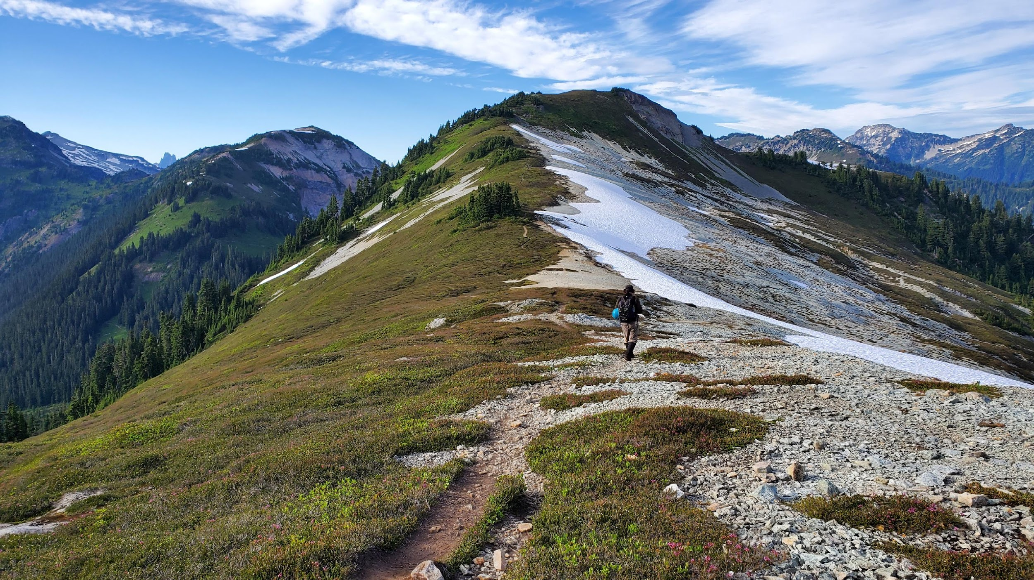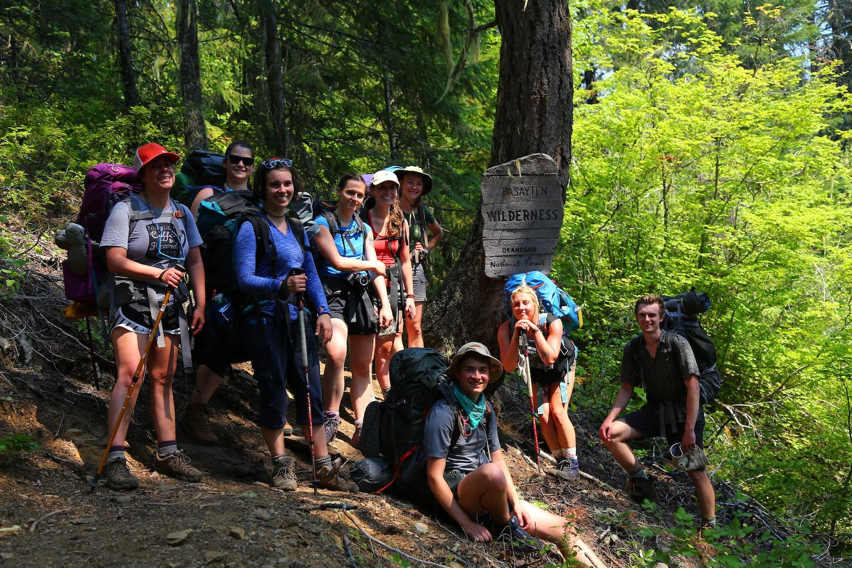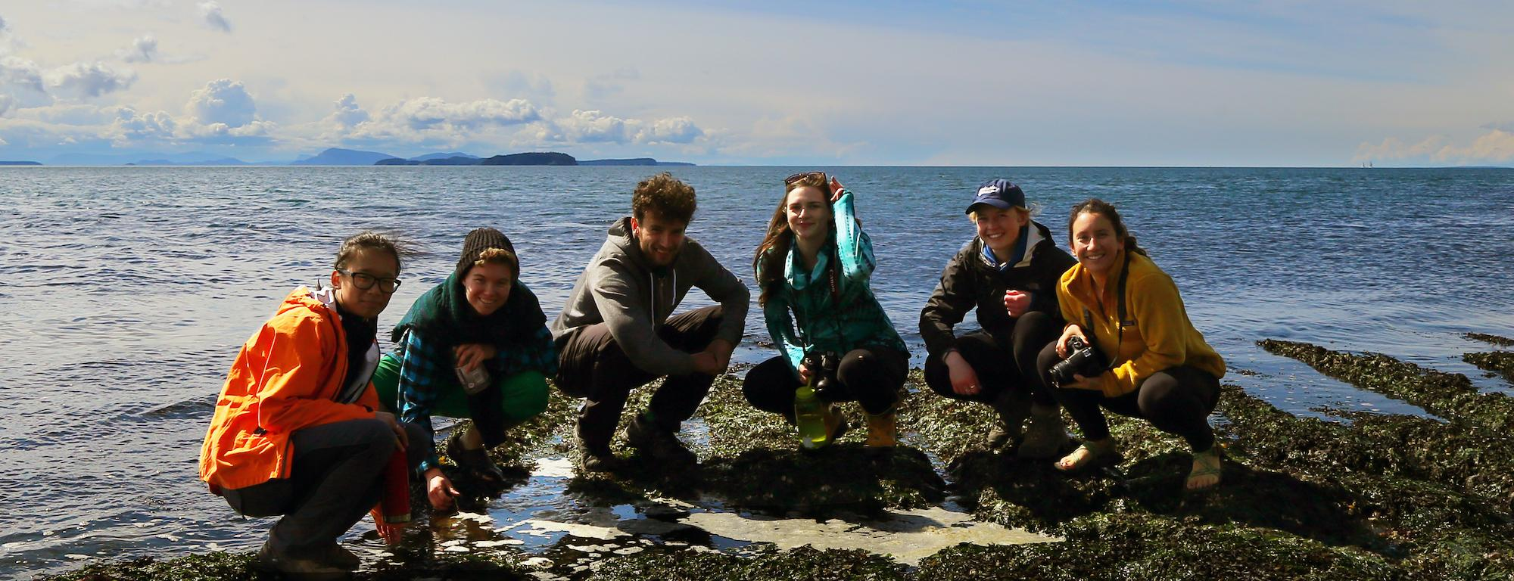

PROGRAM OVERVIEW

This program—run in partnership with InPlace, the Ecocultural Learning Institute—includes immersive field work that encompass academic studies in Salish Sea biodiversity, conservation biology, and ethnoecology. Students will begin by learning how biodiversity is defined, measured, mapped, and conceptualized by biologists and other scientists. A primary focus will be on how communities continue to depend on the biodiversity despite shifts in land management, climate, and economic needs. How can biodiversity and ethnobiology serve as a touchstone for critical thinking about ecological sustainability and the changing needs of humans? In exploring both threats to biodiversity and the ways that people and institutions are attempting to conserve it, we will examine underlying assumptions about globalization, sustainability, and environmental preservation. The four-week program includes three weeks of outdoor, field-based study, and a week of travel in First Nation, Native American, and Settler communities where we will meet with NGOs and public, and Indigenous land managers engaged in the stewardship of biodiversity and cultural heritage.

This is a field-based course where students will have the opportunity to learn from ecologists, resource managers, elders, conservation professionals, activists, and each other. Students are also expected to be actively engaged in their own learning through personal observations, and the use of print and digital resources.

The Salish Sea is a bioregion that encompasses the inland marine waterways of Washington and British Columbia as well as the watersheds that feed them. This region has been inhabited by Indigenous Peoples for more than 10,000 years and today is home to nearly nine million people, two countries, and more than 65 Tribes and First Nations. From sea to sky, habitats range from as deep as a halibut can dive to as high as a mountain goat can climb and provides refuge to an incredible diversity of life including more than 6000 plants, 2500 fungi, 600 birds, 200 mammals, and 4000 insects.

ACADEMIC CREDITS

ESCI 330 Natural History (4 credits) employs a field-oriented introduction to the geology, climate and ecosystems of the Pacific Northwest, with a focus on the biology and the ecology of important organisms.

ESCI 404 Indigenous Resource Management (5 credits) explores ecological mechanisms that Indigenous people have used and continue to use to manage land and seascapes in the Salish Sea.

Upon successful completion of this program, students will be able to:
- Discuss parallels between biological and cultural diversity
- Identify how humans are benefiting from biodiversity
- Identify several common plant and animal species found in the Salish Sea region and understand how the life-history strategy of each organism helps it thrive within its particular niche.
- Describe past and present anthropogenic impacts, and how conservation efforts have attempted to reduce these impacts.
- Critically analyze and evaluate Indigenous and settler approaches to conservation.
- Understand Indigenous and settler colonial histories.
- Engage in meaningful cross-cultural dialogue.
- Travel on Indigenous lands in an ethical manner.

This course is grounded in collaborative learning and ethical travel. Through an intellectually and physically rigorous schedule of activities, the experience promises to be both unique and transformative. Prior to travel, you will participate in orientation, team building, and preparatory study on settler colonialism and Native American worldviews as well as the biodiversity of the Salish Sea region. While traveling, group, community, and institutional activities provide diverse experiences for participatory learning. As a “seminar in motion,” the program draws on remarkable local expertise and diverse social contexts, in a dynamic itinerary that entails both carefully planned and evolving activities. You will engage in on-site academic seminars, scientific data collection, reading, writing, and reflective practices. This 9 credit course is designed to enable students to get the most out of their experience by developing and applying knowledge, skills, values in an intercultural context.

CORE PROGRAM COMPONENTS

Biodiversity and Conservation: Using a combination of guest talks, readings, trailside mini-lectures, and field observation, we will explore the biodiversity and conservation of the lands and waters within the Salish Sea region. We will explore the importance of environmental factors such as geology and climate in shaping ecosystems. We will identify several common plants and animal species and understand how the life-history strategy of each organism helps it thrive within its particular niche. We will describe past and present anthropogenic impacts, and how western conservation efforts as well as traditional management practices have attempted to reduce these impacts. Finally, we will identify how humans are benefiting from biodiversity and reflect on the parallels between biological and cultural diversity.

Cultural Competency & Immersion: This entails academic study of traditional foods, fibers, and medicines, as well as historical patterns, and political dynamics that contribute to the cultural identities of the Indigenous Peoples. The principal objective is to provide background information that enables you to interpret your experiences, ground your studies, and establish a context for specific research. A second objective is to acquaint you with basic heritage, customs, and etiquette of the cultures we visit. This includes instruction in colonial history and Salish ethnoecology. You are expected to participate in a schedule of lectures and discussions from faculty and Indigenous experts and are accountable for core course readings.

Responsible and Ethical Travel: The program is grounded in principles of responsible travel, which include ethical and culturally appropriate behavior, cultivating reciprocal relationships, learning from and valuing Indigenous knowledge, and supporting local economies and grassroots organizations. For the program to be successful and have a long-term positive impact, it requires a full commitment of all participants to uphold these principles. Before departure we will cover general guidelines and expectations, as well as the responsibilities we carry as travelers and guests in Indigenous communities. We will also discuss potential moral dilemmas that can arise while traveling in another culture and strategies on how to handle such situations. With the understanding that responsible and ethical travel is an ongoing learning process, students will be encouraged to share questions, perspectives and insights throughout the trip. Through this collaborative learning, we will aspire as a group to improve upon the practices and principles of the program.

TYPICAL SCHEDULE:
Camping in the front country (~10 days)
7:00-8:00 Nature walk (themes include species identification, understanding how organisms are adapted to their environments, and practical applications of ecological theory)
10:00-12:00 Visit land managers, scientists, Indigenous communities.
1:00-4:00 Visit museums, botanic gardens, and other points of interest
5:00-6:00 Reading discussion or community events
7:00-8:00 Reflection exercises

Hiking, Kayaking & Camping in the backcountry (~21 days)
6:30-7:30 Natural walk (themes include species identification, understanding how organisms are adapted to their environments, and practical applications of ecological theory)
8:30-2:00 Hike to the next location with stops for trailside mini-lectures on topics related to geology and ecology.
3:00-5:00 Time to read and work on assignments
5:00-6:00 Reading discussion
7:00-8:00 Reflection exercises

REQUIRED TEXT AND SUPPLIES
- 2 Rite-in-the-Rain notebooks (5”x7” recommended)
- A digital camera or smart phone (plus extra batteries and charger)
- 7x35, 8x32, or 8x42 binoculars (Wingspan and Celestron are well priced)
- Earth’s Blanket by Nancy Turner
- Two audio books from the following list:
- One field ID book from the following list: (can be shared with a friend on the trip)
  - Plants of the Pacific Northwest Coast by Pojar and McKinnon
  - Cascade-Olympic Natural History by Daniel Mathews
- A digital course pack containing readings from the following books (downloadable on canvas)

ITINERARY
The programs begins at WWU with a three day orientation comprised of lectures, team building, and cross cultural exercises. We then drive to the traditional territory of the Upper Skagit tribe where we will spend the next two weeks meeting with federal and Indigenous land managers and participate in some citizen science projects. We then take to the back country to study biodiversity and conservation while canoeing on Ross Lake and backpacking through one of the most remote corners of the North Cascades. From there we will drive into Canada to visit the Stó:lō Nation for a place names tour of their traditional territory as well as a critical examination of the curation of Coast Salish art and culture at the UBC Museum of Anthropology. The last week will be spent kayaking in the San Juan Islands and learning from Samish and Stillaguamish land managers while studying Salish Sea biodiversity. After returning to Bellingham, the program will take a short break before reconvening on campus for the post-trip seminar and public presentations.

TENTATIVE SCHEDULE

Date | Place/Activity
July 26-28 | Orientation, Bellingham
August 1-3 | Salmon survey, Huckleberry Survey with Upper Skagit, Camp Baker Lake
August 4 | National Parks Service. Camp @ Lake Diablo
August 5-10 | Canoe Ross Lake. Lowland Forest Biodiversity Study
August 11-16 | Hiking Big Beaver Valley, Whatcom Pass, Copper Ridge, Hanegan Pass. Montane biodiversity study. Pollinator survey
August 17-19 | Sto:lo place names tour. Fraser River, Chillwack BC
August 20 | Museum of Anthropology, UBC Biodiversity Museum
August 21 | Washington park, Anacortes. Samish Nation visit
August 22-26 | San Juan Island Kayaking, Inland Sea biodiversity study. Bald habitat sampling. Clam survey.
August 27-28 | Stillaguamish visit, Skagit River System Coop visit. Camp at Deception Pass State Park
August 29 | Summer Lake Bog, Land Trust visit
August 30-31 | Nooksack place names talk, Pit cook. Camp at Professor Lloyd’s house.
September 7-8 | Post-trip seminars, collection curation, public presentation, Bellingham

ASSIGNMENTS AND ASSESSMENT:
Field notebook and travel log (100 pts):
The field notebooks is a place for you to take notes and document reflections on things that you learn and observe while hiking and observing along the trail, in camp, or during conversations with presenters, hosts, and villagers. All good naturalists and ethnologists keep field notebooks in addition to specific data that they may be collecting. Good field notebooks include the following types of information:
- Header: date, location or route for the day, weather.
- People involved: list the people that joined you for a side trip, or the names, contact info, etc. of people that give guest talks or that you are learning from.
- Purpose: if relevant, write a sentence that describes the entry that will follow.
- Observations, notes & data: This is real time information that you are writing down as you hike, sit and observe, or talk to people. Field sketches are a great way to increase your awareness of organisms that you see. Photographs can be pasted into the electronic version of the field notebook you will submit at the end of our trip. Note any photos taken or specimens collected (where appropriate). I find that it is also useful to document the things that I purchased along the way.
- Questions: These are just as important as your observations. Every entry should have a few questions that you are mulling over during the day. Write these down and treasure them as learning opportunities.
- Reflections & Summary: This is written at the end of the day and should include the highlights, challenges, lessons learned and reflections. This is also a great place to write down additional questions, or the answers you may have learned to previous questions. I encourage you to include both personal journaling as well as more course related content in this section. Personal notes can be obscured when you turn in photos of your notebook at the end of the quarter.

On occasion, you will be asked to select and share with the group key passages that reflect your learning, connections to other experiences, or challenges to prior knowledge or points of view.

Digital Species Collection (100 pts): Make a photographic collection of 50 different species. You can focus on a particular group (such as flowering plants, mosses and lichens, mushrooms, insects, wildlife, etc.) or try and represent as many different types of organisms as possible. Upload your collection to our “Salish Sea Biodiversity, Culture & Conservation” class project page on www.inaturalist.org. Points will be awarded for completeness and uniqueness of your collection. Full credit for completeness means 50 research grade observations. This exercise is designed to stretch your understanding of new organisms. Posted on the internet, these digital collections will be available to the public and help contribute to the knowledge of Himalayan biodiversity. Do your best to capture clear images in good lighting so that identification later will be easier.

If you are using a smart phone, be smart! Have the iNaturalist app loaded onto your phone before the trip and use the app to record observations directly into our class project. Add identification guesses and habitat notes as you go so you aren’t swamped with these tasks at the end of the trip. Each species observation will need to include the following:
- Name of organism: Common and Scientific
- Photo: You can upload more than 1 to i-naturalist. It may be useful to photograph several features of larger organisms such as the bark, needles, cones, and overall shape of a tree.
- Location (Some phones have a GPS that automatically stamps coordinates in the photo metadata. If not, you will need to figure out a system of determining the location of photos. I recommend also photographing landmarks such as trail junctions, creek crossings, etc. so that when you view your photographs chronologically, you can estimate proximity to these landmarks).
- Description: Use this space to record the habitat, associated species, and a description of features that might not be evident from the photograph.

Organism Report and Poster (50 pts): Select one organism, that you observed during our travels and write a four to six page (double spaced) report, upon returning to Bellingham. Including in your report a description of the organism, life history, niche, habitat and range, ethnobiology, considerations for conservation, and other information that you find interesting. Your paper should include a bibliography and in text citations. I will publish high quality papers on a blog for this course, so this is a chance to contribute to the broader community of naturalists. Please write for this potential audience. Below are notes on style and content. You will present your work as a poster during the last week of classes.

- Title: Include the scientific name and family for plants and animals as well as the order for insects.
- Why you are interested. Engage the reader with a few anecdotes
- Description: Size, shape, color, texture, etc. Include the family and lower classification for plants and common animals such as birds and mammals. Include the order for lesser known animals such as insects. Include higher levels of classification for esoteric organisms such as slime molds, mosses, bacteria, etc.
- Life History: How long does it live? What life stages does it go through? When does it become sexually mature?
- Habitat, Range, Niche: What eats it? What does it need to survive? What are common associated organisms? What kind of disturbance regime does it favor? Where is it found (including altitude range, latitude range, climate range, soil moisture range, etc).
- Ethnobiology. Who uses it? How is it harvested, processed, and used? How is it managed?
- Images: Include at least one image. Additional images are encouraged if they help communicate elements of your species description, habit, or range in a meaningful way. For example, with trees it is nice to have close-up images of the needles and cones as well as wide angle views of the bark texture, overall tree shape, and habitat. If you don’t have your own images, you may download others from the internet. Just be sure that reproduction is allowed and that you attribute the photographer in a caption below each photograph (e.g. “Don Smith photograph.”
- Range maps are encouraged if you can find one.
- Consideration for conservation: consult the IUCS listing status. Is it getting the disturbance it needs or too much disturbance? Are climate change or pollution threatening it?
- Other interesting information: You can include historical uses, ethnobotany, literary and mythological references, etc.
- Bibliography: Include full citations

Ethnobotany Project (50 pts)
Make a replica of a traditional object such as a mat, cooking tools or techniques, or fishing hook using the appropriate materials and techniques. Document the construction of your item with photos and produce a 3-5 minute video that captures the historical significance of the item as well as the process you used to construct it.

Participation (150 pts)
Your contributions should be positive and take into consideration the learning of the entire class. Any actions that impede your learning or the learning of other class members will adversely affect your participation grade. Outstanding participation and contribution would be characterized by the following behaviors:
- Demonstrating a commitment and understanding of the importance of respecting the local culture, their norms, and their expectations of our partnership.
- Participating in class discussion, including questions, areas for exploration, and discussions that further understanding, according to our learning objectives.
- Demonstrating excellent listening skills by remaining attentive and respectful of other students, teachers, staff, and community members.
- Demonstrating ability to apply, analyze, and synthesize course material.
- Exploring new ideas and challenging questions.
- Demonstrating open and full participation in learning and service activities.
- Demonstrating an understanding of reciprocity in cross cultural interactions.
- Behaving professionally when interacting with representatives from community and non governmental organizations
- Going on walks in small groups
- Trying Indigenous Foods
- Journaling
Activities that show poor participation include:
- Hiking or paddling with headphones instead of paying attention to your surroundings
- Sitting in your tent during the day
- Taking naps
- Dwelling excessively about home

