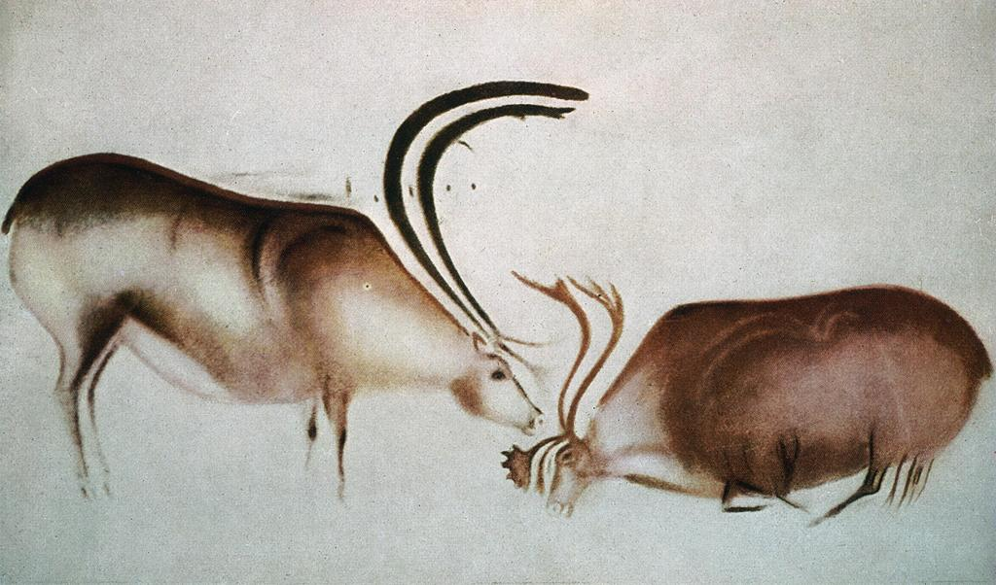
Font de Gaume, France

A/Hi 337: Figure & Symbol: From the Cave to the Studio

Fall 2022
T/R 10-11:50am in FI 232; includes mid-quarter residential program in Southwest France (linked with ART 337: Figure & Symbol: From the Cave to the Studio)

Dr. Monique Kerman
Fine Arts rm 115
650-3804
Monique.Kerman@wwu.edu
Office hours: T/R 9:20-9:50am and 12-12:50pm

Course description: Making symbols is a deeply human activity that is observed in our earliest ancestors up to the present day. This course introduces a range of artistic and figurative practices in societies that represent a small sample of the wide range of systems of representation throughout human history. Topics will include body art and tattooing; totems and animal symbolism; and shamans, sorcerers and hybrid bodies. This course is uniquely designed around primary research of Paleolithic cave art and artifacts in southwest France, and is linked with ART 337 to create an intensive studio experience focusing on the human form with an anthropological approach to figure art across cultures. The quarter-long course starts and ends on campus, and incorporates a four-week residency in France for studio work, three days of visits to Paleolithic art sites, and five days of exploration in Paris museums and cultural sites.

Student Learning Outcomes:
- You will research and observe Paleolithic art and material culture with a focus on that of southwest France.
- You will experience first-hand early human artifacts as well as lectures from current scholars about Paleolithic cave painting.
- You will develop an appreciation of formal and technical practices in the production of artifacts that have been marginalized by Eurocentric art historical narratives.
- You will hone your visual analytical skills, verbally and in writing.
- You will practice and develop your art historical writing skills.
- You will practice independent, critical thinking.

Grading: Based on three response papers (55%), presentation (20%) and participation (25%). Participation grades will be assessed based on attendance, participation in class discussions and activities, and the timely submission and/or completion of assignments.

Final course grades will be assessed according to the following departmental scale: A=94-100%, A- =90-93%, B+=88-89%, B=84-87%, B-=80-83%, C+=78-79%, C=74-77%, C-=70-73%, D=60-69%, and F=59% and below.
- A: Excellent. Achieves and goes well beyond the requirements. Work demonstrates an outstanding, innovative approach with impeccable execution.
- B: Above Average. Satisfies the minimum requirements and demonstrates thorough understanding of concepts and principles.
- C: Average. Satisfies the minimum requirements.
- D: Below Average. Does not satisfy the minimum requirements. Problems with quality and/or knowledge of concepts.
- F: Failure. Falls well below expected standards in meeting the minimum requirements.

Policies: My aim for this course is to facilitate discussions in a classroom climate that is inclusive. The content is explicitly viewed from multiple perspectives and varied experiences. Inclusive classrooms are classrooms in which instructors and students work together to create and sustain an environment in which everyone feels safe, supported, and encouraged to express their views and concerns. This is not to say that you will find the material or issues of the course unchallenging, but rather that I seek to present content in a manner that reduces all students' experiences of marginalization. Inclusive classrooms are places in which thoughtfulness, mutual respect, and academic excellence are valued and promoted.

Student Code of Conduct

Ethical Conduct with WWU Network and Computing Resources (note Section 2.3)

WWU’s Bias Response Team (in the case of an incident to report)

Students are expected to arrive for class on time, having completed the required reading. Each student is responsible for class material as it pertains to exams and assignments. I will not post lecture notes either in PowerPoint or on Canvas.

In the event of my own unavoidable absence or inclement weather, please check Canvas for an announcement of either an assignment or discussion board pertaining to the day’s reading.

Kindly refrain from cell phone use during class. Please also avoid leaving before the end of class unless you are ill or it is an emergency. Keep in mind arriving late and/or leaving early will adversely affect your participation grade. If you know you need to leave early, please inform me before the start of class.

This course is intended for all WWU students, including those with visible or invisible disabilities. Students with disabilities will be provided equitable access to educational experiences and opportunities. If, at any point in the quarter, you find yourself not able to fully access the space, content, and experience of this course, please first contact the Disability Access Center (DAC) to discuss potential accommodations. Faculty and staff partner with the DAC in the implementation of accommodations. If you already have accommodations set up through the DAC, please be sure to send your Faculty Notification Letter to me, through the myDAC portal, and reach out so we can discuss how your approved accommodations apply to this course. If you are unsure if accommodations are appropriate for you, contact the DAC for more information, temporary assistance, or connections to other resources: Disability.wwu.edu or 360-650-3083.
Late assignments will be penalized one letter grade for each day past due, regardless of excuse. If there is a potential conflict, such as a documented medical or family emergency or participation in a University-sponsored sports event, please see me before the due date. If you think you will need an extension for any reason, please see me before the due date. For medical leaves of absence, contact me during office hours; non-medical leaves of absence are granted by the Dean of Students office (Viking Union rm 547; ext. 3775).

Reasonable accommodation for students to take holidays for reasons of faith or conscience or for organized activities conducted under the auspices of a religious denomination, church, or religious organization. Students seeking such accommodation must provide written notice to the professor within the first two weeks of the course, citing the specific dates for which they will be absent. “Reasonable accommodation” means that faculty will coordinate with the student on scheduling examinations or other activities necessary for completion of the course or program and includes rescheduling examinations or activities or offering different times for examinations or activities.

Late papers will be penalized one letter grade for each class date past due, regardless of excuse. There will be NO make-up exams; students with a documented medical or family emergency or conflict due to University-sponsored sports events can see me for extra credit assignment. For medical leaves of absence, contact the Student Health Center (2001 Bill McDonald Parkway; ext. 3400); for non-medical leaves of absence, the Dean of Students office (Viking Union rm 547; ext. 3775) can provide the necessary paperwork.
In the event of a grade discrepancy between the professor’s records and the student, it is the student’s responsibility to produce all returned papers for verification. For concerns about grades, please see me during office hours or by appointment for a face-to-face consultation either in person or via Zoom. Email is not a suitable medium for correspondence about sensitive topics such as grades and thus should be as limited as possible.

Academic dishonesty is a serious offense; it will be dealt with in accordance with the policies outlined in Appendix D (Academic Dishonesty Policy and Procedure) of the WWU Bulletin. For more information, please see www.wwu.edu/integrity

The Hacherl Research & Writing Studio: Staff are on-hand to give support on everything from research papers and lab write-ups to resumes and digital media projects. You’ll receive feedback and step-by-step strategies to help you overcome writer’s block and develop your skills as a scholar. Visit the Studio on the 2nd level of Haggard Hall or online at wwu.edu/rws

Required text:
Desdemaines-Hugon, Christine. Stepping Stones: A Journey through the Ice Age Caves of the Dordogne. New Haven: Yale University Press, 2010.

All assigned articles are available on Canvas through Wilson Library Course Reserves.

Class schedule and required reading (due on the date listed):
Week 1: Introduction
Thursday, September 22
Introduction to the course; screening of Cave of Forgotten Dreams (2012; Dir. Werner Herzog)

Week 2: Paleolithic Symbolism & Culture
Tuesday, September 27
Reading: Desdemaines-Hugon, Stepping Stones: A Journey through the Ice Age Caves of the Dordogne, pp. 1-7 and 28-49.

Thursday, September 29
Reading: Desdemaines-Hugon, Stepping Stones: A Journey through the Ice Age Caves of the Dordogne, pp. 71-95.

Week 3: Beyond the Dordogne
Tuesday, October 4
Reading: J. Bruno David, “Chapter 7: Beyond the European Ice Age” excerpt, in Cave Art (London: Thames &Hudson, 2017), pp. 202-218.

Thursday, October 6
Reading Response I due: Marianna Torgovnick, “Defining the Primitive/Reimagining Modernity,” in Gone Primitive: Savage Intellects, Modern Lives (Chicago: University of Chicago Press, 1990), pp. 3-41.
Reading: Genevieve von Petzinger, “Chapter 10: Of Animals and Humans and Strange Tableaux,” and “Chapter 11: Patterns: Trading Signs and Sharing Symbols, in The First Signs: Unlocking the Mysteries of the World’s Oldest Symbols (New York: Atria, 2016), pp. 147-171.

Friday, October 7
Leave for France

Week 4: FRANCE (Auvillar: Studio focus)
Monday-Friday, October 10-14
Studio sessions only

Week 5: FRANCE (Auvillar and Les Eyzies fieldwork: cave and museum visits)
Monday-Tuesday, October 17-18
Studio sessions only

Wednesday, October 19
Meet 2-5pm
Reading: Desdemaines-Hugon, Stepping Stones: A Journey through the Ice Age Caves of the Dordogne, pp. 9-27, 51-70, 97-120, and 173-192.

Thursday, October 20
Field trip to Cougnac; meet Christine Desdemaines-Hugon; Les Eyzies

Friday, October 21
Font de Gaume and Les Combarelles

Saturday, October 22
Rouffignac and Bernifal with Christine; group lunch with Christine

Sunday, October 23
Musée Préhistoire; return to Auvillar

Week 6: FRANCE (Auvillar)
Monday, October 24
Meet 9:30-11:00am
Reading: Bruno David, “Chapter 7: Beyond the European Ice Age” excerpt, in Cave Art (London: Thames &Hudson, 2017), pp. 219-245.

Tuesday, October 25
Meet 9:30-11:00am
Readings: David S. Whitley, “Symbolic and Ethnographic Interpretation,” and “Other Formal Approaches,” in Introduction to Rock Art Research (Walnut Creek, CA: Left Coast Press, 2005), pp. 79-108 and 123-150.

Wednesday, October 26
Viewing Response: Cave of Forgotten Dreams due (online submission)
Meet 9:30-11:00am
Readings: Natasha Ruiz-Gómez, “The (Jean) Nouvel Other: Primitivism and the Musée du Quai Branly,” Modern & Contemporary France vol. 14 no. 4 (November 2006), pp. 417-432; Farah Nayeri, “Museums in France Should Return African Treasures, Report Says,” The New York Times, November 21, 2018

Thursday, October 27
Studio session & Critique

Friday, October 28
Studio clean up; pack up; Open studio 5-8pm

Saturday, October 29
Leave for Paris; visit Centre Pompidou and Atelier Brancusi

Week 7: FRANCE (Paris fieldwork: museum and cultural site visits)
Sunday, October 30
Visit Musée du Quai Branly (morning), Musée de l’Homme (afternoon), and Palais de Tokyo (evening)

Monday, October 31
Visit Louvre and Tuileries

Tuesday, November 1
Free day (options: Musée d’Orsay, Jeu de Paume, Musée de l’Art Moderne de la Ville, Nôtre Dame, Sacré Coeur and Montmartre)

Wednesday, November 2
Free day

Thursday, November 3
Back to Bellingham

Week 8: No class meetings

Week 9: Body Art, Totems, Symbolism, & Shamanism
Tuesday, November 15
Reading: Desdemaines-Hugon, Stepping Stones: A Journey through the Ice Age Caves of the Dordogne, pp. 121-127 and Peter Gathercole, “Contexts of Maori Moko,” in Arnold Rubin, ed., Marks of Civilization: Artistic Transformations of the Human Body (Los Angeles: Museum of Cultural History, University of California, Los Angeles, 1988), pp. 171- 180 and Liz Willis, “Uli Painting and the Igbo World View,” in African Arts vol. 23, no. 1 (1999), pp. 62-67.

Thursday, November 17
Reading Response II due: Thomas McEvilley, “The Global Issue,” in Jack D. Flam and Miriam Deutch, eds., Primitivism and Twentieth Century Art: A Documentary History (Berkeley: University of California Press, 2003), pp. 396-401.
Reading: David Lewis-Williams and Thomas A. Dowson, “Through the Veil: San Rock Paintings and the Rock Face,” in The South African Archaeological Bulletin vol. 45, no. 151 (June 1990), pp. 5-16.

Week 10: Presentations
Tuesday, November 22
Student presentations

Thursday, November 24
Thanksgiving Holiday—no class

Week 11: Presentations (cont’d)
Tuesday, November 30
Student presentations

Thursday, December 2
Student presentations; Class evaluations

Final Papers due by Tuesday December 7 at 10am in my office (FI 115) or mailbox (FI 116).

