Engage InPlace: SE Asia

Community, Environment & Development in Southeast Asia
Spring 2023 Field Program - INTL 437 (15 credits)
Instructor: Julia Babcock, juliajoanb@gmail.com
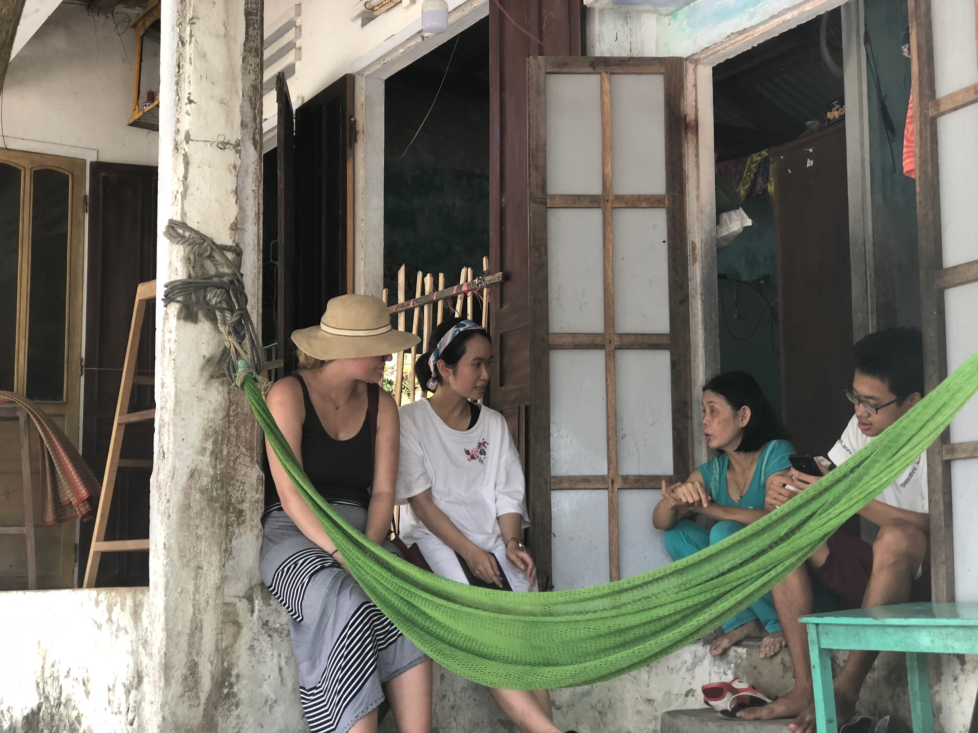 | 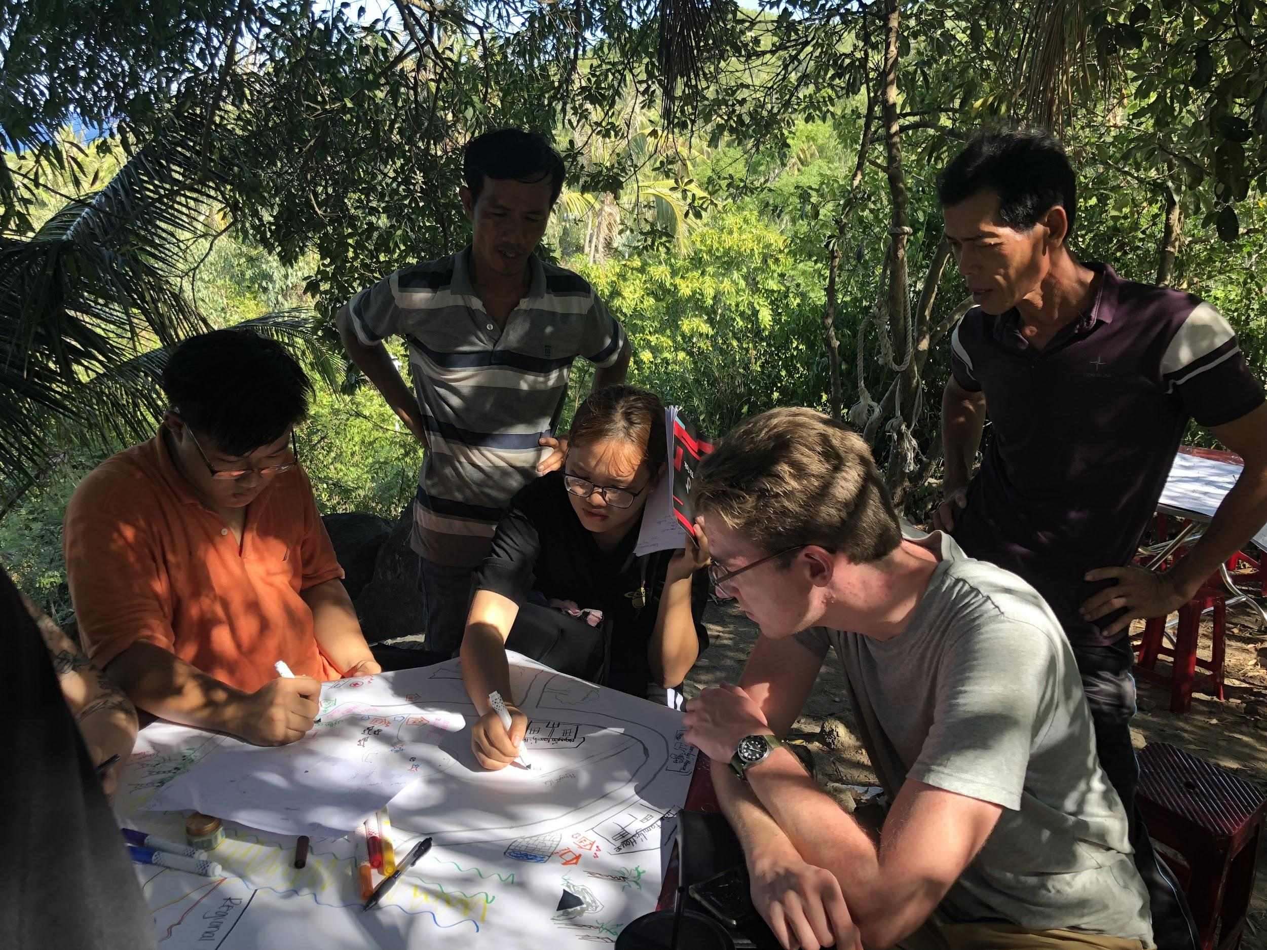 | 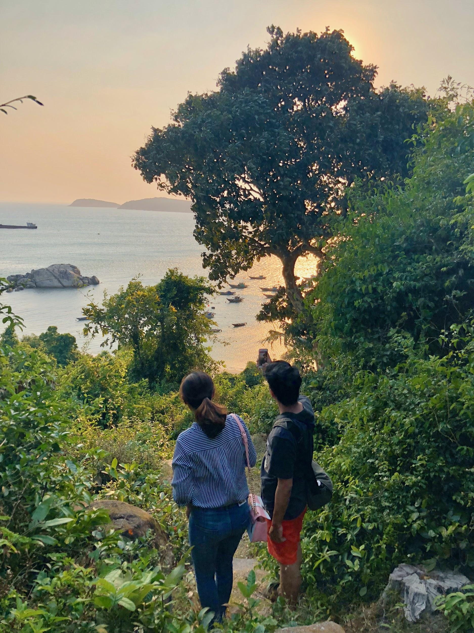
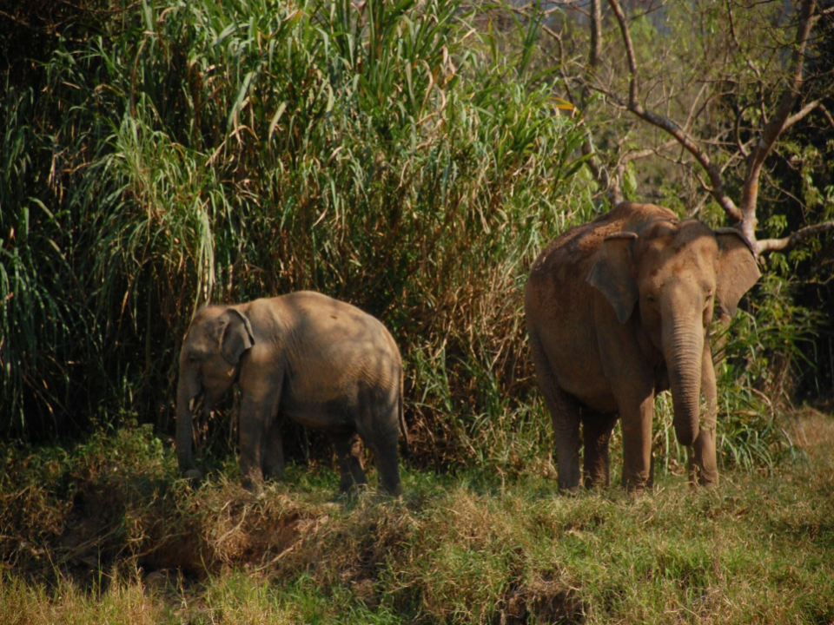 | 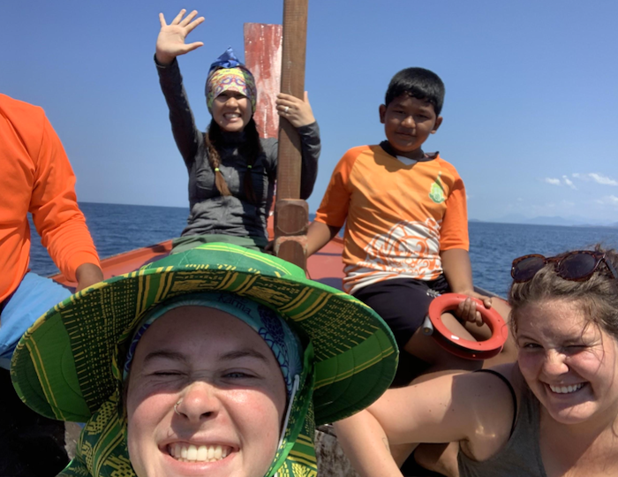

COURSE OVERVIEW:
Southeast Asia is often seen as a leader in global development and innovation. The pace of economic growth in the region is unmatched, which is made possible through a formidable government apparatus, access to education, robust public health systems, and regional trade policies. However, the consequences of ‘growth’ as development throughout Asia are starting to be felt. Regional inequalities and multidimensional poverty are becoming more apparent, which are often made worse by climate change. Despite disparities in the global system, local grassroots actions are beginning to profoundly impact regional environmental conservation, human rights, and social justice. These grassroots efforts are now starting to shift local policy to prioritize the environment and the livelihoods of residents.

During this intensive field program, students will gain an in-depth understanding of the global geopolitical system that guides local development and international policy, as well as learn directly from those living in communities facing these challenges firsthand. We will explore various participatory approaches to development, governance, and community building in cooperation with local partners. This will include learning directly from those working to protect indigenous knowledge, cultures, and practices. Through an intellectually and physically rigorous schedule of cultural study, intercultural interactions, and reflection, the course promises to be both unique and transformative.

This 15-credit course is designed to enable students to get the most out of their international experience by developing knowledge, skills, values, and their application in an intercultural context.

COURSE OBJECTIVES:
- Analyze, synthesize and apply course content at the community, national, regional and global levels, particularly those related to sustainable development, environmental conservation, and community building.
- Identify elements of equitable international partnerships and how they are initiated, nurtured and sustained.
- Explore the cultural dynamics, religious traditions, historical patterns, and contemporary issues that contribute to the identities of the communities we visit.
- Practice critical reflection and inquiry to increase understanding of academic and cultural learning and critically examine one’s own motivations, preconceptions, and assumptions while learning in an intercultural context.
- Practice resilience in new and unfamiliar situations by adapting in ways that are appropriate to cultural context; staying engaged while learning within cultural difference, ambiguity, and discomfort; practicing flexibility and being open to change, and embrace a growth mindset.

Course objectives will be accomplished through a combination of interactive learning experiences, such as formal instructional activities and assignments, living and working with local residents, as well as direct exchange with university students and local youth.

CORE PROGRAM COMPONENTS:
Theories of Sustainable Development, Grassroots Action & Indigenous Knowledge: The course will introduce students to theories of sustainable international development to provide a conceptual framework for students’ learning. As part of this discourse, we will discuss the ethics of international development and what could go wrong when trying to do right. We partner with grassroots organizations and local communities to work on and/or observe projects they initiate. The philosophy of this program is that local communities are the experts in their priorities and in how best to achieve them. Our role as outsiders is to approach international development with a huge dose of humility and let our community partners guide our involvement in the manner that they believe will be most meaningful. Part of this learning will highlight regional diversity, grassroots movements, and local indigenous knowledge.

Ethical Global Citizenship & Responsible Travel: This course examines the ethical and practical questions raised by traveling, working, studying, reporting, and volunteering internationally. By exploring the social, cultural, historical, political, and economic contexts in which international engagement takes place, students will develop a critical lens with which to evaluate their own place in an increasingly interdependent world. As part of this component, students will develop Social Action Plans that empower them to use their experiences in the program to create actions that will have a positive impact on the world, both at home and abroad.

Before departure, we will cover general guidelines and expectations for ethical travel, as well as the responsibilities we carry as global travelers. For the program to be successful and have a long-term positive impact, it requires a full commitment of all participants to uphold these principles. With the understanding that responsible and ethical travel is an ongoing learning process, students will be encouraged to share questions, perspectives and insights throughout the trip. Through this collaborative learning, we will aspire as a group to improve upon the practices and principles of the program.

Mentorship & Professional Development: Fostering relationships is not typically an explicit focus of any experiential education program. Our team of professionals from the United States and Southeast Asia will help guide participants in building the transferable skills they need to succeed in a globalized world. Besides 1:1 guidance from staff, students will also have the opportunity to build relationships with their peers from the places we visit. Along the way, we will invite local university students and youth to take part in guided discussions and workshops on participatory mechanisms to foster opportunities for conservation and sustainable development. Our project-based learning approach will allow students to develop necessary soft skills and intercultural competencies as they cultivate their own global network for future academic and career endeavors.

ITINERARY & OUR FIELD SITES:
This program is designed to be dynamic to respond to the ever-changing context of the global environment. As such, local partners, both academic and community leaders, will play a key role in developing the core content and field sites we visit throughout our travels. This will allow us to maximize learning potential, realize our values of reciprocity throughout the course, and adjust to the world around us. This is especially important in a post-COVID world and will allow our Southeast Asia program to adapt and work only where it is safe to do so and where our local partners explicitly invite us.

Orientation:
Western Washington University, Bellingham, WA
Prior to departure, students will participate in an intensive orientation. It will include lectures and discussions on history, culture, contemporary politics, sustainable international development, and ethical travel. Particular attention will be devoted to health and safety concerns in a post-covid world, including a 2-hour session on health and safety.

The orientation sessions will help students begin to collaborate as a group – to solve problems, communicate clearly and openly, and hopefully make lifelong friends. We will address the challenges of cultural assimilation and the unique aspects of travel and study with a group.

Fieldwork:

Part 1: Introduction to Development in SE Asia
Example Location: Chiang Mai, Thailand and Surrounding Areas
Students will begin to learn about development in Southeast Asia and the geopolitics that guide it during this section of the course. We will visit various local agencies, utilize case study analysis tools to investigate the realities of development and be introduced to local culture, history, and language. Particular attention will be paid to the intersection between indigenous knowledge and sustainable development efforts. We will live with and learn from indigenous groups working to preserve local resources, livelihoods and culture. Chiang Mai University will serve as a hub through our partnership with the Regional Center for Social Science and Sustainable Development (RCSD), where we will collaborate with faculty and students. This is a hub of sustainability research in Southeast Asia and will provide an excellent backdrop to learn about issues facing the Mekong region.

Part 2: Participatory Approaches to Community Development & Environmental Conservation
Example Location: Da Nang City and Surrounding Areas in Central Viet Nam
Students will have the opportunity to work with NGOs, government officials, local universities, and community leaders to see participatory approaches to community development in practice. Local leaders will be our guide, as they teach us about the participatory strategies they have used to develop their own communities, while preserving the environment and maintaining strong community ties. Discussion will focus on how community-based initiatives have started to create more systemic change through policy and development initiatives. Homestays and direct exchange with local university partners will be a key aspect of this portion of the course.

Part 4: Building and Maintaining Partnerships for Systemic Change
Example Location: Bellingham, WA
Students will put what they have learned into practice by conducting community-based research and co-producing social action projects to build their own partnerships for systemic change.

INSTRUCTORS & ACADEMIC RESOURCES:
Instructor of Record:
Julia Babcock
Senior Project Manager, Hatfield School of Government
Portland State University
juliajoanb@gmail.com

Academic Resources:
Nguyen Thi Thuy Thuy
Lecturer, School of Tourism
University of Economics Ho Chi Minh City
thuyntt@ueh.edu.vn

Chu Manh Trinh
Program Manager, Research & International Cooperation, Cham Island Marine Protected Area, Quang Nam, Vietnam
Affiliated Faculty Da Nang University of Education, Environmental Science & Governance
mtrinh.clcmpa@gmail.com

Golf Thanupon Yindee
Project Manager, Makhampom Theater Group
US State Department YSALI Fellow

Chayan Vaddhanaphuti
Regional Center for Social Science and Sustainable Development (RCSD)
Faculty of Social Sciences, Chiang Mai University

COURSE ASSESSMENT:
- Professionalism, Participation and Contribution
This international experience will be fluid and collaborative, and the content of this experience will depend greatly on how your own individual interests mesh with the goals of local communities. Therefore, your professionalism, contributions, and participation in this program are critical to the success of not only your own experience, but also the current and future partnerships with community members and organizations in Southeast Asia.
Your contributions should be positive and take into consideration the learning of the entire group. Any actions that impede your learning or the learning of others will adversely affect your professionalism, participation, and contribution grade. Outstanding participation and contribution would be characterized by the following behaviors:
- Demonstrates a commitment and understanding of the importance of respecting the local culture, their norms, and their expectations of our partnership.
- Participates in class discussion, including questions, areas for exploration, and discussions that further understanding, according to our learning objectives.
- Demonstrates excellent listening skills by remaining attentive and respectful of other students, teachers, staff, and community members.
- Demonstrates ability to apply, analyze, and synthesize course materials.
- Explores new ideas and challenging questions and continually pushes themselves outside of their comfort zone.
- Demonstrates open and full participation in all activities.
Students will receive feedback on their professionalism, participation, and contribution on a regular basis during the fieldwork experience. Everyone is expected to embrace a growth mindset and continuously improve along the way.
2. Learning and Teaching about Southeast Asia
It is important for us to learn about Southeast Asia and the places we will visit before traveling, in order to make the most of the experience and to be respectful of the people and places that we will encounter.

We encourage you to explore local history, geography, cultures, and current events on your own, and will suggest books, websites, and other resources that you might find interesting.
In addition, you will work with a group of 3 of your classmates to design a 30-minute lesson about a particular aspect of SE Asia. We encourage you to include hands-on and/or interactive activities. You will turn in:
❏ A detailed lesson plan
❏ A bibliography including all sources you consulted
❏ A description of the contributions of each team member to your lesson
Your lessons will be delivered before we embark on our travels in SE Asia. Topics that you might consider designing lessons around include:
- Food and agriculture
- Biogeography (distributions of plants and animals) and conservation
- Political issues and conflicts
- History and impacts of colonialism
- Languages and demographics
- Family and gender
- Health systems
- Education systems
- Water and energy
- Economic development and imports/exports
- Popular culture (music, literature, web, etc.)
- And various other issues as they are related to community, environment, development and sustainability in Asia
Your lessons should be focused, creative, informative, and fun. Your goal should be to teach the group something that will stick with us throughout our travels and after we return.
One important step in preparing for your presentation will be gathering a wide array of resources on your topic. You will provide a bibliography of all the sources that you consulted. The range of materials that you consult should include:
- Regional news sources - These include online newspapers, TV and radio broadcasts, and blogs written by locals (not written by tourists or Peace Corps volunteers)
- Global news sources - These include North American, European, African, Asian, Australian and Middle Eastern sources
- Development Research - World Bank, Asian Development Bank, United Nations and others working in Asia have a vast array of reports on various subjects related to environment and development in the region.
- Academic books and/or journal articles - These peer-reviewed, scholarly resources are especially useful in providing critical analysis and context of the issues that you are exploring. If you need assistance, ask our friendly and knowledgeable library staff.

Your lesson will be graded based on the following:
- 20% Clarity of lesson’s scope and purpose
- 20% Structure and flow of lesson
- 20% Quality of information provided about Rwanda
- 20% Effective communication (presenting, listening, giving directions, answering questions)
- 20% Quality and breadth of sources
3. Journal, Book of Questions, and other Critical Reflection Activities:
Throughout the course students will be expected to keep a journal for critical reflections, daily assignments and their book of questions. Journals will be checked periodically throughout the duration of our travels for completion and to grade daily assignments. They should include:
- Book of Questions
You probably already have generated many questions about the experience you are about to engage in. Begin to collect these questions in a journal. Your questions should help you (and your instructors) think about what you hope to learn over the quarter. The questions should capture the important themes and the topics you are still curious about or provoked by. Start your journal with questions from your Teaching and Learning about SE Asia assignment and the course learning objectives, readings, class discussions, current events and news items, and your own experiences related to your theme or idea.
As we travel together, you will add questions and reflections that arise from our new readings, from our interactions and conversations with people we meet, from your observations. Dig deeply for your questions; consider what it means to think critically, to move into a new culture, to listen well and to reflect deeply—especially look for the questions that seem to have no easy answers.
The format is up to you. Write your questions in any order; group them by themes, or importance, or chronology, or by some other means. Make illustrations to go with your questions, if you’d like. Leave space around each question so that you can go back and add notes about what you learn that helps answer this question, and space for new questions that bubble up related to the first question.

- Critical reflection assignments / activities
Students will have multiple opportunities to practice critical reflection throughout the term before, during, and after the fieldwork experience. Sometimes this reflection will take place in seminar discussion. Students will also write a number of short critical reflection papers, based on a prompt provided by the instructors. Reflection papers will be evaluated on content (40%), reasoning (40%) and writing quality (20%). )

- Notes and reflections
Keep your personal reflections from each day. It’s easy to get lost in the experience and forget some of the feelings you had after an activity, or what you were thinking at a certain point during the trip. Take time to reflect a couple of times a week to stay ground in throughout the duration of the course.
4. Case Study Assignment
Case studies are analyses of persons, events, decisions, periods, projects, policies, institutions, or other systems that are studied holistically by one or more methods…. – G. Thomas
We will use case studies to analyze the ‘development as usual approach’ and projects throughout southeast asia.
The Context:
- What is the situation—what do you actually know about it and what are your sources of information?
- What issues are at stake? What is the need or needs (or assets) of the individual/community that are being addressed? What are the root causes of an issue?
- How do you know what the needs or assets are?
- Who is affected most by the development project?
- Who defines the context? Who are the decision makers?
- What questions do you have? What information are you missing? Where/how can you find it?
- What are the underlying assumptions in the case—where do you see them?
- What are the constraints and opportunities implicit to this situation?
Implementation:
- Who are the stakeholders in the development project? Who are the decision makers?
- Who executes the project? Who holds the procedural knowledge?
- Is this a short, medium, or long-term project?
- Who will benefit from the project?
- What methods are used to assure a successful and sustainable project outcome?
Results:
- Was the project successful in addressing the needs or context of the community? Who’s needs have been met? How?
- How do you know?
- What were the outcomes?
- Were there any unintended outcomes?
- In the end was anyone better off?
- Is there anything that could have been done differently? What are the possible alternative options?
- What tells you this?
5. Social Action Plan
Your experiences in Southeast Asia will give you a different perspective on the places we visit, the world, the U.S. and your local community. You will have a greater understanding of your role as a global citizen. Your social action project plan is your way of giving back to a community of your choice, and honoring those who made your study abroad trip possible.
Please keep your plan simple and doable by using an asset-based framework in your approach and outline your action plan as follows:
- Executive summary (1 page or less):
  - Provide a summary of the project and its purpose, setting the stage for the rest of the action plan.
  - Include a vision and a mission statement at the end of the executive summary.
- Actions, Service and/or Product Description (2 pages or less)
  - Prepare a step-by-step outline of what you will do to prepare for your project and ensure that your project is realistic and can be successfully completed.
  - Describe all of the physical assets, including materials, locations, human resources, etc. (often described as the “supply chain”) needed to accomplish your project from beginning to end.
  - Provide a realistic timeline for your project. Your project completion should take no more than one to two years.
  - Provide a budget for the scope of the project.

EVALUATION:
This is a 15 credit, graded course. Your grade will be calculated according to the following matrix (each item will be ranked on a scale of 1 to 5 and your averages across all categories will be calculated):
10% Pre-trip Bellingham participation / coursework
1 2 3 4 5 Learning and Teaching About SE Asia assignment
1 2 3 4 5 Active participation in Bellingham orientation
1 2 3 4 5 Adequate preparation for trip
40% Class participation and assignments completed in SE Asia
1 2 3 4 5 Participation in group / individual activities
1 2 3 4 5 Engagement with community partners
1 2 3 4 5 Field journal assignments and reflection
1 2 3 4 5 Critical reflection (written and oral), including case study assignments
30% Professionalism, Engagement and Contribution
1 2 3 4 5 Adherence to group guiding principles
1 2 3 4 5 Follow through with plans (insofar as possible, from your side)
1 2 3 4 5 Active participation in group sessions, including WWU and partner organization meetings
1 2 3 4 5 Adherence to group codes of conduct concerning alcohol, behavior, dress, clean-up, ethical travel
1 2 3 4 5 Self-drive / taking responsibility for your learning / pushing yourself to maximize the learning experience
10% Action Plan (due at the end of the quarter, graded on 100 pt scale)
10% Post-trip Bellingham participation
1 2 3 4 5 Final reflection assignment
1 2 3 4 5 Class participation
1 2 3 4 5 Action Plan Presentation

REQUIRED SUPPLIES:
- Field journal or notebook of your choice. Bring something that is easy to carry around and that you want to write in. Please NOTE, you will need to turn in a digital copy at the conclusion of the class.
- 2 pens to write in your journal and take notes.
- Colored markers, pens or pencils. You will make presentation posters/ materials often during the course of the trip, so choose one thing to bring that you can share with the group to maximize your creative abilities.
- A phrasebook, dictionary or app of your choice. Challenge yourself to practice the local language. Learning a few key phrases can go a long way in integrating into local communities. You should note - you can download various apps/dictionaries on your phone, which may be helpful during your travels.
- Small notebook to create your own dictionary that you can carry in your pocket and practice your language skills
- Digital Course Pack. You can choose to print it out or download contents onto a device. Additional reading may be added in country.
- One book of your choice related to SE Asia to read during the trip. This can be fiction or nonfiction. It will help you fill downtime and allow you to think more deeply about an issue you’re interested in.
- Taranath, Anu. Beyond guilt trips: mindful travel in an unequal world. Between the Lines, 2019. This will be a core piece of our curriculum for self-reflection before, during and after your travels.

SELECTED READINGS/COURSE RESOURCES FROM REQUIRED TEXT & SUPPLIES:
Brennan, Linda, et al. Growing Sustainable Communities: A Development Guide for Southeast Asia. Tilde University Press, 2013.
Demaria, Federico, and Ashish Kothari. "The Post-Development Dictionary agenda: paths to the pluriverse." Third World Quarterly 38, no. 12 (2017): 2588-2599.
Evrard, Oliver, Dominque Guillaud and Chayan Vaddhanaphuti. Mobility and Heritage in Northern Thailand and Laos. Institut de Recherché pour le Développement, 2013.
Green, Gary Paul, and Haines, Anna L. Asset Building & Community Development (ebook). Thousand Oaks: SAGE Publications, 2015.
Huyen, Nguyen Thi Thu, et al. “Marine Biodiversity and Wetlands Conservation in Vietnam,” GEF Small Grants Program. UNDP & Global Environment Facility, 2015.
Ives, Mike. “In Mekong Delta, rice boom has steep environmental cost (article).” Report on Yale Environment 360, July 11, 2013.
Jesionka, Natalie. “The Reality of Voluntourism and Converations We’re Not Having (article).” The Muse.
Kothari, Ashish, et al. Pluriverse: A Post–Development Dictionary. Tulika Books, 2019.
McCaskill, Don N., Prasit Līprīchā, and He, Shaoying. Living in a Globalized World : Ethnic Minorities in the Greater Mekong Subregion. Thailand: Mekong Press, 2008.
O’ Rourke, Dara. Community-Driven Regulation: Balancing Development and the Environment in Vietnam. The MIT Press, 2004.
Pimhidzai, Obert, et al. “Climbing the Ladder: Poverty Reduction and Shared Prosperity in Vietnam (pdf).” The World Bank, 2018.
Sachs, Wolfgang, ed. The Development Dictionary: A guide to knowledge as power. Orient Blackswan, 1997.
Stuart, Graeme. Sustaining Community: Families, Community Engagement and Environmental Sustainability. Blog. Wordpress: https://sustainingcommunity.wordpress.com/what-is/ (blog)
Taranath, Anu. Beyond Guilt Trips. Mindful Travel in an Unequal World. Lutzen, MN: Between the Lines Publishing, 2019.
Taylor, K.W. 1998. “Surface orientations in Vietnam: Beyond histories of nation and region.” Journal of Asian Studies. Vol. 57. Issue 4. 949-977.
Tuck, Eve. "Suspending damage: A letter to communities (pdf)." Harvard Educational Review 79, no. 3 (2009): 409-428.
Wheatley, Margaret, and Deborah Frieze. "Leadership in the age of complexity: From hero to host (pdf)." Resurgence Magazine264, no. January/February (2011): 14-17.
Wheatley, Margaret. "Who do you choose to be? An invitation to the nobility of leadership (pdf)." Leader to Leader 2017, no. 85 (2017): 37-41.
Wyatt, David K. “Development and Revolution & Fresh Starts.” In Thailand: A Short History, 2nd ed., 266-308. New Haven, CT: Yale University Press, 2003.
Yos, Santasombat. The River of Life: Changing Ecosystems of the Mekong Region. Mekong Press, 2011.

Syllabus and itinerary subject to change. An updated final version will be provided at orientation.

