WWU Global Learning Program
Course Syllabus
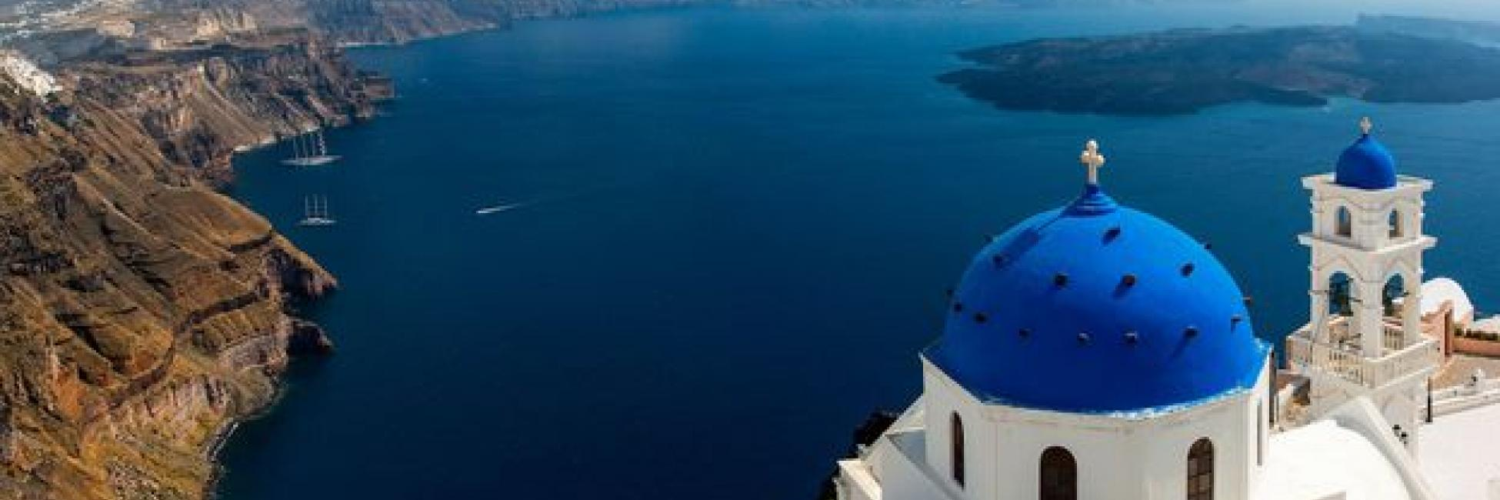
UEPP 437P: GREECE: APPLIED STUDIES IN MEDITERRANEAN SUSTAINABLE DEVELOPMENT
SUMMER 2023
6 credits

Department of Urban and Environmental Planning and Policy
College of the Environment, Western Washington University

Tentative dates:
Phase 1: Pre-departure course preparation phase. TBA. Logistics, Canvas readings, written assignments
Phase 2: June 16 - July 2, 2023 (Travel and Field Research Phase)
Phase 3: July 8 – July 29, 2023 (Final Assignments Due)

COURSE SYLLABUS
UEPP 437P GREECE: APPLIED STUDIES IN MEDITERRANEAN SUSTAINABLE DEVELOPMENT (6 credits)

Instructor Nicholas C. Zaferatos, Ph.D., AICP, Professor of Urban Planning
Urban and Environmental Planning and Policy
Western Washington University

Overview The program involves analysis of urban spaces in Athens’s neighborhoods, comparative studies of traditional (medieval) villages (Horas) in Aegean Island communities and applied studies in a case study Ionian Island community. The course emphasizes studies in sustainable development in both urban and traditional Mediterranean Island communities. The course entails field investigations emphasizing sustainable community development principles, the study of sustainable village form and heritage design, as well as current political, socioeconomic, and cultural issues facing Greek communities. Students will have an opportunity to explore sustainable transitional processes in urban neighborhoods as well as ancient sites, museums, and cultural events in Athens and will undertake a series of applied studies, including comparative assessment of village form characteristics using sustainability metrics; urban renewal practices; and the study of urban and village architecture and public spaces. Our residency stay on the island of Ithaca focuses on developing sustainable design alternatives as part of our ongoing research in sustainable development planning for this island community.
Course Highlights: Explore Mediterranean architecture, urban planning, historic development, and historic and contemporary culture while performing fieldwork in urban and village community settings. The international field program involves 3 distinct phases: Part 1: Our exploration begins exploring urban Athens, emphasizing urban design, the city’s historic development, efforts to pedestrianize the central city, and exploring the current impacts of migration. Part 2: involves touring a series of Aegean islands for comparative studies of traditional settlement villages. Part 3 includes a residency study in the island of Ithaca.
Readings (Tentative list: Final Readings will be posted on Canvas)
- Mediterranean strategy for sustainable development, UNEP/MAP
- Traditional Mediterranean Architecture, MEDA, EUROMED HERITAGE
    - The Living Community Challenge (sustainability metrics)
    - Blueprint for a Living Village, Kioni, Ithaca. Western Washington University
    - Sustainable Tourism Development in the Greek Islands and the Role of Tourism research and Education, G. Zaharatos, P. Tsartas
    - Social and Spatial Impact of the Crisis in Athens: From Clientelist Regulation to Sovereign Dept Crisis. Thomas Maloutas

2023 Project Emphasis
Study Projects undertaken in the 2023 Program emphasize sustainable community development, urban morphology studies of medieval towns, urban pedestrian planning (Athens), heritage town design and other sustainable design topics, and analysis of village infill capacity by implementing national policies for the rehabilitation of abandoned residential structures and ruins.

Comparative Analysis Focus in Aegean Island communities:
- Assessment of town morphology as traditional forms of sustainable development.
- Design and function of community marketplaces, pedestrian spaces, and civil expressions in reaction to economic austerity.

Final Projects Students will develop illustrated site drawings depicting elements of village sustainability; a photo journal, a journal of impressions experienced; and sustainable design planning solutions for a topic in our Ithaca case study village.

Schedule The summer course involves pre-departure preparation, self-study review of materials provided, field investigation in Greece, and a final project. The typical in-country field day consists of (daily) combined lecture, fieldwork, and seminar discussions. Each morning we convene for daily instruction regarding research objectives, methods to be employed, design objectives, team assignments and the coordination of field logistic. Students generally work in small teams to conduct daily research tasks. End of day sessions consists of reflection, discussion, and critiques (and several program dinners).

Credit Hours
Pre departure instructions: (credit option a) .5 credit GLP. (30 hours x .5 credits) of which 5 hours direct instruction and 10 hours student work. Consisting of group orientation, logistics planning, reading assignments and preparation of impression reports. Expectations pre-departure for in-country experience.

In-country travel: (credit option b) 5.5 credits GLP (30 hours x 5.5 credits) 165 hours of which 110 hours direct instructions and 55 hours additional student work. Comprised of three 5-day modules. Daily organization of field study, speakers; field studies, excursions, community-based projects; daily seminars, in addition to student field studies, reporting, and other independent exercises.

Post-travel instruction: directed evaluation of final projects.

Methodology Study teams will visit village sites daily to identify village form characteristics and relationship between social activities and physical form. Students learn how to apply metrics to evaluate sustainability of space. Digital photography, field sketches, and field notes of observations are emphasized.

Evaluation Final grades will be based on the following: 1) pre-departure readings reflection paper (10 points); 2) illustrative interpretation of village urban design (20 points); 3) daily journal of observations and reflections (20 points); 4) Photo survey (20 points), and 5) team design solutions to an assigned sustainable development problem (30 points).

500 Level: Students enrolled in graduate programs are required to conduct independent research related to the curriculum and subject to instructor approval, submit the research design for instructor approval, and formulate the research paper.

