Honors 103: Navigating Human Experiences in Premodernity
Fall Quarter 2024: Meeting days & Times TBD; Room TBD
4 credits; HUM GUR

Caveant Discipulae (Discipulique)
ELECTRONIC DEVICES ARE STRICTLY PROHIBITED INSIDE THE CLASSROOM UNLESS I AM PRESENTED WITH AN EXPLICIT ACCOMMODATION FROM THE DISABILITY ACCESS CENTER. WE ARE GOING TO WORK ON TAKING BACK OUR FOCUS AND ATTENTION SPANS AND ASSERT SOME AGENCY BACK OVER OUR NEUROCHEMISTRY (TO THE EXTENT THAT THIS IS POSSIBLE). I NEED TO WORK ON THIS AS WELL.

[We initially concluded that] It is easier, given his nature, for a human being to rule all the other kinds of animals than to rule human beings. But when we reflected that there was Cyrus [the Great King of Persia]…we were thus compelled to change our mind to the view that ruling human beings does not belong among those tasks that are impossible, or even among those that are difficult, if one does it with knowledge.
Xenophon, Cyropaedeia 1.3, translation by Wayne Ambler [my contextual notes and emphasis]

Even if one man reads another person perfectly by his actions, it serves him only with his acquaintances, who are few. He who is to govern a whole nation must read in himself not this or that particular man, but mankind. This is hard to do and harder to learn than any language or science.
Thomas Hobbes, Leviathan, Introduction (Modernized Edition) [emphasis mine]

On the coming of evening, I return to my house and enter my study; and at the door I take off the day’s clothing, covered with mud and dust, and put on garments regal and courtly; and reclothed appropriately, I enter the ancient courts of ancient men, where, received by them with affection, I feed on that food which is only mine and which I was born for, where I am not ashamed to speak with them and to ask them the reason for their actions; and they in their kindness answer me; and for four hours of time I do not feel boredom, I forget every trouble, I do not dread poverty, I am not frightened by death; entirely I give myself over to them.
Machiavelli, No. 137, translation by Allan Gilbert [emphasis mine]

Most of the ancient peoples lived in governments that had virtue for their principle, and when that virtue was in full force, things were done in those governments that we no longer see and that astonish our small souls.
Charles de Secondat, baron de Montesquieu, Spirit of the Laws 1.4 [emphasis mine]

All the best memories are hers.
Blade Runner 2049, spoken by KD6-3.7 [emphasis mine]

Instructor Information
(Dr.) Tristan Goldman
Office: Old Main 330K
E-mail: Tristan.Goldman@wwu.edu
Schedule an Appointment!

Course Description
What is Honors 103? What is “premodernity”? What are the humanities? What is humanism? There are a lot of potential directions to take a course such as this. Is it my role to introduce you to a specific set of “great books” that are the best ones? That seems problematic on its face on so many levels. We only have ten weeks; there is so much great art from all over the world! If achieving diversity is our main goal in this sense (visiting as many cultures as possible), I feel I am bound to fail you simply due to the constraints of time alone. We have a quantitative and qualitative problem; too little quantity of time; too much quality in works of art from around the globe. Still, in navigating human experiences going about as far back as we can go, we do encounter a limit of sorts. As a starting point at least (we’re novices after all), it makes sense to work with humans whose experiences they sought to record in a manner reasonably accessible to us. Now, recording experiences in writing does not make a human being’s life or culture better or more important than anyone else’s; we simply have the opportunity to interact with them to a different degree. Another limit on designing the course is me. I have to feel comfortable working with you all on what I put in front of you. If you are thinking that means we ought to work on having faculty with a wide array of experiences, then you are correct. And we are working on that. And we actually do have a faculty with tremendous breadth! But there is always more work to be done.

So I am putting in front of you this quarter works of art from the distant past (mostly) that I feel comfortable discussing with you, organized around what I consider to be core to humanism: inquiry into wellness and human well-being, individually, communally, and interdependently. What is essential to human well-being? How do we go about having meaningful conversations about such a profound topic? Well, we’ll need to practice. We’re going to need some materials to practice on. How about we look at some material that our culture here in North America has pretended is the basis of our own way of life? What if I told you that it is not? That we ought to look again? Perhaps we’ll find something new amidst what’s supposed to be familiar. In my opinion, this work of figuring out how to be well (individually and collectively; the two are interrelated, are they not?) is work worth doing; I intend to help you begin figuring out how to go about doing it for yourselves. I hope you are already doing it. Allow me to boldly claim that what we practice in Honors 103 (and the first-year sequence of courses) is fundamental to our well-being, individually and as a community.

Course Goals (in order of import)
- To develop and refine critical thinking skill using the diverse ancient literature of the Near East and Mediterranean as our subject. The literature of these regions, particularly the Greek and Roman authors, have been put to this purpose for the last two thousand years and are remarkably well-suited to precisely this sort of exercise. That said, we ought to endeavor to look with fresh eyes. The last few hundred years of studying this material in particular are not going to lead us anywhere we want to go, in my opinion. The I Ching will help us cleanse the palate a bit, but it too will present us with a myriad of problems. The challenge of the critical thinker and analyst is to see the connection between seemingly unconnected facets of the universe. Since we are thinking about premodernity, this challenge has an extra layer of complexity for us, if we are aiming to look with fresh eyes. If, in fact, the core, self-evident truth at the heart of the human experience among premodern humans is and was something other than the analogous truth at the heart of our contemporary, rather Eurocentric (especially post 1500s) human experience, then a great many of the connections we have come to know in order to make our way through the world of our experiences are not going to help us very much when trying to understand the human beings who produced the art about which we are going to be spending our time thinking, feeling, and reacting.
- To turn our critical faculties toward the decoding of difficult primary source materials. This task will be the basis for much of the evaluated work in the course. Drawing connection between these ancient texts and the three core questions in the first-year Honors sequence ought to pose a significant challenge (see questions below). I find it challenging.
- To gain an introductory understanding of humanism and how such study can enrich and safeguard individual and collective experience, contributing to an ability to build a society that reflects our shared values and preserves our shared well-being.

Required Texts
R. Wilhelm and C.F. Baynes, The I Ching or Book of Changes (Princeton 1997)
S. Helle, Gilgamesh (Yale 2021)
S. Lombardo, The Essential Homer (Hackett 2000)
P. Meineck and P. Woodruff, Four Tragedies (Hackett 2007)
Cicero, On Obligations (Oxford 2008)
T. Stoppard, The Invention of Love (Grove 1998)

All (most?) of the aforementioned texts are available through the university’s bookstore, as well as many other local and online retailers. Use your own discretion when deciding where to purchase your texts. Students are expected to obtain these materials by the second week of the quarter with no exceptions. As such, waiting until some time into the quarter to obtain specific materials, and subsequently finding them out of stock at the university’s bookstore is not an excuse for an inability to complete assigned work. That being said, please do let me know if you encounter problems. Sometimes working out these sorts of problems is a team effort!

Summary of Grading Criteria
Daily Deep Thought [DDT]: 36% (~1% each)
Fortnightly Critical Reflections [FCR] [4 total] 30% (5% each)
Final Project 4%
Good thoughts, good words, good deeds 30%

Things to Keep in Mind
As usual, I reserve the sole right and authority to adjudicate whether or not late work will be accepted and what penalty will be imposed upon it within the parameters established by Western Washington University, especially under the headings “Class Attendance” and “Emergency Leaves of Absence.” Please also consult these additional resources; this website covers a wide range of policies meant to protect student wellbeing. Two important points: first, you must complete all of the aforementioned assignments to complete the course. Failure to complete and submit any one assignment may result in an F for the entire course, at my discretion. All of your assignments will be able to be submitted through Canvas. I tend to be a very compassionate human being to a fault. Please do not abuse my good faith. Think of the suitors.

Daily Deep Thoughts (DDTs) First Due Monday, October 2nd
Your DDTs will form the basis of your daily scholarly industry in the course. Every day we are scheduled to meet, MTRF, you will submit an annotation due an hour and a half (90 minutes) before our meeting based on the twenty-five (25) to thirty-five (35) pages of reading you are required to prepare for that day. This daily annotation must be approximately one hundred and twenty (120) words in length, though I do not plan to be pedantic about it, i.e. I am not going to count the words or require you to do so. I am suggesting one hundred and twenty (120) words so that you all have a rule of thumb to go on and, as a result, do not become too anxious about whether “you are doing enough.” I intend to look over your submissions before we meet so that I can use them as the starting points for our discussions. In this manner, the quality of our discussions are going to depend on the quality of your DDTs! The content of your DDT ought to be an encapsulation of a personal reaction to a section of the reading as you engaged in reflection. I encourage you to employ the framework of the relationship of individuals to their communities with an eye to human well-being, as that will help ensure that, thematically speaking, our thoughts will have a greater degree of initial interrelation, leading to deeper discussion.

Please consider directing your daily annotation toward one of our core questions in the first-year sequence:

What must we change and challenge to create the classrooms we desire?
What could it mean to trust in uncertainty and explore without intent?
How can selfless learning empower the communities we inherit, inhabit, and establish?

I intend to evaluate your DDTs as “complete/incomplete.” You may submit your DDT in a Canvas textbox or as an image of your handwritten notes in PDF format. I would like your DDTs to help me get to know each of you personally and become familiar with your ideas and outlook. Completing >95% of the DDTs will result in an “A” for that part of the course; >90% an “A-“; >85% a “B+”; etcetera.

Fortnightly Critical Reflections (FCRs) First Due Sunday, October 15th
Here’s what I have learned teaching in the Honors College: You all have great things to say provided that you feel that you have the space and media you desire in which to say them. Here’s what I’ve also learned: You all need the opportunity to practice your composition skills with a proficient instructor as often as possible. Here’s what I’ve also, also learned: You tend to need some structure to provide a spur of sorts to put energy into your work; there need to be some stakes. I am looking to create curriculum that serves your interests in as many ways as I am able. Produce something your heart desires in this course (with an accompanying essay, if your FCR is not a standalone essay). Produce something that you look forward to working on (along with an essay). Figure out what that is. It need not be the same thing every time. There are essentially two main approaches to your FCRs: a three-page, standalone essay; or a two-page essay alongside a project of your own devising. If you require direction, please consider this angle: What did you encounter in the course of our readings for that particular period that changed the way you think about some aspect of the human experience, or, to put it another way, how did the experiences of premodern humanity and our in-class conversations open your eyes to something either entirely new or a whole new way to look at something familiar? I will be providing formatting guidelines for the essay in the Canvas assignment descriptions.

FINAL PROJECT Due Friday, December 15th
The FINAL PROJECT will be a 8 hours-of-labor-of-love project at the conclusion of the quarter that captures your synthetic, holistic understanding and reaction to the experience this quarter. The type of project that you undertake is of your own devising. It could be an academic essay. It could be a poem. It could be a painting. It could be a song. It could be an interpretive dance. It could be a stand-up comedy routine. It could involve sock puppets. Think of your FINAL PROJECT as an FCR with a larger scope and scale.

Good thoughts, good words, good deeds Due every day of your life
You are now studying at the university level. I expect a high degree of self-motivation. Nobody is making you do this. Furthermore, you chose to join the Honors College. You may blame the economy for making you go to college, but surely you chose to enroll in the Honors College. Now I know what you’re thinking; you’re thinking that studying in the Honors College will also help you get a better job or get into med school. So it’s the economy again. We’re after something a tad bit more ambitious here in Western Honors. We’re interested in changing the world. Perhaps having an economy that doesn’t make you do things that damage your wellness would be nice. As you navigate your way through this course and this college, consider how your decisions affect the well-being of others, including MINE (I’m not a robot; the internet asks me all the time). It’s not so easy to figure this out! Turns out nobody else is you! Consider how the decisions and well-being of others affects your own well-being. Be respectful to me and those with whom you share space. I have feelings. I have a sense of self-worth that often feels fragile. I try to be brave like my mom and my grandma taught me. I try not to let them down. If you have people in your life that love you like they loved me (and I sincerely hope that you do), try not to let them down. #ancestorcult

Schedule of Readings
I shall be giving you explicit instructions of what you will be reading day-to-day on our Canvas site under the DDT assignment section. Our first reading is going to be Gilgamesh. As noted above, expect to have prepared approximately 25 to 35 pages of reading per course meeting. We are going to be looking at several pieces of literature, about nine, over the course of the quarter. We have approximately 38 meetings over the course of the eleven weeks, so I estimate we’ll spend about four to five meetings on each selection.

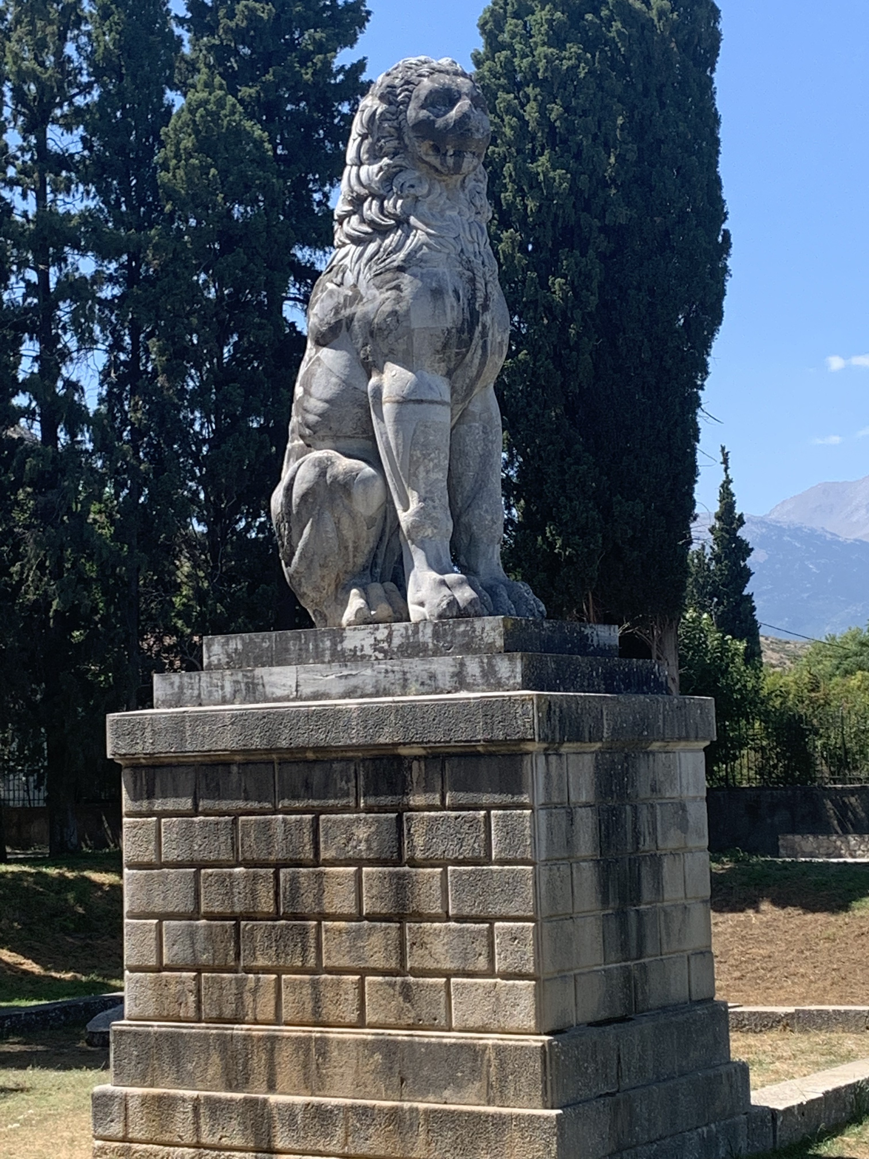
When the Spartan spear was dominant, then Xenocrates took by lot the task of offering a trophy to Zeus, not fearing the host from the Eurotas or the Spartan shield. “Thebans are superior in war,” proclaims the trophy won through victory by the spear at Leuctra; nor did we run second to Epaminondas.

…(Philip of Macedon) shed tears and said, whoever suspects baseness in anything these men did, let him perish.

Though trodden beneath the shepherd’s heel,
the wild hyacinth blooms on the ground.

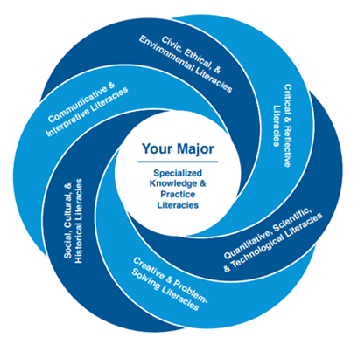
Above is the GUR Rosette, which serves to offer a visualization of the interaction of the “literacies” that a WWU committee decided form the foundation of a “Liberal Arts” education. As an indigenous person, I do have objections to the use of the term “literacies.” However, I have been instructed that I am required to display this image on my syllabus. Furthermore, the “liberal” part of the phrase “Liberal Arts,” I take as representing the Enlightenment understanding of the concept “liberal,” which has produced our strange negative liberty culture of private citizenship. Though having been raised so, I must say that I find it bizarre that I am required to place this image on my own curricular materials. Is this not an affront to my creative freedom!?

Through our investigation of premodern human experiences, it is my hope that the “Social, Cultural, & Historical Literacies; Civic, Ethical, & Environmental Literacies; Critical & Reflective Literacies; Communicative & Interpretive Literacies; and Creative & Problem-Solving Literacies” that underpin such an investigation will reveal to us a significantly more profound relationship with the concept of “LIBERTAS” than that on offer by a few prominent Sixteenth and Seventeenth Century CE (largely Northwesterly) Europeans, whose legacy continues to surreptitiously lurk beneath our educational institutions.
As an Honors College foundation course, Honors 103 promotes the following Student Learning Outcomes (SLOs). These Student Learning Outcomes (SLOs) emphasize ways of thinking, doing, and being.

Students who earn the Honors Interdisciplinary Studies Minor will have:

- experimented with unfamiliar modes of process, inquiry, thought, and dialogue by engaging with challenging, diverse materials in both textual and non-textual forms;
- engaged in a praxis of communication design;
- cultivated an appreciation for the generative potential of self-reflection, unlearning, and not-knowing, in part by undertaking willful acts of creativity, interdependence, and vulnerability in the classroom;
- acquired substantial knowledge of the ways that the methods, tools, and discourses of academic disciplines have been developed and deployed in a variety of historical periods and geographical locations, as well as by the individuals and communities within them;
- demonstrated fluency in the mobility of disciplinary-specific methods, tools, and discourses, especially in their generative potential when combined with the methods, tools, and discourses from other fields of inquiry;
- undertaken sustained, rigorous, and relevant work that integrates the methods, tools, and discourses of several academic disciplines;
- immersed themselves in a community of practice, thereby expanding their appreciation for the importance of self-reflection and accountability, ambiguity and complexity, contingency and difference;
- engaged in regular acts of service to the communities in which they are locally embedded: the Honors community, the broader campus community, and/or communities in Whatcom County; and
- deployed each of the above in everyday life.

