Honors 237: Democracy: A Love Story, 3 credits
Study Abroad: Athens and sites in Central and Southern Greece

Instructor Information
(Doctor) Tristan Goldman
Office: Old Main 330K; E-mail: goldmat@wwu.edu
Phone: 360 650 6558 / Alt Phone 206 697 1156

Course Description
Honors 237, Democracy: A Love Story, is the experiential, study-abroad component of our suite of courses for the Honors College Greece Program, which includes Honors 103: Navigating Human Experiences in Premodernity; Honors 205: Colloquium in History; Honors 206: Colloquium in Political Science; and Honors 101: The Big Picture. Honors 237 will include two fully scheduled weeks touring Greece. The study abroad component is dedicated to guided site visits (including archaeological sites, museums, and contemporary Greek communities) alongside opportunities to begin the process of interpreting the experiences of those visits in real time, along with time set aside for assignments, travel, and opportunities for self-guided tourism. Honors 237 is designed and scheduled within Fall Quarter to be an experiential culmination of the six weeks of pre-departure classroom instruction in which students will simultaneously be enrolled in an introductory course on Greek history (Honors 205), as well as their introductory Honors courses (Honors 103 and 101). Furthermore, our time on campus prior to departure allows students to complete Honors 206, our Colloquium in Political Science, which is meant to enrich and deepen our exploration of and conversations about Greek democracy in the Archaic and Classical Periods of Greek history (c. 800 - 300 BCE). Our itinerary includes visits to many of the most famous polis communities where the Greek culture experimented with their peculiar democratic practices that have captured the imagination of humanity ever after. As an outgrowth of the suite of preparatory coursework that will occur on campus, our time in Greece will be dedicated to experiencing the spaces in which democracy flourished and an attempt to understand the basis of those practices. As the title of the course suggests, Greek democracy was formed out of the cultivation of a sense of duty and obligation between those who shared a homeland, which premodern humans around the world often describe as love in its highest form.

Course Goals
- To develop and refine critical thinking skill through deliberation and interrogation of the ancient Greek notion of human wellness, which for us will serve as a very peculiar cultural reflex of premodernity globally.
- To turn our critical faculties toward the decipherment of our own, individual cognitive frameworks through a potentially life-changing, study-abroad experience. To analogize from the discipline of Computer Science, what OS has been installed in us by the circumstances of our birth and lives? Assuming we are all children of modernity, spending time with human beings who do not share the same OS as we do ought to be an excellent opportunity to understand our own cognitive frameworks, but also update them where we come to believe they are not serving our wellbeing.
- To gain an introductory understanding of what it truly means to study “Humanism” and to live a “life of the heart and mind.”

Course Requirements
- Semi-formal research annotations of our experiences on a day-to-day basis throughout our time abroad on site visits. These research annotations require a very high degree of industry and attentiveness.
- Summary Critical Reflection synthesized from semi-formal research annotations.
- Exemplary citizenship in attendance and participation in course meetings, and appropriate, respectful conduct abroad. We are traveling in a very large group. It is of the utmost importance that you consider how every decision you make and how your behavior impacts both other members of our Honors community, the sacred spaces we are going to visit, and the human beings who are kind enough to guide us and share their knowledge. I have extremely high expectations.

Summary of Grading Criteria
Research Annotations 40%
Summary Critical Reflection 20%
Citizenship 50%

You will notice that the total of the various components of the course add up to more than 100%. This is purposeful. I intend to use the “Citizenship” category to reward those who demonstrate exemplary behavior this quarter. I would like the manner in which you carry yourself during our time abroad especially as an opportunity to earn some “extra credit” to potentially alleviate whatever stress you might be feeling toward the academic workload in your first quarter at WWU.

Things to Keep in Mind
As usual, I reserve the sole right and authority to adjudicate whether or not late work will be accepted and what penalty will be imposed upon it within the parameters established by Western Washington University, especially under the headings “Class Attendance” and “Emergency Leaves of Absence.” Please also consult these additional resources; this website covers a wide range of policies meant to protect student wellbeing. Two important points: first, you must complete all of the aforementioned assignments to complete the course. Failure to complete and submit any one assignment may result in an F for the entire course, at my discretion. All of your assignments will be able to be submitted through Canvas. I tend to be a very compassionate human being to a fault. Please do not abuse my good faith. Think of the suitors.

Research Annotations and Experiential Learning
Your annotations will form the basis of your day-to-day scholarly industry during our time abroad. Annotations are meticulous notes that you take down at the end of each day we visit sites in Greece. What type of observations do you note? Well, in all honesty, the list is potentially inexhaustible. However, at the bare minimum, you ought to find yourself transcribing your thoughts and feelings on specific exhibits, archaeological remains, or on-site conversations in which we will be regularly engaged. A study-abroad experience demands a great deal of discipline and focus: we are not on vacation; we are scholars in a class. Focus on your personal reactions. Also try to keep in mind our central inquiry: How is the core truth of premodernity reflected in the ancient Greek experience? This inquiry ought stretch your mind to draw out connections between a wide variety of evidence: artistic depictions, architecture, epigraphy, statuary, ceramics, geography, topography, and an assortment of other material and literary evidence. The ability to draw out connections between seemingly unconnected aspects of the human experience is the hallmark of the critical analyst, the humanist.

Your annotations ought to serve as the basis by which you interact in our conversations. Ideally, I would like to go around our group, asking individual members of our cohort to share what they feel is the most impactful note that they took from our site visits on any given day. As we proceed around the group, be prepared to jot down the site or experience whence your peers have noted something you find particularly insightful and compelling. You may very well add their contribution to your own annotations. Thus the course has a community-based cooperative component. We help each other learn. Consider the perspective of an ancient Spartan who was not adjudged to be among the three hundred finest warriors in Sparta. When asked his attitude on his “failure,” he maintained that he was glad to be part of a polis that could count on three hundred warriors finer than himself.

How much is enough? This is an impossible question to answer. But as a general rule of thumb (setting the bar very low, which I dislike doing very much) let’s aim for at least three, full annotation (approximately 120 words) for every day of our tour. Thus, I expect you to provide a relatively full accounting of your reactions to our site visits.

Summary Critical Reflection
You will be tasked with synthesizing your Research Annotations into a Summary Critical Reflection upon our return to WWU, an approximately three week period. This critical, reflective project is meant to be open ended, meaning that the project can take whatever form seems appropriate to the ideas, feelings, and themes you wish to communicate about your experiences in Greece. Literary, visual, auditory, or other artistic approaches are all equally valid; scholarly or academic approaches are just as welcome as any other, if a scholarly or academic medium best communicates your ideas as you wish to express them.

Citizenship (or Good Thoughts, Good Words, Good Deeds)
You are now studying at the university level. I expect a high degree of self-motivation. Nobody is making you do this. Furthermore, you chose to join the Honors College and committed to a study abroad experience. You may blame the economy for making you go to college, but surely you chose to enroll in the Honors College; you definitely decided to take this intense, but rewarding version of your first quarter at WWU. Now I know what you might be thinking; you’re thinking that studying in the Honors College will also help you get a better job or get into med school. So it’s the economy again; and you didn’t really feel like you had a choice. I do understand that. Still, we’re after something a tad bit more ambitious here in Western Honors. We’re interested in changing the world. Perhaps having an economy that doesn’t make you do things that damage your wellness would be nice. As you navigate your way through this course, this college, and most especially our time traveling as a group abroad consider how your decisions affect the well-being of others, including MINE (I’m not a robot; the internet asks me all the time). It’s not so easy to figure out how our decisions will impact others! It requires a lot of effort! Turns out nobody else is you! Consider how the decisions and well-being of others affects your own well-being. Be respectful to me and those with whom you share space. I have feelings. I have a sense of self-worth that often feels fragile. I try to be brave like my mom and my grandma taught me. I try not to let them down. If you have people in your life that love you like they loved me (and I sincerely hope that you do), try not to let them down. #ancestorcult

Tentative Itinerary, November 6th through November 21st
Day One, 11/6
Travel to Athens, Greece.

Day Two, 11/7
Arrival in Athens. Travel to accommodations.
Walking orientation of our neighborhood (Mets/Pangrati); Visiting the Athens Centre.
Welcome dinner at a traditional, local establishment (taverna).
(Overnighting in Athens)

Day Three, 11/8
Guided visit to the Athenian Acropolis, including the lower site.
(Overnighting in Athens)

Day Four, 11/9
Guided visit to the Acropolis Museum.
Walking orientation/tour to central Athens, including Plaka, Syntagma, and Monasteraki.
(Overnighting in Athens)

Day Five, 11/10
Bus leaves for Delphi.
Guided visit of the upper Delphi archaeological site.
Guided visit of the Delphi Museum.
Dinner and walking tour of Arachova (near Delphi).
(Overnighting in Delphi)

Day Six, 11/11
Guided visit to the lower Delphi archaeological site.
Bus leaves for Osios Loukas (Saint Luke) Monastery and Thebes.
Guided visits to Osios Loukas Monastery and Theban Archaeological Museum.
Bus returns to Athens.
(Overnighting in Athens)

Day Seven, 11/12
Visit to the National Archaeological Museum in Athens.
(Overnighting in Athens)

Day Eight, 11/13
Day trip by ferry to the island of Aegina.
Guided visit to the Temple of Aphaia.
Guided visit to the site of Kolona.
Ferry back to Piraeus in Athens.
(Overnighting in Athens)

Day Nine, 11/14
Free day for independent activities.
(Overnighting in Athens)

Day Ten, 11/15
Bus leaves for Corinth.
Guided visit to archaeological site of ancient Corinth and the accompanying museum.
Visit to the Akrocorinth.
Bus to Nauplion (a town in the Argolid).
Walking orientation to Nauplion.
(Overnighting in Nauplion)

Day Eleven, 11/16
Guided visit to the archaeological fortress site of Mycenae and accompanying museum.
Bus to modern Sparta.
Guided visit to archaeological sites in Sparta and/or the Byzantine site of Mistras.
(Overnighting in Githeon)

Day Twelve, 11/17
Bus to Pylos.
Guided visit to the Mycenaean archaeological site “Nestor’s Palace.”
Bus to Olympia.
Visit to the archaeological museum at Olympia.
(overnighting in Olympia)

Day Thirteen, 11/18
Guided visit to the archaeological site of ancient Olympia.
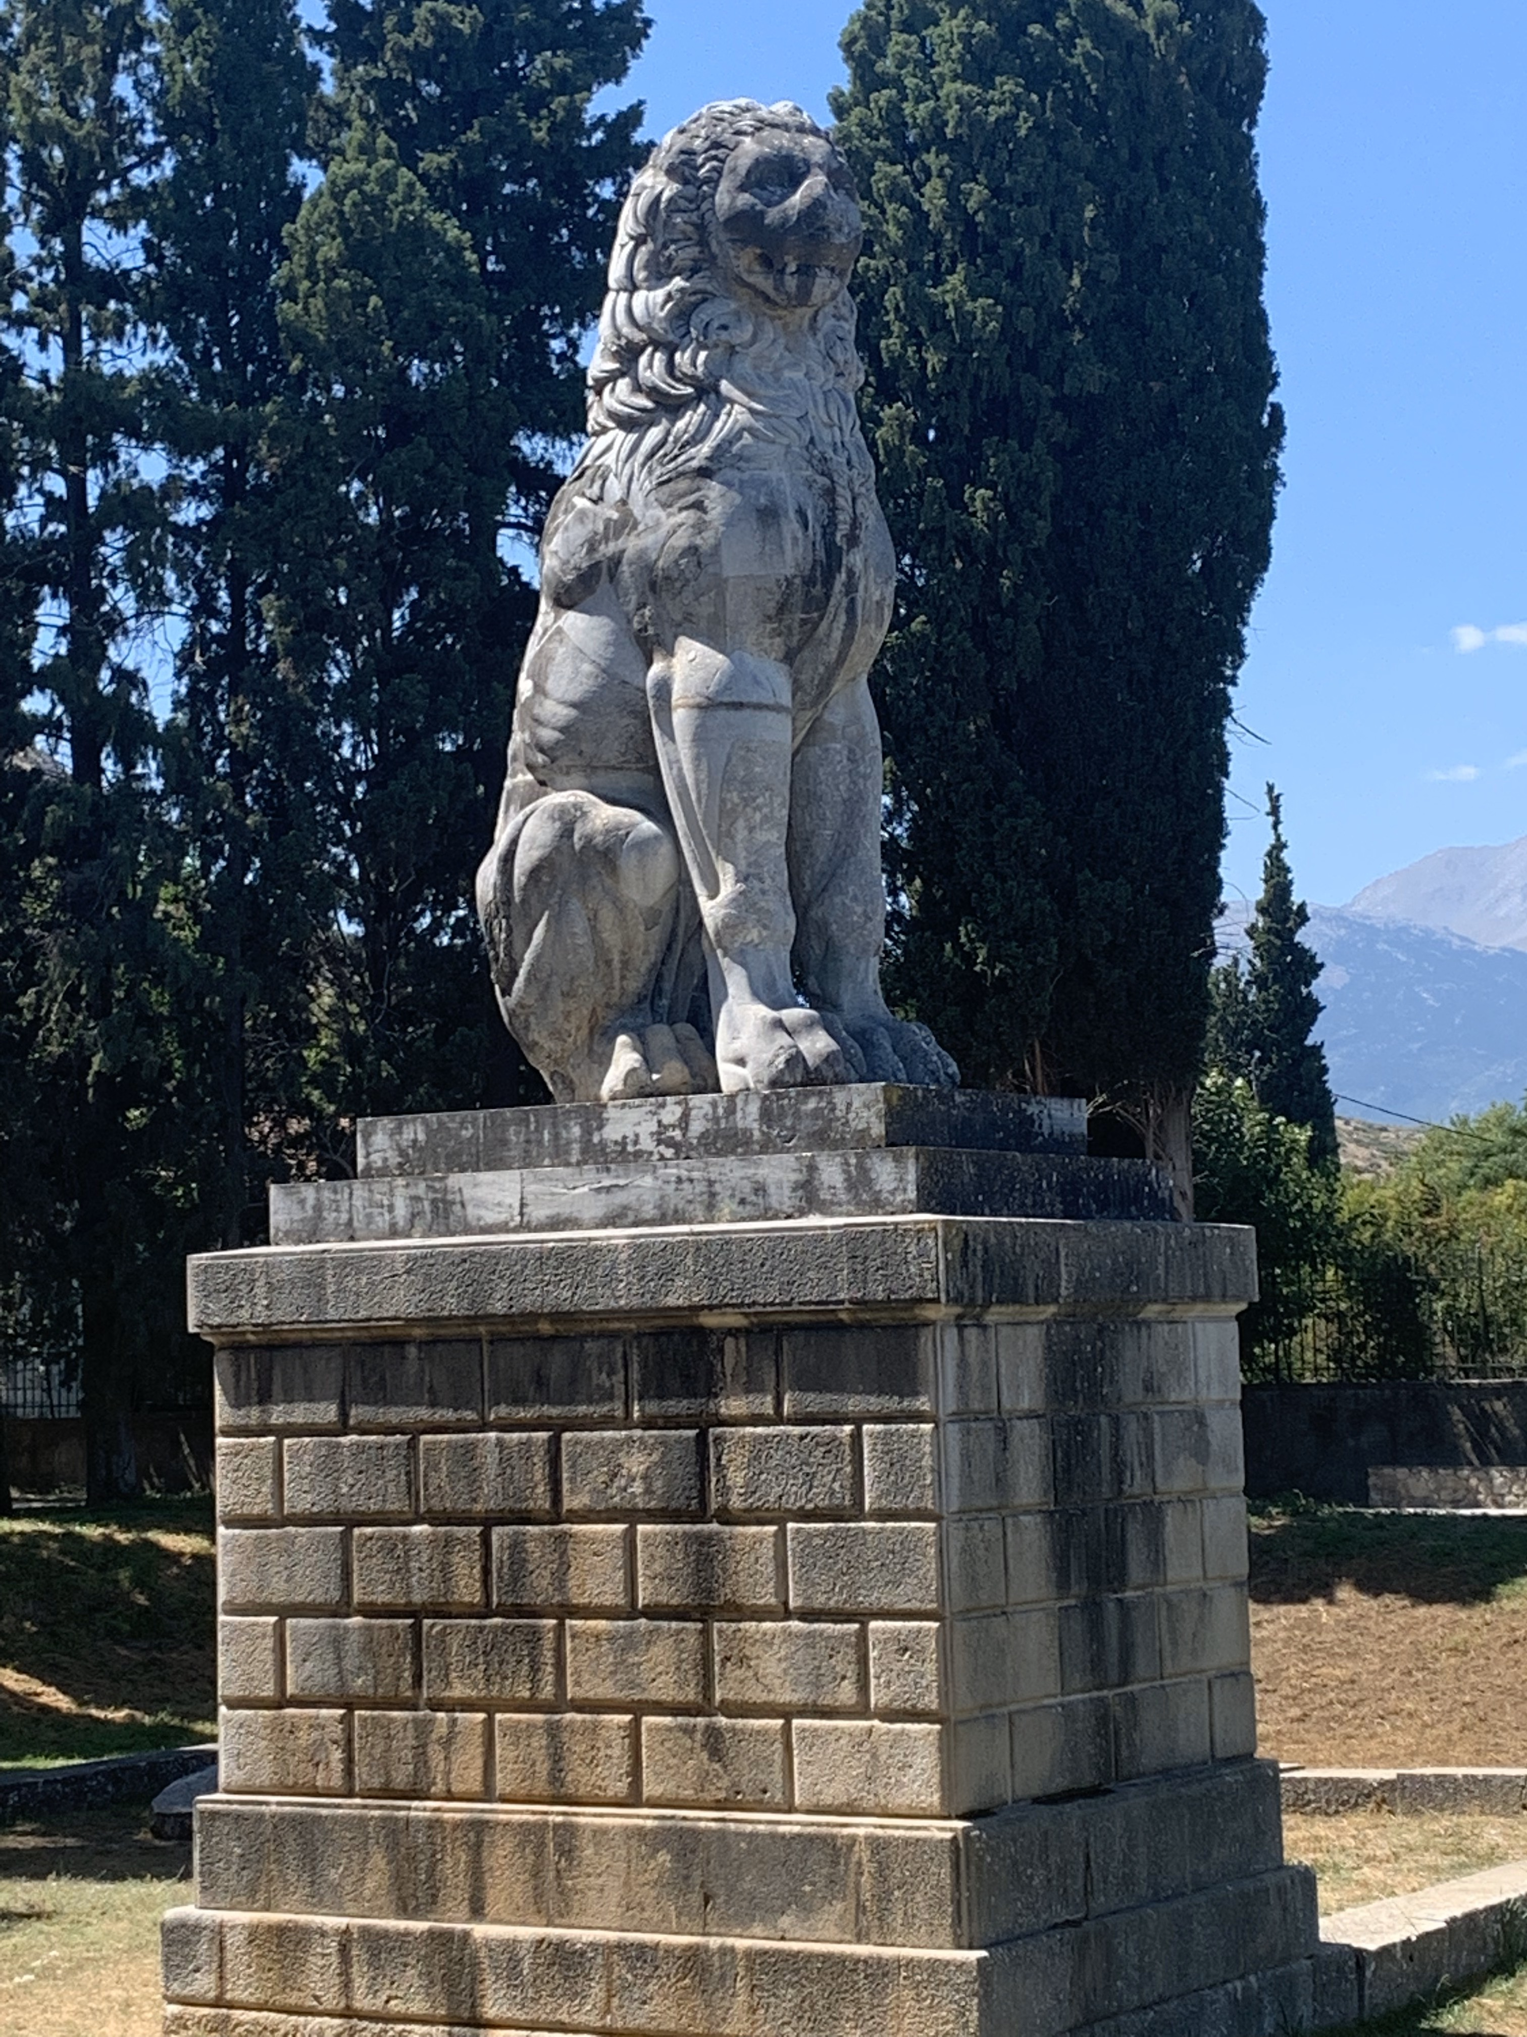
Bus to Athens.
(Overnighting in Athens)

Day Fourteen, 11/19
Guided visit to the Kerameikos archaeological site and accompanying museum.
Visit to the Benaki Museum (tentative).
Group dinner at a local taverna.
(Overnighting in Athens)

Day Fifteen, 11/20
Free day for independent activities.
Farewell dinner at a local taverna.

Day Sixteen, 11/21
Early morning bus to airport for flights departing from Athens.
As an Honors College course, Honors 237 promotes the following Student Learning Outcomes (SLOs). These Student Learning Outcomes (SLOs) emphasize ways of thinking, doing, and being.

Students who earn the Honors Interdisciplinary Studies Minor will have:

- experimented with unfamiliar modes of process, inquiry, thought, and dialogue by engaging with challenging, diverse materials in both textual and non-textual forms;
- engaged in a praxis of communication design;
- cultivated an appreciation for the generative potential of self-reflection, unlearning, and not-knowing, in part by undertaking willful acts of creativity, interdependence, and vulnerability in the classroom;
- acquired substantial knowledge of the ways that the methods, tools, and discourses of academic disciplines have been developed and deployed in a variety of historical periods and geographical locations, as well as by the individuals and communities within them;
- demonstrated fluency in the mobility of disciplinary-specific methods, tools, and discourses, especially in their generative potential when combined with the methods, tools, and discourses from other fields of inquiry;
- undertaken sustained, rigorous, and relevant work that integrates the methods, tools, and discourses of several academic disciplines;
- immersed themselves in a community of practice, thereby expanding their appreciation for the importance of self-reflection and accountability, ambiguity and complexity, contingency and difference;
- engaged in regular acts of service to the communities in which they are locally embedded: the Honors community, the broader campus community, and/or communities in Whatcom County; and
- deployed each of the above in everyday life.

