Starting Honors in Greece: Democracy’s Origin Story, Itinerary, Fall 2024

Tentative Itinerary, November 6th through November 21st
Day One, 11/6
Travel to Athens, Greece.

Day Two, 11/7
Arrival in Athens. Travel to accommodations.
Walking orientation of our neighborhood (Mets/Pangrati); Visiting the Athens Centre.
Welcome dinner at a traditional, local establishment (taverna).
(Overnighting in Athens)

Day Three, 11/8
Guided visit to the Athenian Acropolis, including the lower site.
(Overnighting in Athens)

Day Four, 11/9
Guided visit to the Acropolis Museum.
Walking orientation/tour to central Athens, including Plaka, Syntagma, and Monasteraki.
(Overnighting in Athens)

Day Five, 11/10
Bus leaves for Delphi.
Guided visit of the upper Delphi archaeological site.
Guided visit of the Delphi Museum.
Dinner and walking tour of Arachova (near Delphi).
(Overnighting in Delphi)

Day Six, 11/11
Guided visit to the lower Delphi archaeological site.
Bus leaves for Osios Loukas (Saint Luke) Monastery and Thebes.
Guided visits to Osios Loukas Monastery and Theban Archaeological Museum.
Bus returns to Athens.
(Overnighting in Athens)

Day Seven, 11/12
Visit to the National Archaeological Museum in Athens.
(Overnighting in Athens)

Day Eight, 11/13
Day trip by ferry to the island of Aegina.
Guided visit to the Temple of Aphaia.
Guided visit to the site of Kolona.
Ferry back to Piraeus in Athens.
(Overnighting in Athens)

Day Nine, 11/14
Free day for independent activities.
(Overnighting in Athens)

Day Ten, 11/15
Bus leaves for Corinth.
Guided visit to archaeological site of ancient Corinth and the accompanying museum.
Visit to the Akrocorinth.
Bus to Nauplion (a town in the Argolid).
Walking orientation to Nauplion.
(Overnighting in Nauplion)

Day Eleven, 11/16
Guided visit to the archaeological fortress site of Mycenae and accompanying museum.
Bus to modern Sparta.
Guided visit to archaeological sites in Sparta and/or the Byzantine site of Mistras.
(Overnighting in Githeon)

Day Twelve, 11/17
Bus to Pylos.
Guided visit to the Mycenaean archaeological site “Nestor’s Palace.”
Bus to Olympia.
Visit to the archaeological museum at Olympia.
(overnighting in Olympia)

Day Thirteen, 11/18
Guided visit to the archaeological site of ancient Olympia.
Bus to Athens.
(Overnighting in Athens)

Day Fourteen, 11/19
Guided visit to the Kerameikos archaeological site and accompanying museum.
Visit to the Benaki Museum (tentative).
Group dinner at a local taverna.
(Overnighting in Athens)

Day Fifteen, 11/20
Free day for independent activities.
Farewell dinner at a local taverna.

Day Sixteen, 11/21
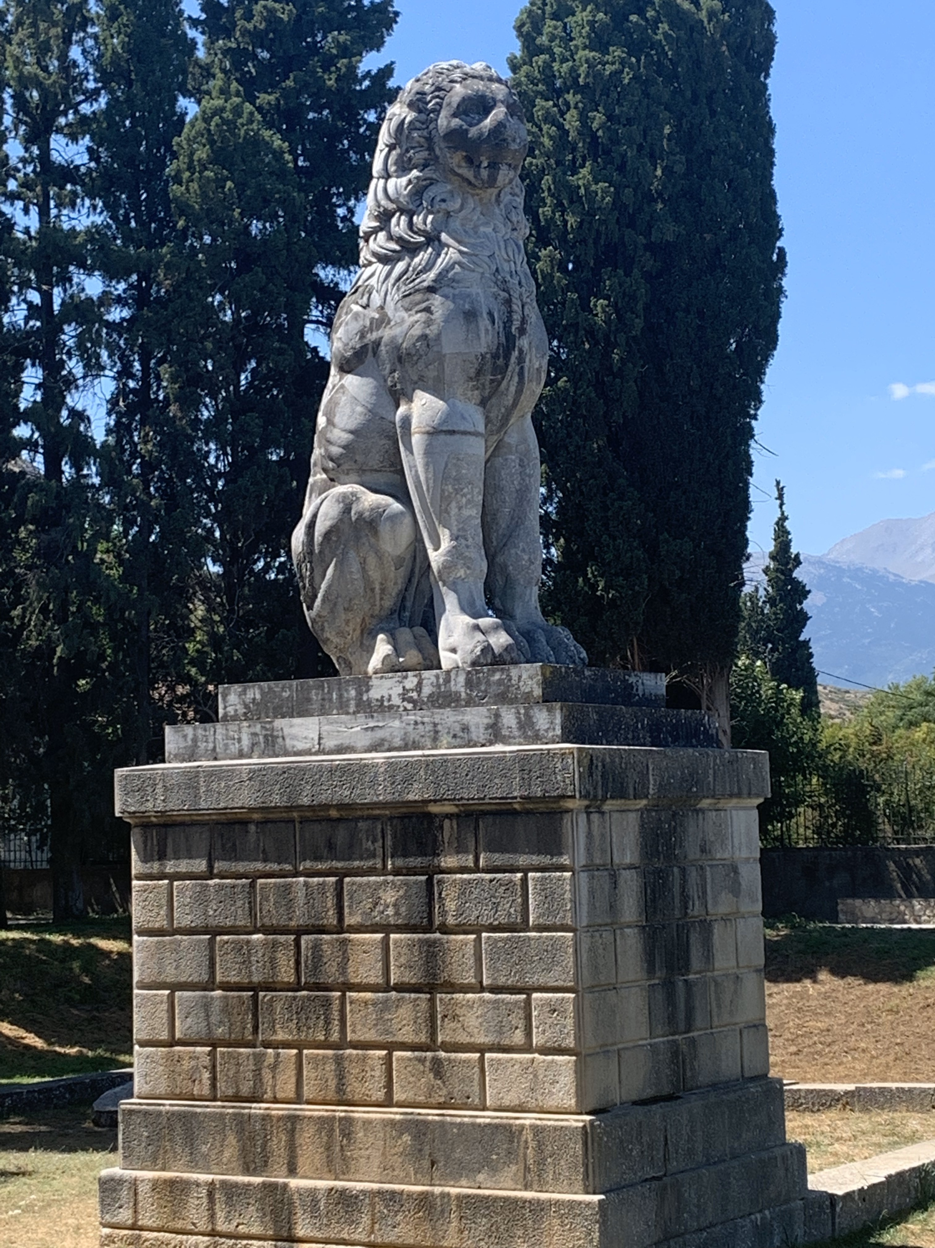
Early morning bus to airport for flights departing from Athens.

