Art History 337: Art and Visual Culture in Japan: Field Study, Fall 2023
MW, 2:30-4:20pm, FI 232
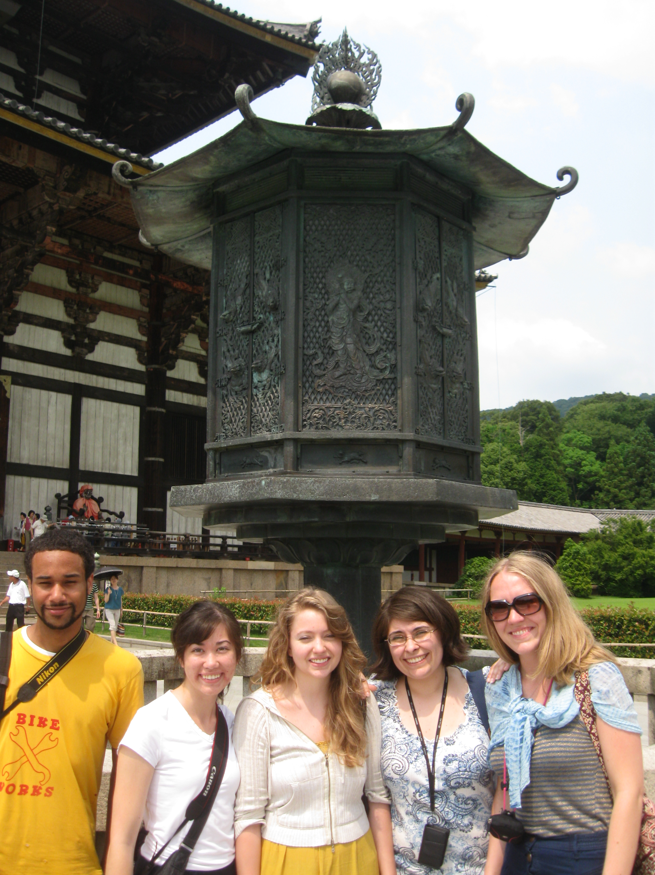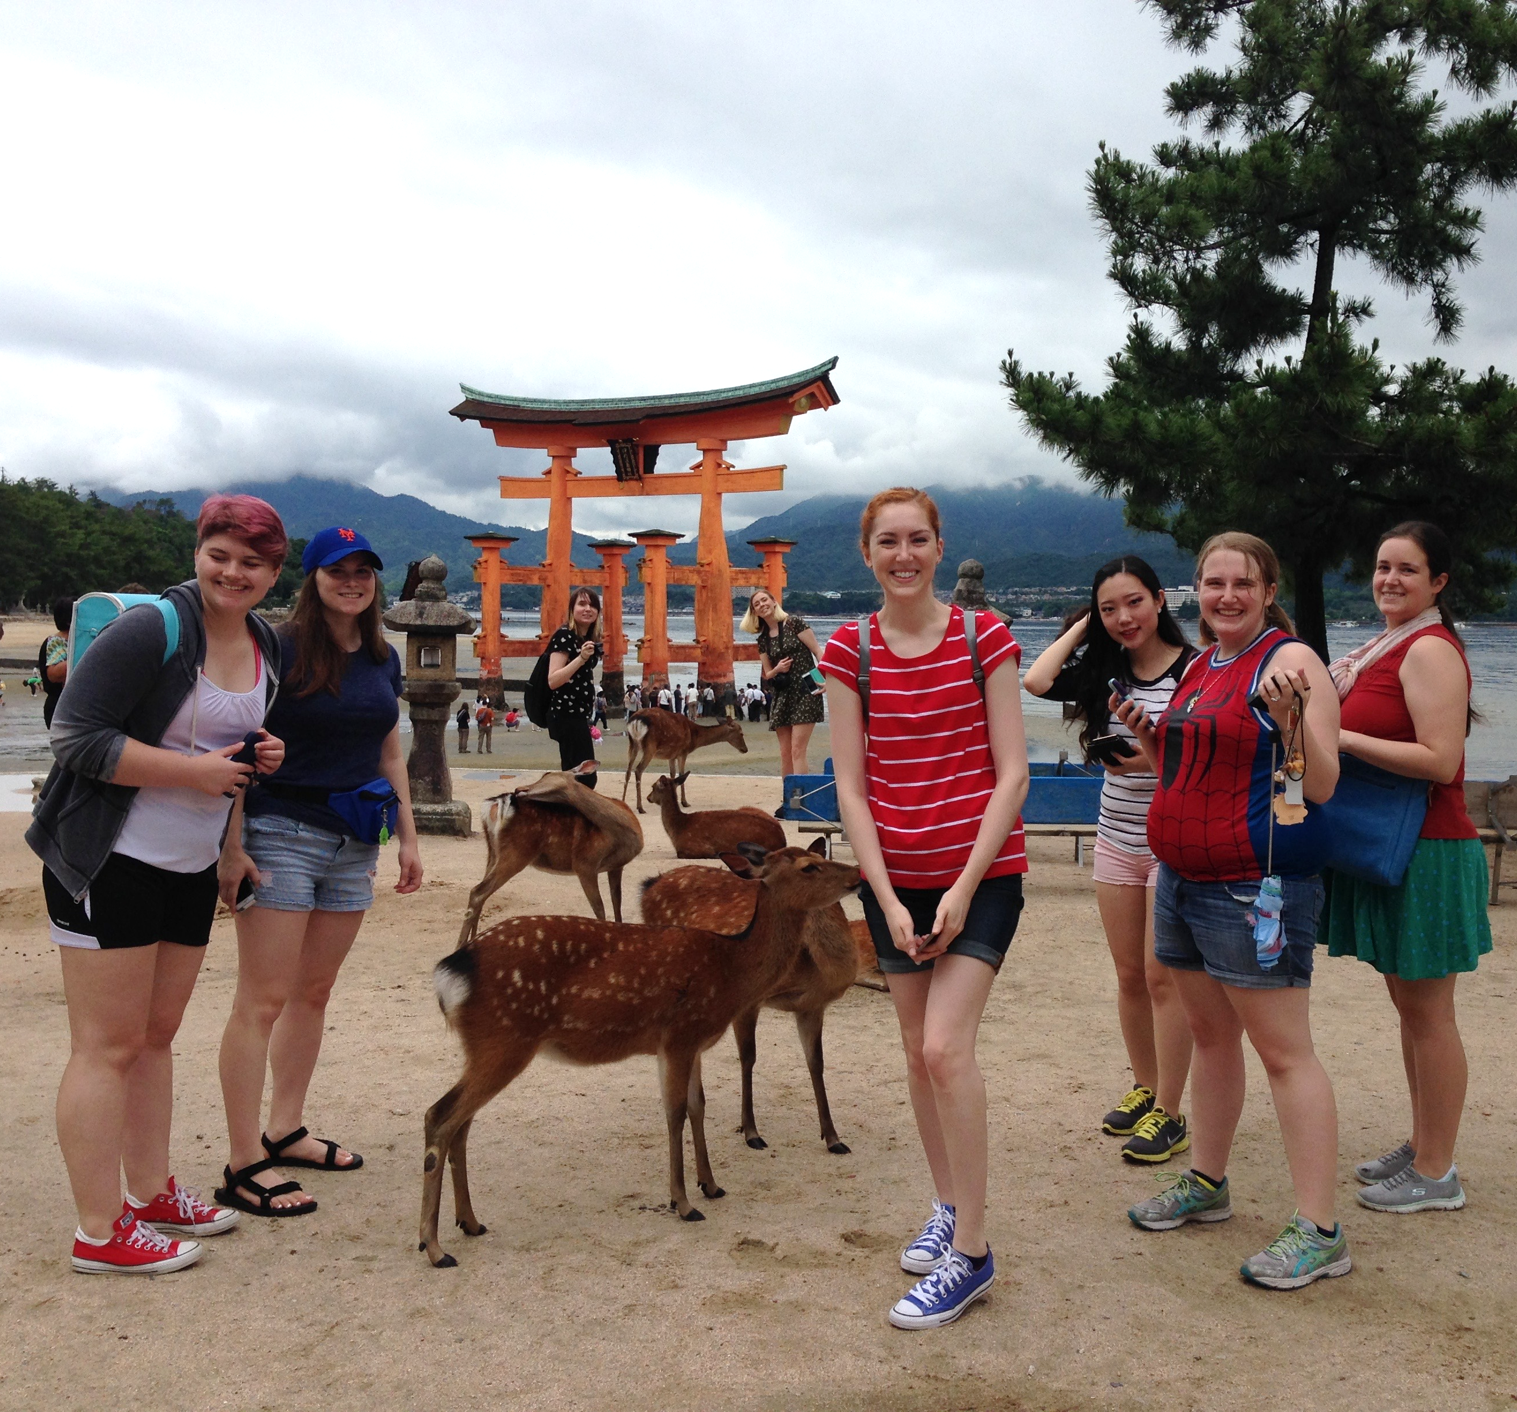
Todaiji Temple, Nara Itsukushima Shrine, Miyajima

Instructor:
Julia Sapin (julia.sapin@wwu.edu), 650-3670; Office hours: TR, 2:30-4pm and by appointment

Course Description:
This course offers an in-depth exploration of some of the prominent themes of Japanese visual culture, along with the opportunity to study them in situ. We will address subjects such as the combustion of different aesthetic currents, the impact of Buddhism on Japanese visual culture, new perceptions of Japan’s medieval military elite gained through conservatorial discoveries, art activism in Japan, and the construction of identity through the manipulation of the visual environment. The parameters of “Japanese-ness” are constantly shifting; studying the cultural sway between tradition and transformation is one way of coming to understand of those cultural shifts.

The on-site aspect of this course complements the in-class study. You will learn about both traditional and contemporary Japanese culture in Tokyo, Kyoto, Hiroshima, Miyajima, and Mount Koya. You will visit historical sites, galleries, artists’ studios, markets, museums, and department stores. You will also participate in natural dyeing, papermaking, and calligraphy workshops.

Student Learning Outcomes:
*Develop an understanding of Japanese visual culture, grounded in some of the specific interpretations that have shaped the field of Japanese art history
*Experience living (at least temporarily) outside your own culture
*Take in a wide variety of Japanese art and culture, from the tea ceremony to Harajuku fashion
*Have hands-on experience with Japanese art-making processes
*Explore you own individual interests in Japanese visual culture through investigation of particular topics
*Experience a Japanese university art and art history program (by visiting Kyoto Seika University)
Student Responsibilities:
*Students are required to attend all scheduled class meetings, lectures, museum visits, and studio tours while we are in Japan. Each missed event will result in a 5-point drop in the final grade.
*Students should arrive on time with the necessary materials for the event.
*Excessive late arrival will result in a loss of points: every late arrival will cost the student 5% of the total grade.
*Students are required to submit their artworks or writing assignments during finals week of fall quarter.

Participation:
*Participation in group discussions is mandatory.
*Traveling in a group will require cooperation, teamwork, and sensitivity to others. Therefore, students will be expected to be part of the class group more fully than in a normal class.

Reasonable Accommodation: It is the policy of Western Washington University to provide reasonable accommodation to the known physical, sensory, or mental limitations of qualified individuals except where such accommodation would impose undue hardship on the institution. To request accommodation, students must contact WWU disAbility Resources for Students at 360-650-3844 or www.drs.wwu.edu

Grading requirements for the course: Presentations: 20%
3 quizzes: 10% each, 30%
Journal 10%
Research toward artist statement: 20%
Attendance/Participation: 20%
Total: 100%

Required Readings:
Varley, Paul. Japanese Culture. 4th ed. Honolulu: University of Hawai’i Press, 2000.
Electronic readings available via Wilson Library (access via Canvas site, “Course Reserves” folder)

Grade scale:
376-400=A 336-351=B 296-311=C
360-375=A- 320-335=B- 280-295=C-
352-359=B+ 312-319=C+ 240-279=D 239 and below=F

*Plagiarism will not be tolerated. Please familiarize yourself with WWU’s Academic Honesty Policy: http://libguides.wwu.edu/plagiarism
Make-ups can be taken the day of the final, unless there is a verifiable excuse.

Lecture, discussion, and reading schedule:
Wednesday, September 26: Introduction

Varley pp. 91-163.
Website: http://www.columbia.edu/itc/ealac/V3613/ryoanji/ryoanji.htm
Article (1st journal entry due Sun., Sept 30): Onishi Hiroshi, “Immortals and Sages: Paintings from the Ryoanji Temple.” The Metropolitan Museum of Art Bulletin (Summer 1993), 3-47.

Weeks 4 and 5 (October 15-31): Nature Internalized: Architectural and Literary Moves
Quiz #1: due at the beginning of class, Oct 15
Quiz#2: due at the beginning of class, Oct 31
Calza: “An Intimate Perception of Reality,” pp. 156-177.
“Nature’s Magnificence,” pp. 190-205
Varley pp. 48-89.
Primary Source (for Wed., Oct 17): Murasaki Shikibu, “The Bell Cricket (Suzumushi),” in The Tale of Genji, trans. Edward G. Seidensticker (New York: Alfred A. Knopf, 1983), 668-675.
Website (1-24): http://www1.seattleartmuseum.org/exhibit/interactives/deerscroll/webSAM_deer.swf

Weeks 7-9 (November 1-22): Japan field study

Week 10 (November 26-28): research focus

Week 11 (Dec 3-5): The Art of Tea, Epitome of Japanese Culture
Calza: “Tea and the Aesthetics of the Undefined,” pp.14-31.
Varley pp. 271-351
Primary Source (for Tues., Dec 4): Okakura Kakuzō, “The Cup of Humanity,” from The Book
of Tea (Charles E. Tuttle Co., 1956), 3-17.

Quiz #3 and Research artist’s statement, due during Finals Week

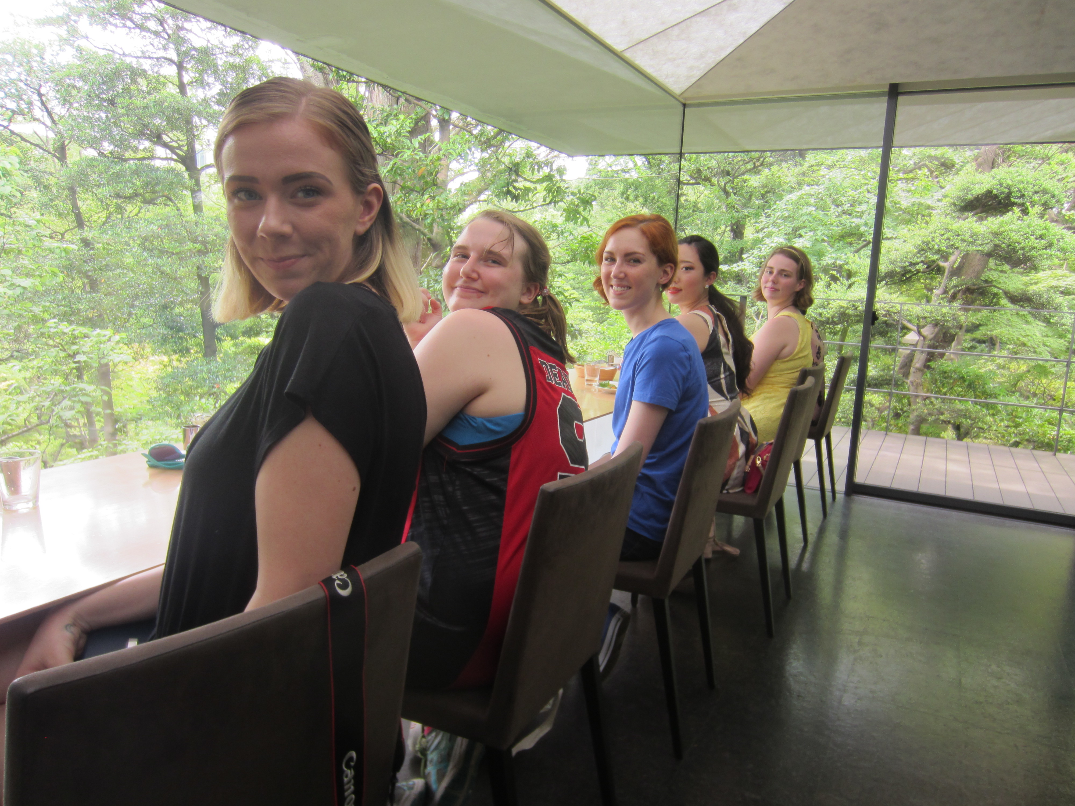
Kuma Kengō, Nezu Museum Café, Tokyo.

