ART 360 Fibers and Fabrics I
Fall 2023, T&TH 9-11:40am plus Japan trip

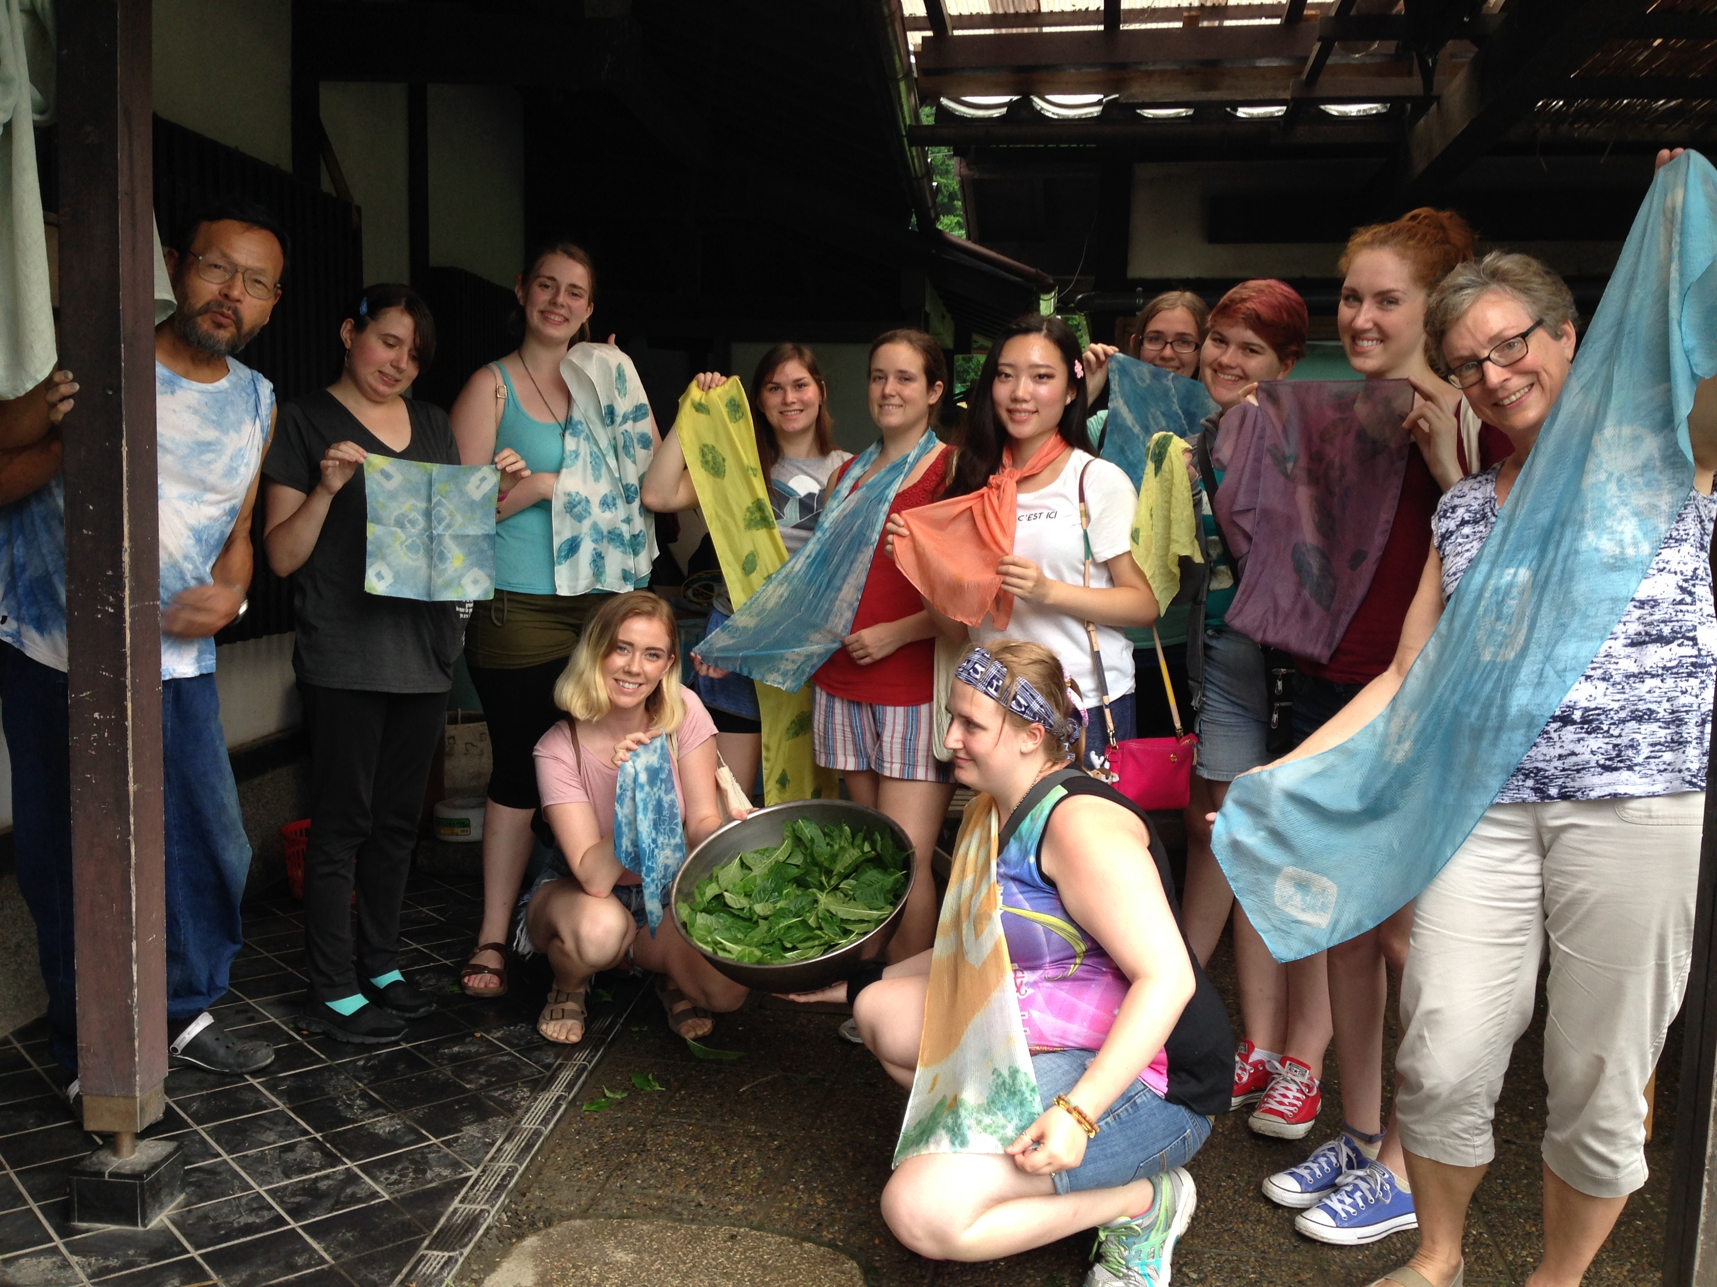
Seiko A. Purdue
Office: FI 226A
Office Hours: Mondays: 12-3pm
Tel: 360-650-4832
E-mail: Seiko.Purdue@wwu.edu

Linked with ART494 and AH337 through GLP

Course Description: This course is an introduction to technical explorations of dye application, fabric manipulation, and a three week field trip to Japan. The hands-on projects mainly involve resist dye techniques using professional materials and equipment. Integrating both Western and Eastern traditional techniques and aesthetics, students will develop their own ideas and skills. The on-site aspect of this course complements the in-class study. We will study various traditional and contemporary processes (Shibori and Katazome) before departure. Then we will understand these techniques at a deeper level through the experiences in Japan. The field trip introduces students to both traditional and contemporary Japanese culture in Tokyo, Kyoto, Hiroshima, and Miyajima. Students will visit historical sites, galleries, artists’ studios, markets, museums, and department stores. They will also participate in natural dyeing and visit a calligraphy workshop.

Schedule:
9/28 TH Class Introduction: What is fiber, textile?, Viewing visual examples
10/ 3 T Introduction of Dyes: Immersion Dyeing with Procion MX
10/ 5 TH Tie Dye (sample making), Viewing visual examples
10/10 T Tie Dye, Contemporary Shibori
10/12 TH Tie Dye: work day, Katazome introduction
10/17 T Critique: Tie Dye project
10/19 TH Katazome demo (Design making, Paste making & application)
10/24 T Katazome demo (Color application, Viewing sample images),
10/26 TH Katazome demo (Color application, Viewing sample images)
10/31 T Due: Katazome 1
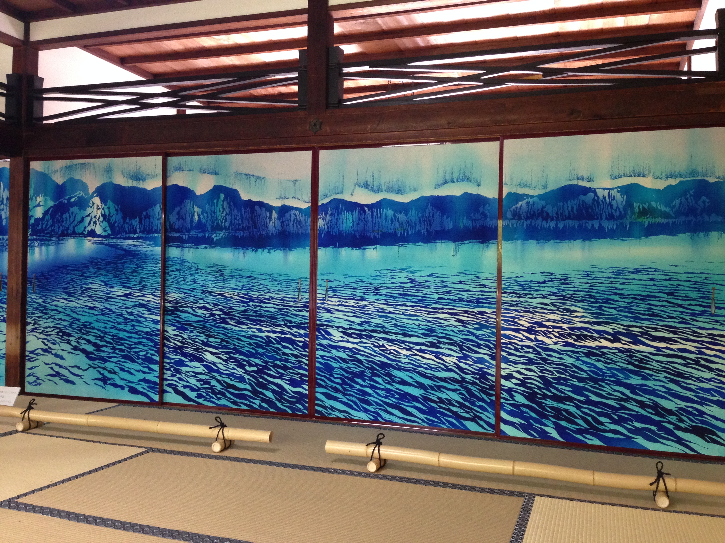

11/ 2 TH Leave for Japan (21 days)
11/ 7 T Japan
11/ 9 TH Japan
11/14 T Japan
11/16 TH Japan
11/21 T Return to the US
11/23 TH Thanksgiving Break
11/27 T Final project: Katazome 2, paste-making
11/29 TH No class, Final project: Katazome 2
12/ 4 T No class, Final project: Katazome 2
12/ 6 TH No class, Final project: Katazome 2
12/11 T Critique: Final project: Katazome 2

Course Requirements:
1. Assignments will require you to work outside of scheduled class time. There is class time scheduled for you to work on projects. You must work in class on
those days. Refer to the supplemental handout for each project.
2. Research class projects to a deeper level using books, slides, catalogues, magazines, and the internet. It is important to explore actual sites, such as visiting fabric stores, libraries, galleries and museums. Try to find personal connections to the projects, then share those with other people. Keep a journal all the time.
3. You can use phones/computers for research, music (during the working time) and as a part of the artwork (technology). Checking cellphones during the critiques is absolutely not allowed.
4. Your participation in all aspects of this class is expected. You should use extra time to experiment for understanding new techniques, materials, tools and facilities. It is important to understand basic techniques in order to develop new ideas. Try to find uses for new materials and methods in your daily life.

Participation:
Lectures and project demonstrations will not be repeated for absent or tardy students. If you miss five class periods you will receive a grade of “Z” for non-attendance. Late projects will have a grade level deducted from them for each day they are late. If you are sick please call and leave a message. 2 unexcused absence may constitute one grade drop. Come fully prepared to the next class. Missing a critique is the equivalent of missing an exam. Traveling in a group will require cooperation, teamwork, and sensitivity to others. Therefore, students will be expected to be part of the class group more fully than in a normal class.

Student Expectations:
1. Be original; Create work that we have never seen before.
2. Think and work more than what you think I am asking for.
3. Get excited about what you are doing and make connections to your other experiences.
4. Try to know the historical background of each theme and respect traditional techniques; then, integrate your contemporary idea.
5. Develop your creativity towards art.
6. Challenge yourself technically and aesthetically.
7. Question yourself and any steps so that you understand why the process is necessary. Engage in wonder.
8. Ask questions when you don’t understand something. You will also be expected to ask for help as needed during the individual project class periods.
9. Enjoy the class with other people. Give comments & suggestions during the critiques.
10. Don’t be afraid of making mistakes. They may lead to successes.
11. Respect other people’s work and the facility, and keep working spaces clean.
12. Take a quick workshop for sewing machine access in the lab.
13. Check Canvas and Email often.
14. No texting or cell phone use during the class discussion, critiques and lectures.
15. Please follow all university guidelines regarding COVID: https://www.wwu.edu/coronavirus

Assignments & Grading: total 300 points
- Shibori (tie dye samples) and one big project(50)
- Katazome (Japanese rice paste resist printing) (60)
Two pieces (18” x 22” and 24”x72”) of the main Katazome design
- Field trip to Japan (21days)
Participation (120)
Tie dyeing at Ohara Kobo (20)
- Final Project after trip (50)
The ART360 final project is the large piece of katazome 2.

Grade:
Each project will be evaluated based on these criteria.
Exploration of material and technique:  (20%) | Successful relationship of forms:  (20%) | Concept and Originality:  (20%) | Presentation  and craftsmanship:  (20%) | Participation (attendance and voice):  (20%) | Total points:  (100%)  Grade:

Final course grades will be assessed according to the following departmental scale: A=94-100%, A- =90-93%, B+=88-89%, B=84-87%, B-=80-83%, C+=78-79%, C=74-77%, C-=70-73%, D=60-69%, F=59% and below.
A: Outstanding work. Highest level of quality and effort contributed.
A-: Excellent work. Extra effort contributed.
B+: Good Work.
B: Average work. Adequately does required work.
B-: Average work. Contributes less effort than is expected.
C: Poor

Student Learning Outcomes:
-Understand the design principals using resist techniques and dyes.
-Understand the traditional techniques and historical background.
-Developing your own artwork integrating your own idea.
-To expose you to a wide variety of Japanese art and culture, from the tea ceremony to fashion.
-To have hands-on experience with Japanese art-making processes
-To give you the opportunity to explore your own individual interests in Japanese visual culture
-To introduce a Japanese university art program (by visiting Kyoto Seika University).

Reasonable accommodation for persons with documented disabilities should be established within the first week of the class and arranged through Disability Resources for Students: 650-3083 (phone), drs@wwu.edu, Student Health Center: 650-3400, University Police: 650-3555

Material list: sketchbook, pencil, rubber gloves, sharp scissors, tape measure, sewing needles, seam ripper, tapestry needles, sewing thread (thick cotton, for quilting), masking tape, X-acto knife (with#11 blade), cutting mat (8“x11“), apron, and fabrics: cotton, muslin, rayon, silk, hemp etc.

Lab Fee: The lab fee is included in the GLP fee.

Basic Reference:
Textiles, Mary Schoeser
Techno Textiles 2, Sarah E Braddock Clarke, Marie O’Mahony
Textiles Today, Chloe Colchester
Scraps, Fashion Textiles, and Creative Reuse, Cooper Hewitt
Surface Design for Fabric, Richard M. Proctor and Jennifer F. Lew.
Memory on Cloth, Yoshiko Wada
Shibori: The inventive Art of Japanese Shaped Resist Dyeing
Yoshiko Wada, Mary K. Rice, Jane Barton
Shibori for Textile Artists, Janice Gunner
Some o Manabu, Kyotozokei Art University
Weaving, Shirley E. Held

Magazines:
Surface Design (http://www.surfacedesign.org/)
Textile: the Journal of cloth and culture
Selvedge (http://www.selvedge.org/)
American Craft, Handwoven, Spin-Off, Mixed Media, Sculpture
Shuttle Spindle Dyepot, Textile Museum Journal, Fiberarts

Supply Sources:
Pro Chemical & Dye MA, www.prochemical.com, 1-800-228-9393
Dharma Trading Co. CA, www.dharmatrading.com, 1-800-542-5227
John Marshall (Asian supplies in CA), www.johnmarshall.to, 707-983-6636
Kakishibui (Stencil paper), http://www.kakishibui.com/
Maiwa Handprints Ltd. (Granville Isl. BC) www.maiwa.com, 604-669-3939
Jo-ann Fabrics and Crafts: Sunset Square, 360-734-8922
Northwest Handspun Yarns, 1401 Commercial St, 360-738-0167
Social Fabric, 1302 Commercial St, www.socialfabricart.com
Ragfinery, 1421 N. Forest St, www.ragfinery.com, 360-738-6977
Foundry, 1000 F Street, www.bellinghamfoundry.com

