ART 394 ARTS OF ITALY Fall 2024
3 linked classes
Art 394, 5 credits, Art 494 5 credits, Art 355 5 credits •
Travel Dates Depart Oct. 18, Return November 14
• Prof. Cara Jaye cara.jaye@wwu.edu • Assist. Prof. Sasha Petrenko petrena2@wwu.edu

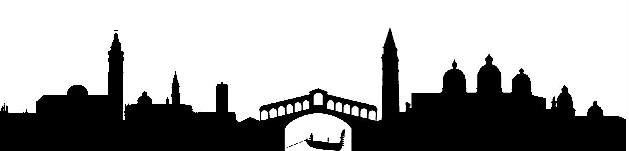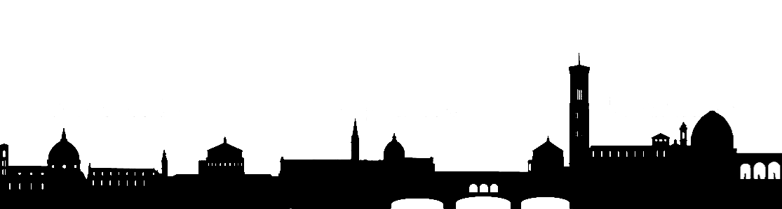

FLORENCE TUSCANY VENICE

Arts of Italy is an intensive course that takes place in Central and Northern Italy. In this class we will
explore Italian art and culture focusing on the arts and architecture in Florence, Tuscany, and
Venice. We will cover art from ancient through early modernity to contemporary.

Students will engage in visual exploration and creative problem solving through a variety of media, tools, and techniques. The class emphasizes drawing, photography, mixed media on paper, sound and video, and other portable methods of art making while traveling. Students are encouraged to keep an open mind as to the possibilities in solving the problems of Art 394 and are expected to challenge themselves.

Office Hours: By appointment
Prerequisites & Notes: Major, Senior or Over-ride status
Grade Mode: Letter

PARTICIPATION AND ATTENDANCE in this course is mandatory. You are required to participate
and be on time with the required materials for every class. Each person is accountable for their assignments and materials and must be able to carry or transport their own belongings. More than two unexcused absences will lower your grade by a full letter grade. Six absences for any reason will result in a failing grade. Excessive lateness, early departures, and lack of being prepared will be counted as
absences.

GRADING: Your grade will be determined by the quality of your work, attendance, determination, progress, and
participation in class discussions.
A - excellent work, strong in all areas, advancing consistently both formally and creatively.
B - good work, knowledge of the principles, assignments well executed
C - competent work, average output, and a basic understanding of the principles.
D - poor work, effort, and attendance, a lack of creative or technical skill.
F - lack of understanding, and/or a failure to complete the required work.

GRADING SCALE: 94 - 100 % A, 90 - 93 A-, 87 - 89 B+, 84 - 86 B, 80 - 83 B-, 77 - 79 C+, 74 - 76 C,
70 - 73 C-, 67 - 69 D+, 64 - 66 D, 60 - 63 D-, below 60 % F

STUDENT LEARNING OUTCOMES:
• To gain global awareness with emphasis on Italian art and culture.
• To understand art in relation to social, political, cultural, and historical developments.
• To offer an insight into the historical creation of contemporary values.
• To interpret visual experiences from diverse perspectives, analyzing ideas and assumptions.
• To improve abilities and skills in visual art making.
•To develop the creative thought process through research, exposure, and dialog.
• To develop a group of individual and progressively complex art works.
•To develop strong research skills in the context of your own creative practice.
•To present visual information in an intelligent, coherent, and balanced way.

ACADEMIC MISCONDUCT: Students are reminded that academic misconduct is a violation of the code of
student conduct. Academic integrity is demanded, and academic dishonesty at Western Washington
University is a serious infraction dealt with severely. No student shall claim as his or her own, the
achievements, work or arguments of others. At Western Washington University, misconduct in research
and scholarship is defined as: The intentional fabrication or falsification of data, research procedures, or
data analysis; plagiarism; or other fraudulent activities in proposing, conducting, reporting, or reviewing
research. You have to cite anytime you take ideas from someone else, not just his or her language.

If you may need an accommodation based on the impact of a disability please contact disAbility Resources at www.wwu.edu/drs or stop by Old Main 120.

COURSE ASSIGNMENTS

Canvas assignments and pre-departure responses (10%)
In preparation for the course there will be a selection of videos and readings that you will need to review on Canvas, and respond to accordingly. These are all due in the weeks before we depart for Rome.

Journal / Sketchbook roughly 6” x 9” (10%)
• Use your sketchbook for drawing and as a way of absorbing and recording what you are experiencing. You should make a minimum of one drawing a day. Although some of your recording will be done with photography, drawing is a deeper type of visual recording. Drawings may include collage, photomontage with drawing, or other mixed media pieces. You may also use the sketchbook as a journal or written log of your journey, in addition to the Digital Journal/Blog (below).

Digital Journal/Blog (10%)
A written and visual log of the journey. You will be regularly prompted to respond to questions, thoughts and ideas through the course of our travels. Additionally, you may make entries in the blog including what you saw during the day, descriptions of encounters, experiences and observations. The class blog will naturally accommodate photographs, videos, and images from your sketchbook that you would like to share. Remember to tag your post with your name, and clearly state where you are, and if you are citing an art work who created the piece.

Studio Assignments:
THEMATIC PROJECT ONE: Mapping the City, A Project in Four Parts (30%)

Part One: Memory Map
The Centro Storico, in which our hotel is located, is centuries old and made up of a maze of small streets. You should take a map with you when you go out and try to be aware where you are – it is easy to get lost but very possible to find your way back with a map.

After you get to know the area a bit, make a drawing of the area as you remember it in your head. DO NOT use a map or your phone to make the drawing. Include landmarks you have become familiar with in the area. You may expand it to include other parts of the city, but do not check a map for accuracy until you have finished the drawing. Include in your drawing: images, experiences, feelings, etc. You may choose to include other elements such as perceived distance between landmarks, a hierarchy of places and spaces as designated by larger or more ornate embellishment, a key, or color-coded areas. Your map could function as a tool that could be used by yourself or another to re-trace your steps, memories, moods and/or experiences. It could be a recollection of events; you might include places to avoid and must-see places, recommendations, or encounters you had at various points in time. Color coding and measurements can be important elements of the map. You may ask yourself other questions such as: Where will the center be? What are the edges or borders? Are there congested areas where a lot of things occurred? Are there dull, boring parts? Is there a hierarchy? What is the top part of the map? How do you get from one part to the next? Is there an order and is it obvious? What is the best way to get there and are there other paths? Think about the symbols you know, include symbols you are seeing here in Rome, such as the SPQR symbol and where this seems to occur. You may need to research some symbols and you may want to create your own.

You can use simple materials such as pen or pencil, or you might use mixed media in various combinations to create your map. Consider collage, markers, ink, paint, tape, staples, various papers, string, anything that seems applicable or relevant.

• Look at the Peutinger Table online – link in Canvas

Part Two: Grid and Perspective – on site in Florence and Tuscany
One of the hallmarks of Renaissance Art is the development of perspective in painting – the ability to show space and depth in two-dimensional works. You will get to see many defining examples of this in person, such as Masolinos’ St. Peter Healing a Cripple at the Brancacci Chapel in Florence, or the Annunciation by Fra Angelico in the San Marco Museum.

When moving around these cities, notice the street-level design of an area in Florence, Siena, or Prato. Situate yourself either lined up with the grid (one-point perspective) or at an angle to the grid (two-point perspective) and make 3-4 sketches in your sketchbook. Using sighting to correct angles and sizes, make freehand perspective drawings of your subject. With each sketch, take notes on color, design, and also experiences, people, encounters, feelings, the weather, or even food etc., at each site. You may also want to take photographs from where you are sitting. These sketches should take about 30-60 minutes each.

In the studio you will have more time to work on these visual responses. You might choose to elaborate on one of these sketches to make a longer drawing with ink, collage, watercolor washes or other material. Later, incorporate some of the details that reflect on your personal experiences at the site. You may add text, drawing, collage elements, or zoomed-in details to expand upon the drawing.

Part Three: Assemblage City – on site in Venice
Urban organization in Venice is forced into the compressed space of islands. Over centuries the architecture of the city, reflecting an eclectic cosmopolitan trading center, was layered over sinking layers.

“The Venetian eye … was an eye that appreciated the visual complexity of the pastiche – the collage-like assemblage of ‘borrowed’ fragments.” (Art and Life in Renaissance Venice)

The first part of this project will take place throughout the trip. You will build a collection of found and gathered materials along the journey, from small pieces of paper (wrappings, packaging, newspaper, receipts, etc.) to other small objects. Think of these materials as information from another place, like evidence from another planet. You might want to trade and swap some of these materials with other people in the group to enhance your collection.

From your collection you are to construct a mixed media work that includes the items collected. In this work you will introduce a new structure that both displays and re-contextualizes all the items in the collection. This new map/city/place contains links to the past from where the objects came from, – but re-sites them in your new location. Consider the framework of the map as a viable option, but also other means of organizing such as: gardens, altarpieces, reliquaries, tapestries, architectural adornment, etc. Consider texture, color and ornament. Think about strategies for indicating significance: the differences between focal and subsidiary, precious and ordinary, sacred and profane, old and new.

The first three parts of the project will be reviewed at critiques in stages along the trip.

Part Four: Consolidation

When you return home, you will organize and combine the three parts of this project to investigate, compare, and contrast the different encounters of a city they express. The earlier parts of this project will become one large composite work – or you may use some elements from 1, 2, or 3, but not necessarily all, in this final version. You may need to remake or reconfigure earlier elements onto another surface or surfaces in order to unify the components into a cohesive whole.

Various formats or templates may be utilized: for example a triptych, the book, layers, fold-out, pop-up, doors and windows, grid-based serial format, containers, 3-d elements, installation, floor maps, sculpture etc. Consider how the information changes depending on different visual approaches and organizing systems. Use text to reflect on order, disorder, and your experience of space.

Thematic Project Two: The Mythic Figure (15%)

Roman and Greek Mythology have been a driving force of inspiration and creativity for artists throughout the millennia. In the 14th and 15th Century classical myths provided a great source of inspiration, freedom and creativity for artists. We will see a great number of stand-out works that provide similar context for this prompt. Renaissance paintings and sculptures of classical mythology were created for the salons in the houses of private patrons. For example, Botticelli painted the Birth of Venus for the Medici. In the myth the Goddess Venus rises naked from the sea. In this way, Botticelli is able to explore the nude figure not as a central theme, but as justification for as a central part of the story.

Modern and contemporary artists similarly mine these stories to examine human suffering, love, mystery and tragedy. These ancient stories reflect not only the original source of the myth, but also a modern context for the artists’ time and locale. For example, Fabrice Montiero’s figure rises from the sea similar to Botticelli’s Venus. However, in this context the work speaks of environmental degradation on the Senegalese coast, and on a global scale.

Your project is to make an artwork that relates a myth and corresponding art work that we see on this trip to contemporary life. Think about the story, and how it could be updated and re-staged in a different place, in our own time, with similar but more contemporary issues, problems, elements and details.

It is recommended that you select either a figure from Roman and Greek Mythology, or a specific myth before we travel to Italy. Once you have selected your figure or myth, do outside research to gain understanding with more depth. What was the purpose of the myth for the people at that time? What were the lessons taught within this unique story? How did the different versions of each story operate to serve different populations? By doing this, the site-specific research that you do in your travels will be richer and more manageable in reference to this particular assignment.

Read: Myth in Art part 1, 2 and 3 in Canvas before departure in preparation for this project

Thematic Project Three: The Stranger and the Journey: Outsider Stories (15%)

Travel is a primary source of the ‘new’ in history. The displacements of the journey create exotica (‘matter out of place’) and rarities, as well as generating that peculiar species of social being of unknown identity – the stranger.

While you are in Italy you will have encounters with people that make you realize that you are a stranger, the outsider and, in particular, the American. People will make assumptions about you based on a host of beliefs that you have no control of, and may be far from you're your own beliefs and lifestyle. Foreign travel – full of experiences of the strange and new – also allows us to see ourselves in a new way. We become stereotypes for good or ill, exotic and rare, or banal and irritating. We may realize that we are more or less interesting, nice, smart, rich, attractive or powerful than we thought we were.

For this project you will create a multi-frame group of works on paper with the central character of yourself as the stranger. This could take the form of a storyboard, cartoon strip, book pages, a cartoon for a painting cycle (as in frescoes), or separate pieces representing successive moments. You may use any media including drawing with or without color, collage, photography, video, painting or sculpture for this project. Just remember that you are supposed to show a narrative sequence in whichever format you choose.

Breakdown of Grade Evaluation
10% Canvas Responses and Pre-departure activities
10% Sketchbook/journal
10% Digital Journal/Blog
20% Mapping the City – A Project in Four Parts
15% The Mythic Figure
15% Stranger and the Journey
20% Overall Participation: includes lectures, critiques, discussions and exercises

Materials List for Art Workshop in Italy – 2024 Jaye

Paper 2 commercial sketchbooks: 1 small (about 4”x6”)
1 medium size (about 8” x 10”)
Optional: 1 “prepared” sketchbook with a variety of papers
or a roll or folded bundle of drawing paper for larger work when possible

pencils a good selection including colored pencils or pastel pencils

pastels a small set of individual colors, about 8-16

paint watercolor, gouache, or small tubes of acrylic paint

brushes assorted sizes and styles, packed in a small brush holder

markers fine and medium line black markers

gesso small jar (optional)

clear acrylic medium- small jar (optional)

pva or other glue: for collage, small jar

masking tape - wide

small pair of scissors and/or xacto knife – (must be packed in “checked luggage”)

erasers kneadable, white plastic, and clic type

charcoal pencils – various hardnesses, about 6

glue stick

*Pack everything in large gallon size Zip Lock bags. This will all go in your checked luggage.

**Emphasis on: small size, fold up kits, and a variety of materials that you like to use, and might be willing to swap and share with others in the class.

***Small quantities of glue, acrylic medium, etc. pack and store well in containers.

****There are art supply stores in Rome, Florence and Venice, so you will be able to purchase many things there. This can be great fun!

*****Do not travel with flammables (mineral spirits, combustible paints, etc.) You can purchase these items in Italy if you have to have them.

