Biocultural Diversity in Nepal
Fall 2024 Field Program in the Nepal Himalayas

ESCI 437 – 15 credits
ITINERARY
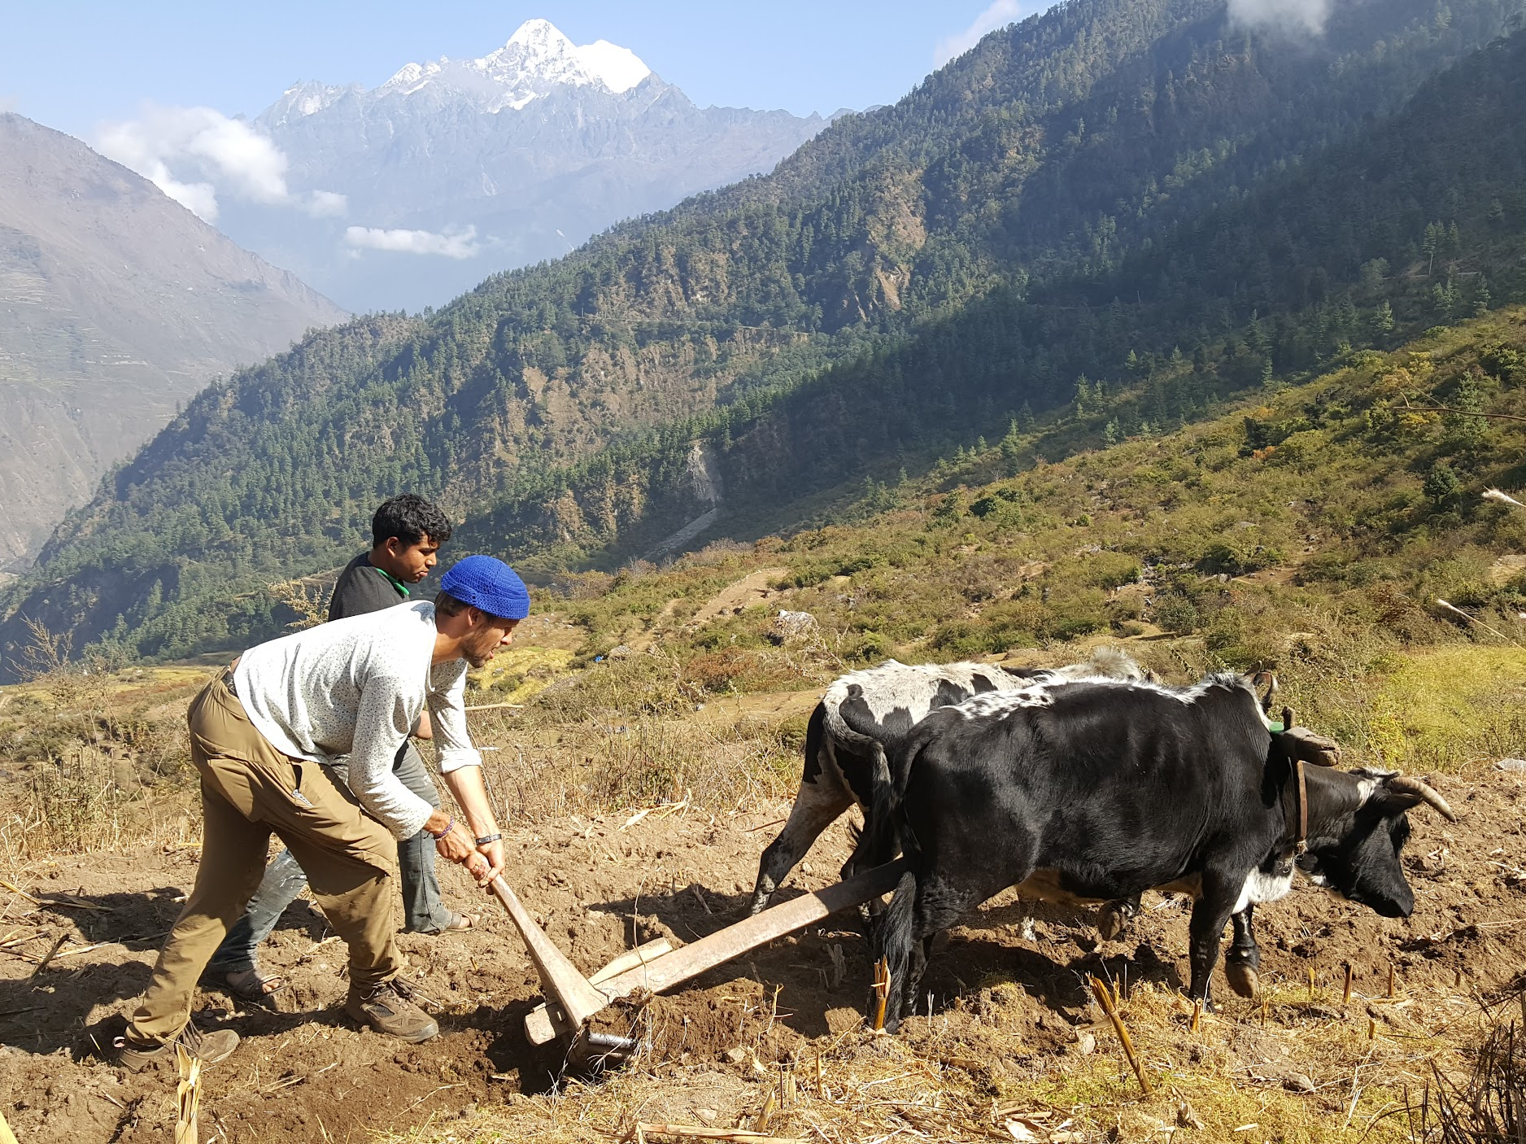
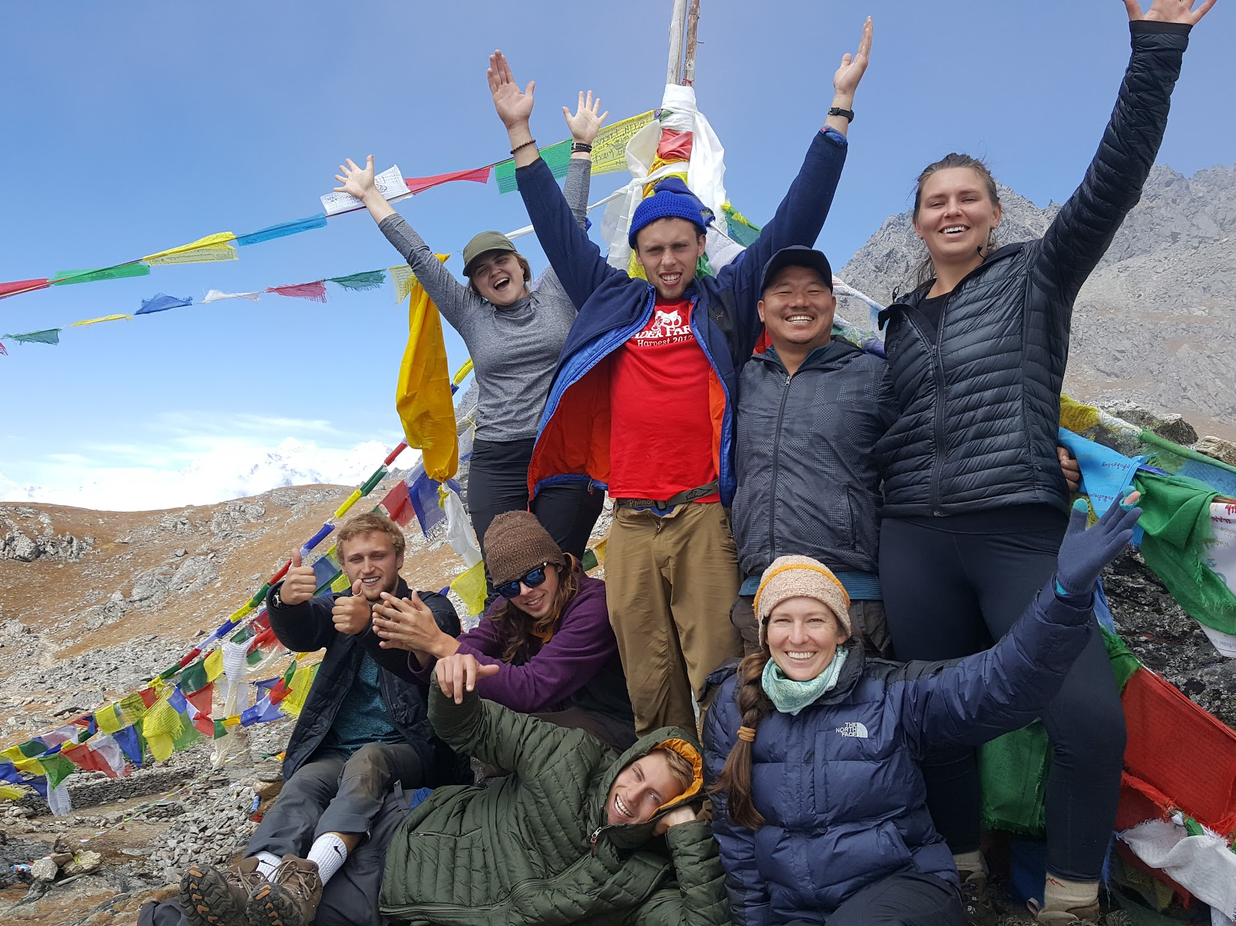
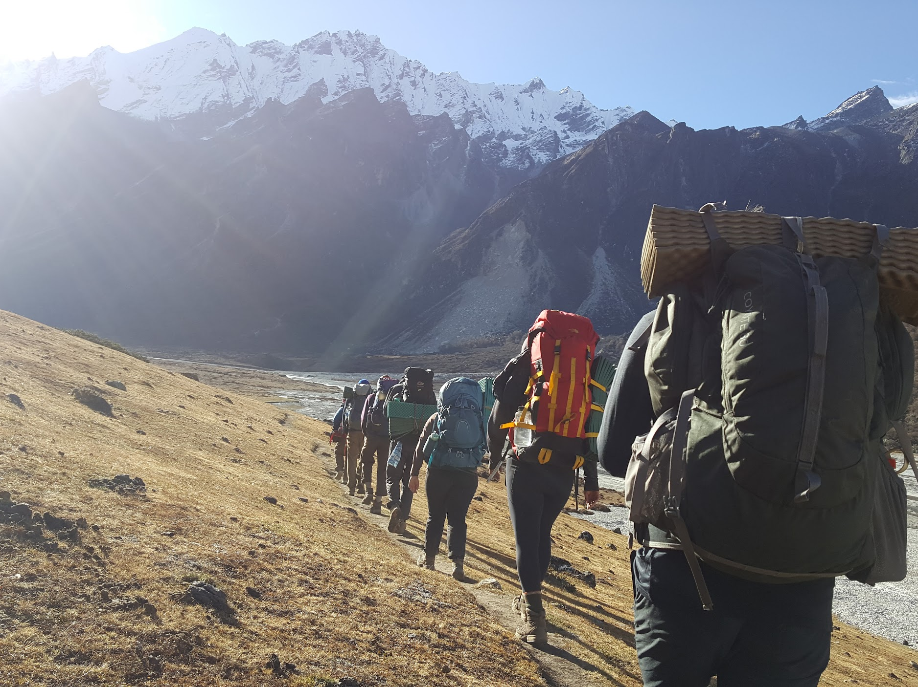
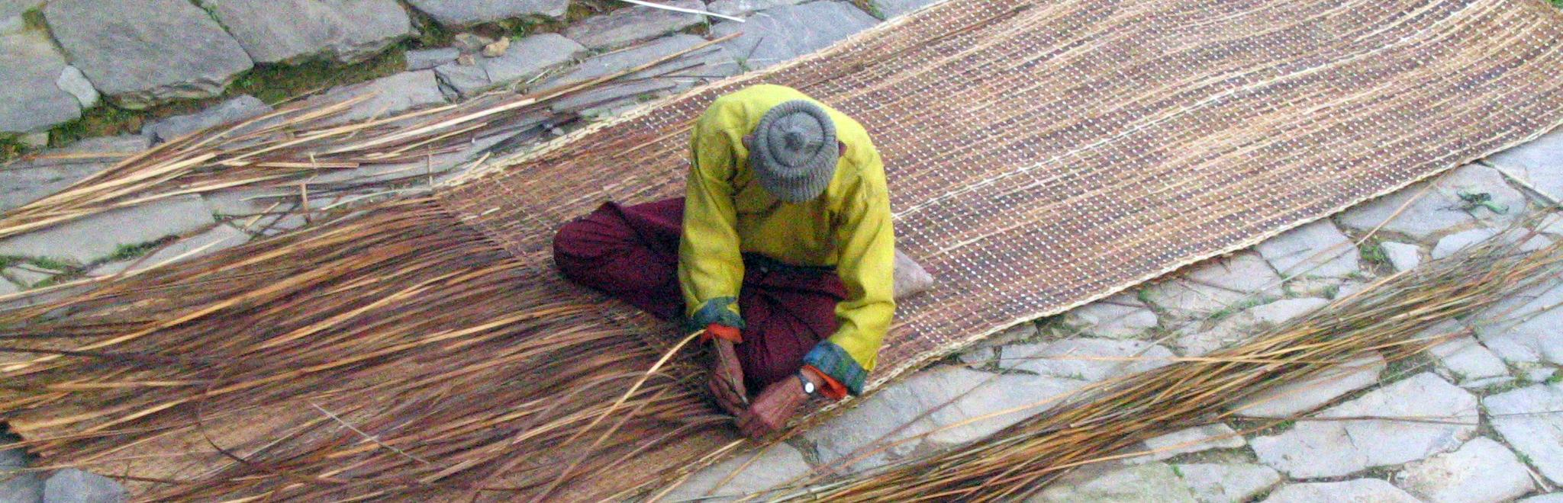

TYPICAL SCHEDULE:

Kathmandu (~7 days)
7:00-8:00 Birding
10:00-11:30 Visit NGO
12:30-1:00 Nepali language
1:00-4:00 Visit world heritage sites, museums, botanic gardens, etc.
5:00-6:00 Reading discussion
7:00-8:00 Reflection exercises

Trekking (~28 days)
6:30-7:30 Natural Walks focusing on plant/bird/mushroom identification
8:30-12:00 Hike to the next location with stops for trailside mini-lectures on topics related to geology and ecology.
12:30-1:00 Nepali language
1:00-3:00 Finish hiking
3:00-5:00 Time to read and work on assignments
5:00-6:00 Reading discussion
7:00-8:00 Reflection exercises

Homestays (~14)
7:00-8:00 Community Walks (themes include ethnobotany, sustainable agriculture, and pastoralism)
8:00-1:00 Help with home chores and meal prep
1:00-5:00 Group activity (blacksmithing, weaving, grain processing, etc.)
5:00-6:00 Reading discussion
6:00-8:00 Help family prepare dinner
8:00-9:00 Time to read and write

ITINERARY
Following a two day orientation in Bellingham, the program proceeds to Kathmandu where we will spend four days visiting botanical gardens, non government organizations, world heritage sites, and scholars while residing in a Buddhist Monastery. Then we travel to the Everest/Makalus region for two weeks of studying the transition in biogeoclimatic zones as we trek up the Arun River Valley to the village of Chumusur. In Chumusur we will participate in our first homestay and examine the local subsistence economy that villagers recently began supplementing with the cultivation of Medicinal and Aromatics Plants for international markets. From there we will loop back towards the trailhead via the Everest Region. After a transit day to the Langtang Region, we will follow the Tamang Heritage Trek participating in homestays leading up to and including the village of Briddim, where we will more critically examine the homestay model for rural poverty alleviation. From Briddim we will cross into Langtang National Park and ascend the rugged Langtang Valley Trek. Climbing up the Langtang valley gives us an excellent opportunity to view wildlife and examine how the slow work of rivers and glaciers along with more rapid changes from seismic events have etched the landscape. At higher elevations in the valley we will explore the glaciology in more detail, and get a chance to see wildlife and plants adapted to life above the treeline. From there we will cross Kangja La Pass and reach our highest elevations and our best opportunity to see threatened wildlife while spending nights camping. Then we drop down to the village of Melamchigau, the subject of one of our major readings to reflect on how village life has changed in Nepal since the author first began collecting data in the 1970s. Our return itinerary includes a stop at the National Park headquarters where we can report our findings and ask questions of park staff.

Tentative Dates | Place/Activity
Sep 23-24 | Orientation, Bellingham
Sep 27 | Departure
Sep 28 | Arrive Kathmandu
Sep 29-2 | Kathmandu, visit NGOs world heritage sites, museums. Stay in Buddhist Monastery
Oct 3-7 | Fly to Tunmingtar Upper Arun Valley. Medicinal and Aromatic Plants study. Homestays.
Oct 8-19 | Makalu Base Camp Trek
Oct 20 | Fly to Kathmandu
Oct 22 | Drive to Gatlang
Oct 31-Nov 3 | Tamang Heritage Trail. Homestays.
Nov 3-12 | Gosaikunda or Langtang Trek. Wildlife study
Nov 13-15 | Kathmandu. NGOs cultural attractions
Nov 16 | Flight Home

Topics
Biodiversity of the Himalaya
Intro to the geology and climate of the Himalaya
Floristic zones in mountains
Plant morphology and adaptations that help plants survive in the mountains
Environmental disturbances
Bird ID and adaptations

Introduction to South Asia, Nepal, and the Tibetan Buddhists of the Himalayas
Cultural geography of a diverse region
Nepali language
Tamang ethnobotany. Basket weaving, farming, medicine, incense, etc.
Subsistence farming

Protected Areas Management
Habitat destruction, poaching
Endangered species conservation
Island Biogeography and park design
Climate change
Managing natural and cultural heritage- tensions between livelihoods and conservation
Stewardship principles and practices

Ethical study and travel
Kathmandu
Staying found, safe, and healthy in a developing country
Cultural heritage
Villages (Gatlang, Thuman, Briddim,
Medicinal and Aromatic Plant Cultivation
Participatory learning
Himalaya cultures: past, present, and prospective
Dynamics of economic and cultural changes
Village life: work, families, a sense of place
Ethnoecology, resources, and rights: health, food, water, fuel, shelter
Homestay Tourism

Team Building
Group processing
Overcoming physical and emotional challenges

